Name: Muhammad Farhan

Roll no: 25K-0538

Section: BCS-3K

Course: Computer Organization & Assembly Language - Lab

Course Instructor: Miss Fareeha Jabeen

Date: 10/09/2026
Lab: 4

Note: Tasks were done together with Muhammad Faraz (K25-0780) during Lab (due to one pc not working). I did Tasks 2, 4, 6, 8 and 10, Faraz did 1, 3, 5, 7, 9.
Task 1:

INCLUDE Irvine32.inc

.data

reading BYTE 0E8h

.code
main PROC

movzx eax, reading
movsx ebx, reading

call DumpRegs
exit

main ENDP
END main

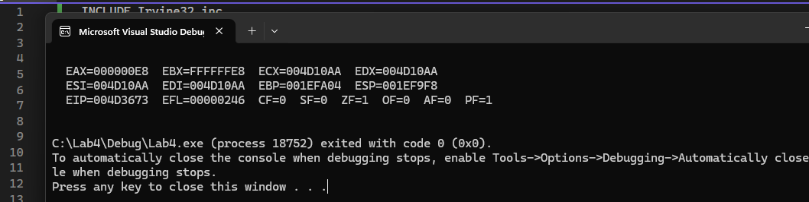

Task 2:

INCLUDE Irvine32.inc

.data

counting BYTE 3

.code
main PROC
INC counting ;first car arrived
INC counting ;second car arrived

DEC counting ;first car left
DEC counting ;second car left
DEC counting ;third car left

movzx eax, counting ;putting into register
call DumpRegs
exit

main ENDP
END main

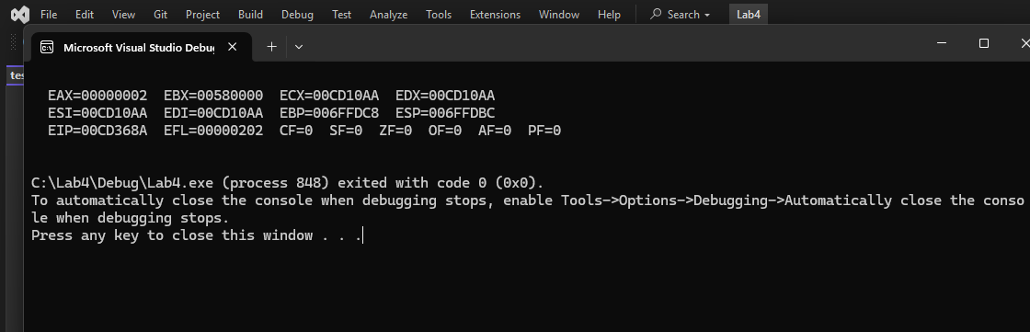

Task 3:

INCLUDE Irvine32.inc

.data

Ali word 78
Sara word 85

.code
main PROC

mov ax, Ali
xchg Sara, ax
mov ali, ax

movzx eax, Ali ; moving ali marks into eax for print
call writedec ; displays 85
call crlf ; skip line

movzx eax, Sara ; moving sara marks into ebx for print
call writedec ; displays 78

exit

main ENDP
END main

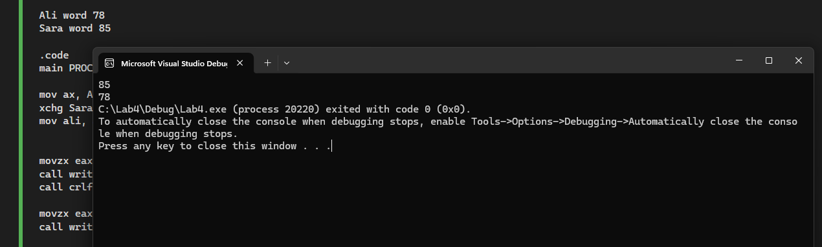

Task 4:

INCLUDE Irvine32.inc

.data
itemA DWORD 45000
itemB DWORD 62000

.code
main PROC

mov EAX, itemA
mov EBX, itemB

add EAX, 30000
sub EBX, 70000

mov itemA, EAX ;the actual output is 000124F8
mov itemB, EBX

call DumpRegs
exit

main ENDP
END main

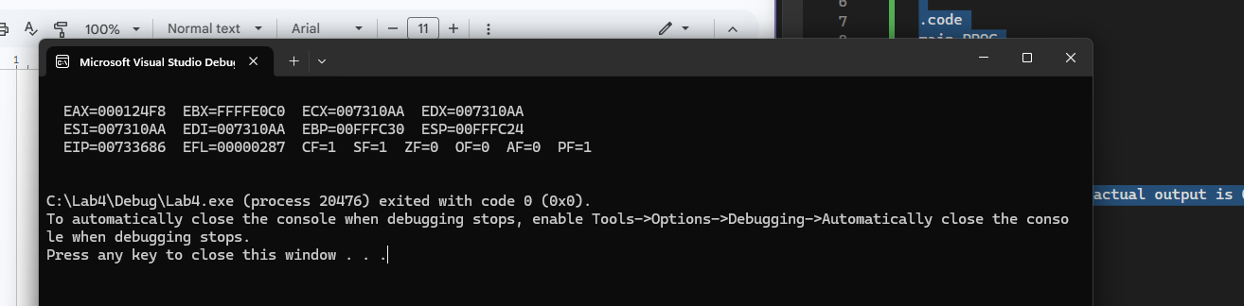

Task 5:

INCLUDE Irvine32.inc

.data

profit SDWORD 1500

.code
main PROC

mov eax, profit
mov ebx, eax

neg ebx

call DumpRegs
exit

main ENDP
END main

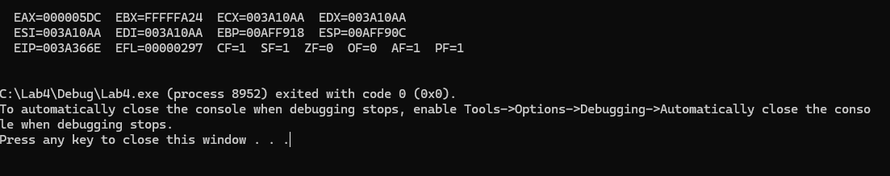

Task 6:

INCLUDE irvine32.inc

.data
array25 BYTE 25 DUP(0)

.code
main PROC

mov ECX, LENGTHOF array25
mov EBX, SIZEOF array25
movzx EAX, array25[0]
call DumpRegs

exit
main ENDP
END main

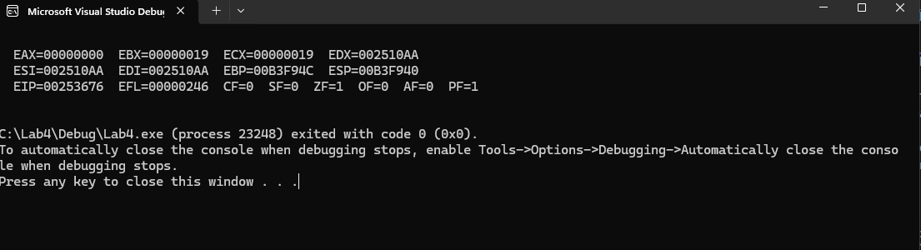

Task 7:

INCLUDE irvine32.inc

.data

breakduration BYTE 15
days = 6
periods = 8

grid BYTE days * periods Dup (0)

.code
main PROC

exit
main ENDP
END main

Task 8:

INCLUDE irvine32.inc

.data
MidtermScore SDWORD 35
FinalExamScore SDWORD 55
Deductions SDWORD 8
FinalGrade SDWORD ?

.code
main PROC
mov EAX, MidtermScore
mov EBX, FinalExamScore
mov ECX, Deductions

mov EDX, EBX
sub EDX, ECX
add EDX, EAX

mov FinalGrade, EDX

call DumpRegs

exit
main ENDP
END main

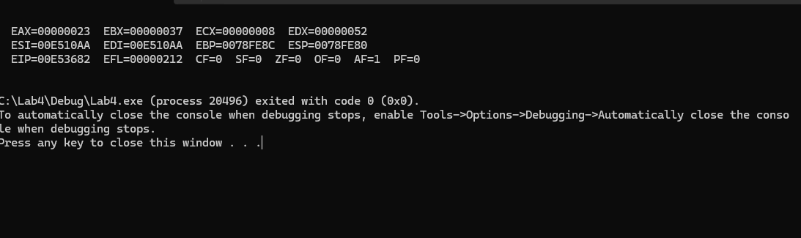
Task 9:

INCLUDE irvine32.inc

.data

industrialSensor BYTE 80h

.code
main PROC

movzx eax, industrialSensor
movsx ebx, industrialSensor

call DumpRegs

exit
main ENDP
END main

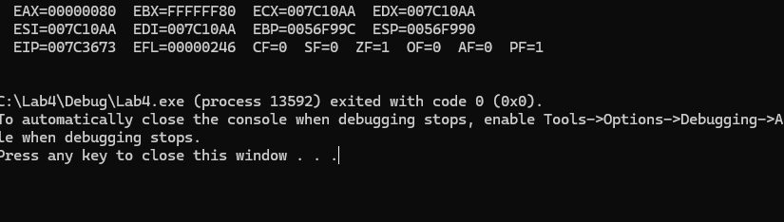

Task 10:

INCLUDE irvine32.inc

.data

.code
main PROC
mov EAX, 12345678h
mov AX, 0

call DumpRegs

exit
main ENDP
END main

