Name : Muhammad Farhan
Roll no: 25K-0538
Section: BCS-3K
Course: Computer Organization & Assembly Langauge – Lab
Course Instructor: Miss Fareeha Jabeen
Date: 09/09/2026

Task 1:

INCLUDE Irvine.inc

.data
book_category BYTE "ENG-11", 0 ;random category name
shelf_num BYTE "3C", 0 ;random
member_person BYTE "Studnet", 0

.code
main PROC

exit
main ENDP
END main

Task 2:
INCLUDE Irvine32.inc

.data
decimal_system BYTE 15
binary_system BYTE 1111b
octal_system BYTE 17o
hexa_system BYTE 0Fh

.code
main PROC

mov eax, 0 ;cleaning out the register so the end result is more obvious
mov ebx, 0
mov ecx, 0
mov edx, 0

mov al, decimal_system
mov bl, binary_system
mov cl, octal_system
mov dl, hexa_system

call dumpregs

exit
main ENDP
END main

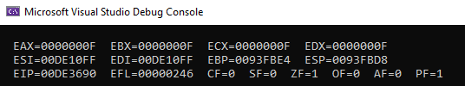

Task 3:
INCLUDE Irvine32.inc

.data
seat_letter BYTE 'F'
passenger BYTE "Muhammad Farhan", 0
;The 0 at the end of a string marks the end of the string, similair to '\0' on C.

.code
main PROC

exit
main ENDP
END main

Task 4:

INCLUDE Irvine32.inc
COMMENT @
so this program is supposed to add the price of individual items,
and then subtract it from the payment amount.
@

.data
bill WORD 0

.code
main PROC
add bill, 10 ;adding 10 to the bill
add bill, 20 ;adding 20 to the bill
mov eax, 0 ;cleaning the eax register
mov ax, 50 ;the payment for the bill
sub ax, bill ;subtracting bill from payment

call DumpRegs

exit
main ENDP
END main

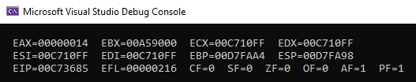

Task 5:
INCLUDE Irvine32.inc

.data
age BYTE 10
phone DWORD 1234567
temperature SBYTE -60
serial_number QWORD 223497243987

.code
main PROC
mov EAX, 0 ;clearing register for easy readability
mov al, temperature

call DumpRegs

exit
main ENDP
END main

