Applied Physics
Assignment 3: Section 2
Name: Muhammad Farhan
Roll no: 25K-0538
Section: BCS-1K
Course: Applied Physics
Course Instructor: Sir Rameez Mateen
Task 1:
#include <stdio.h>
#include <math.h>

int main()
{
float EFlux, Area, Angle, rad, Result;
printf("\nEnter magnitude of Electric Flux: ");
scanf("%f", &EFlux);
printf("\nEnter the Area of the rectangular surface: ");
scanf("%f", &Area);
printf("\nEnter angle between electric field vector and area vector in Degrees: ");
scanf("%f", &Angle);
rad = Angle*(M_PI/180);
Result = EFlux*Area*cos(rad);
printf("\n\nThe Electric Flux through the rectangular surface is %.3f", Result);
printf("\n");
return 0;
}
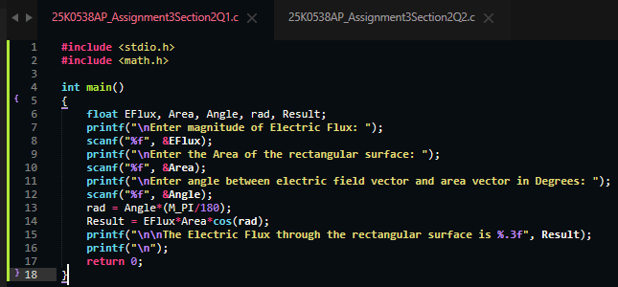
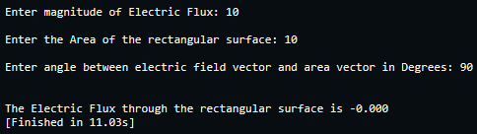
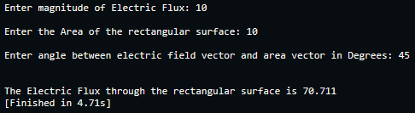
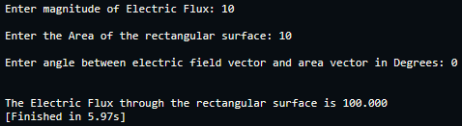

Task 2:
#include <stdio.h>

int main()
{
float C[3]={0}, result=0;
int choice;
printf("\n1. Series\n2. Parallel\nEnter your choice: ");
scanf("%d", &choice);
if (choice == 1)
{
for (int i = 0; i <= 2; ++i)
{
printf("\nEnter Capacitance of C%d in Farads: ", i+1);
scanf("%f", &C[i]);
}
result = 1/((1/C[0])+(1/C[1])+(1/C[2]));
printf("\n\nThe Equivalent Capacitance is %.3f Farads.", result);
}
else if (choice == 2)
{
for (int i = 0; i <= 2; ++i)
{
printf("\nEnter Capacitance of C%d in Farads: ", i+1);
scanf("%f", &C[i]);
result+=C[i];
}
printf("\n\nThe Equivalent Capacitance is %.3f Farads.", result);
}
else
{
printf("\nError: Invalid Input.");
}
return 0;
}
