  Climate Change and its impacts | A Study on Causes, Effects, and Solutions  Mohammad Farhan  25K-0538

Table of Contents:
Contents
Table of Contents: 1
Introduction: 2
Causes of Climate Change: 3
Natural Causes: 3
Human Activities: 3
Combined Effect: 4
Impacts of Climate Change: 5
Environmental Impacts: 5
Social Impacts: 5
Economic Impacts: 6
A Global Challenge: 6
Global Responses to Climate Change: 7
International Agreements: 7
Role of Global Organizations: 7
National and Community-Level Efforts: 7
The Ongoing Challenge: 8
Solution and Mitigation Strategies: 9
Renewable Energy Transitions: 9
Sustainable Practices in Industry and Agriculture: 9
Adaptation and Resilience: 9
Individual and Community Actions 10
The Way Forward: 10
Table: Greenhouse Gas Emissions by Sector (Global, 2020) 11
Chart: Global Temperature Rise (1880–2020) 11
Related Images: 12
Bibliography 13

Introduction:

Climate change has become a major issue of the 21st century. It relates to long-term changes in temperature, precipitation, wind patterns, and other parts of the Earth’s climate system. While the planet's climate has always undergone natural shifts, what makes the current situation concerning is the speed and scale of change in recent decades. Scientific research shows that human activities, like burning fossil fuels, cutting down forests, and expanding industries, have significantly increased greenhouse gas levels in the atmosphere. This traps more heat and disrupts the natural balance of the environment.

The effects of these changes are visible around the world. Average temperatures are rising, glaciers and ice caps are melting faster than ever, and sea levels are rising higher each year. Communities are experiencing more frequent floods, droughts, and storms. These events threaten food security, human health, and economic stability. For developing countries, the challenges are even greater since limited resources make it harder to adjust to the quickly changing climate.

This report aims to give a clear overview of climate change. It will start with the causes and then cover its wide-ranging impacts. It will also highlight the actions that governments, organizations, and individuals are taking to address the crisis. By understanding both the risks and the solutions, we can better appreciate the importance of working together to create a sustainable future for generations to come.

Causes of Climate Change:
The causes of climate change can be divided into natural factors and human activities. While natural forces have always affected the Earth’s climate, the scale of human activity since the Industrial Revolution has sped up the process. This has made the current changes much more dangerous than those in the past.

Natural Causes:
Climate has never been completely stable. The Earth has gone through several ice ages and warm periods long before humans had any impact. Natural causes include volcanic eruptions, solar variations, ocean currents, and changes in the Earth's orbit. Volcanic eruptions can release large amounts of ash, sulfur dioxide, and other particles into the atmosphere, temporarily cooling the planet by blocking sunlight. Historical records show that the eruption of Mount Tambora in 1815 led to the "Year Without a Summer," resulting in widespread crop failures and food shortages across the Northern Hemisphere (1815 eruption of Mount Tambora, 2025). Changes in solar activity, such as fluctuations in sunspot cycles, slightly change the amount of solar radiation reaching Earth. This can influence climate patterns over decades. Another important natural factor is the greenhouse effect, which makes Earth livable by trapping some of the Sun’s heat in the atmosphere. Without it, Earth would be too cold for life. However, even small changes in naturally occurring greenhouse gases like water vapor, carbon dioxide, and methane can affect global temperatures. While natural processes do play a role in climate change, they cannot solely explain the rapid warming trend observed in recent centuries.

Human Activities:
The evidence clearly shows that human activity is the main cause of modern climate change. Burning fossil fuels, such as coal, oil, and natural gas, for electricity, heat, and transportation releases billions of tons of carbon dioxide (CO₂) each year. This increase in greenhouse gases has intensified the natural greenhouse effect, trapping more heat and causing global temperatures to rise. Deforestation is another major contributor. Forests act as carbon sinks by absorbing CO₂ from the atmosphere. When trees are cut down for agriculture, urban development, or logging, not only is this capacity lost, but the carbon stored in trees is also released back into the air. Industrial activities also release additional greenhouse gases such as methane (CH₄) and nitrous oxide (N₂O). Methane, mainly produced from livestock farming, landfills, and natural gas operations, is significantly more effective at trapping heat than CO₂, making it especially harmful. Nitrous oxide, released from fertilizers and certain industrial processes, also has a strong warming effect. Modern agriculture contributes significantly as well. Livestock such as cows and sheep produce methane during digestion, while overusing chemical fertilizers releases nitrous oxide. Rapid urbanization and increasing demand for goods have led to higher energy use, expanded transportation networks, and more waste production, all of which increase greenhouse gas emissions.

Combined Effect:
While natural processes have always influenced Earth’s climate, the speed, scale, and intensity of current climate change are largely connected to human activities. According to the Intergovernmental Panel on Climate Change (IPCC), over 95% of scientists agree that humans are the main cause of global warming observed since the mid-20th century (Intergovernmental Panel on Climate Change (IPCC), 2013). Without urgent and large-scale changes in how societies produce energy, use land, and manage industries, the factors driving climate change will continue to increase. This will put the planet on a path of worsening impacts that future generations will find hard to reverse.

Impacts of Climate Change:
The effects of climate change are already visible around the world, and they go beyond just rising temperatures. These impacts can be categorized into three main areas: environmental, social, and economic. Together, they show how deeply connected human societies are to the planet's natural systems. This is why many consider climate change the greatest challenge humanity has ever faced.

Environmental Impacts:
One of the most noticeable consequences of climate change is the steady rise in global temperatures. Even small increases in average temperature can disrupt ecosystems and change weather patterns. Glaciers and polar ice caps are melting quickly, which contributes to rising sea levels. Low-lying coastal areas and island nations are already at risk of flooding, erosion, and even permanent land loss.
Climate change also makes severe weather events worse. Heatwaves are now more frequent and intense, causing wildfires to spread rapidly in regions like Australia, California, and the Mediterranean. At the same time, storms and hurricanes are becoming stronger due to warmer ocean waters, bringing devastating floods and damage to coastal communities. Droughts in some areas and heavy rain in others disrupt water availability, affecting ecosystems and agriculture. Rising ocean temperatures are also causing coral bleaching, which threatens marine biodiversity and fisheries that millions rely on for food.

Social Impacts:
Climate change does not impact everyone the same way. Vulnerable communities, especially in developing countries, experience the harshest effects. Rising temperatures can lead to health risks like heat exhaustion, dehydration, and the spread of diseases such as malaria and dengue fever. Food security is also at risk, as changing rainfall patterns and extreme weather reduce agricultural output and lead to crop failures.
Moreover, water scarcity is becoming a serious problem in many places, increasing competition for limited resources and straining relationships between neighboring regions and countries. This pressure can lead to displacement, forcing millions to leave their homes. The number of “climate refugees” is expected to rise significantly in the coming decades, creating humanitarian, social, and political challenges worldwide. The loss of traditional ways of life in rural and indigenous communities also shows how climate change disrupts cultures as well as livelihoods.

Economic Impacts:
The economic costs of climate change are alarming. Natural disasters linked to extreme weather events destroy infrastructure, homes, and businesses, requiring vast amounts for reconstruction. Agriculture, forestry, and fisheries are especially vulnerable, leading to income losses for millions. Tourism, particularly in areas known for natural beauty like coral reefs or snow-capped mountains, is also threatened as these attractions degrade or vanish.
Insurance companies and financial institutions are facing greater risks as climate-related damages increase claims costs and threaten market stability. Supply chains may also be disrupted by floods, storms, and changing resource availability, affecting local businesses and international trade. For many developing countries, these economic challenges add to existing struggles with poverty, making it even harder to invest in adaptation and resilience measures.

A Global Challenge:
Overall, the impacts of climate change show it is not just an environmental issue but also a social and economic crisis. Every degree of warming brings new challenges that affect how people live, work, and interact with their environment. If we do not address these issues, the effects will worsen, putting the health, safety, and prosperity of current and future generations at risk. The urgency of the situation calls for collective action to limit damage and create a sustainable future.

Global Responses to Climate Change:
As the impacts of climate change grow clearer, the global community has increasingly recognized the need for coordinated action. Responses have focused on reducing greenhouse gas emissions, adapting to unavoidable changes, and building resilience through international cooperation.

International Agreements:
One key step in global climate policy is the Paris Agreement (2015). Nearly every country in the world signed this treaty, committing to limit global warming to well below 2°C above pre-industrial levels, aiming to keep it closer to 1.5°C. Countries must submit nationally determined contributions (NDCs), which outline their plans to reduce emissions and adapt to climate change (Paris Agreement, 2015).
Earlier efforts laid the groundwork for this progress. The Kyoto Protocol (1997) set legally binding targets for developed nations (United Nations, 1997), while the United Nations Framework Convention on Climate Change (UNFCCC), signed in 1992 (United Nations, 1992), created the framework for annual global climate meetings, known as COPs (Conferences of the Parties), which are still held today.

Role of Global Organizations:
Many organizations play a critical role in guiding and supporting climate action. The Intergovernmental Panel on Climate Change (IPCC) provides scientific assessments that influence global policies and highlight the urgency of reducing emissions. The United Nations Environment Programme (UNEP), the World Bank, and other institutions assist countries, especially developing nations, by offering financial support, sharing technology, and developing adaptation strategies like improved agriculture and disaster resilience programs.

National and Community-Level Efforts:
At the national level, many countries have heavily invested in renewable energy and sustainable infrastructure. For instance, the European Union aims to reach net-zero emissions by 2050 (European Union, 2019), while countries such as China and India are increasing their use of solar and wind power to meet growing energy needs more sustainably.
Local communities and grassroots movements have also become influential. Campaigns like Fridays for Future, led by young activists, stress the urgency of climate action and hold governments accountable for their promises. NGOs and civil society groups support climate education, conservation, and sustainable development projects (36 Organizations Helping Solve the Climate Crisis, 2020).

The Ongoing Challenge:
Despite these efforts, progress has been uneven. Global greenhouse gas emissions keep rising, and many countries struggle to meet their targets. Developing nations often face the greatest risks from climate change but lack the resources to adapt. This makes financial support, technology transfer, and stronger international cooperation essential.
In summary, global responses to climate change have made important strides, but much work remains. Only through ongoing international collaboration, national commitment, and community action can the world hope to lessen the severity of climate impacts and build a sustainable future.

Solution and Mitigation Strategies:
Addressing climate change requires a mix of mitigation, which is reducing the emissions that cause global warming, and adaptation, which is adjusting to the impacts that are already unavoidable. Solutions must work on multiple levels, from international policy to individual actions, to be effective.

Renewable Energy Transitions:
One of the most important solutions is moving away from fossil fuels and adopting renewable energy sources. Solar, wind, hydro, and geothermal energy offer cleaner alternatives that can significantly lower carbon emissions. Countries that invest in renewable energy not only cut their greenhouse gas emissions but also gain sustainable economic growth and energy security. For example, large-scale solar farms and offshore wind projects are becoming more common in regions committed to ending coal and oil use.

Sustainable Practices in Industry and Agriculture:
Industries and agriculture also play a key role in climate solutions. Factories can lower emissions by using energy-efficient technologies, recycling materials, and investing in cleaner production methods. Agriculture can help by adopting sustainable practices like organic farming, reducing fertilizer use, and improving livestock management to limit methane emissions. Reforestation and afforestation projects help absorb carbon dioxide, while protecting existing forests keeps vital ecosystems intact and preserves their carbon storage capacity.

Adaptation and Resilience:
Alongside reducing emissions, communities must adjust to the changes that are already occurring. Building stronger infrastructure, such as flood defenses and climate-resilient housing, can protect people from extreme weather events. Farmers can choose drought-resistant crops and improve irrigation systems to adapt to changing rainfall patterns. Early warning systems for disasters like hurricanes, floods, or heatwaves can save lives and minimize economic losses.

Individual and Community Actions
Individual choices, while small on their own, can collectively make a big impact. People can cut their carbon footprint by using public transport, saving energy, recycling, and opting for plant-based diets or reducing meat consumption. Community-driven initiatives, such as tree planting campaigns and local renewable energy projects, empower individuals to take charge of climate action and inspire wider change.

The Way Forward:
Tackling climate change requires collaboration at all levels. Governments need to implement strong policies, industries should innovate with sustainable technologies, and individuals must choose environmentally friendly lifestyles. Climate change is a global issue, but with dedicated action and shared responsibility, it is possible to slow its progress and create a safer, more sustainable world for future generations.

Table: Greenhouse Gas Emissions by Sector (Global, 2020)
Sector | CO2 emissions (million metric tons) | % of total emissions
Energy (electricity & heat) | 13100 | 40%
Industry | 7000 | 21%
Transport | 7200 | 22%
Agriculture | 5100 | 15%
Forestry / Land Use | 600 | 2%
Table 1: Global CO₂ emissions by sector in 2020 (Source: IPCC, 2021)

Chart: Global Temperature Rise (1880–2020)

Chart 1: Global Temperature Rise (1880–2020) (Source: NASA, 2023)

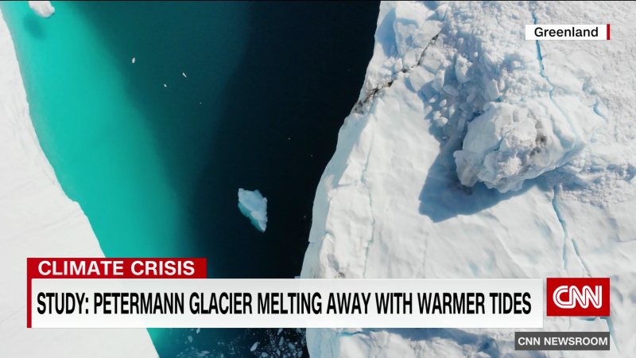
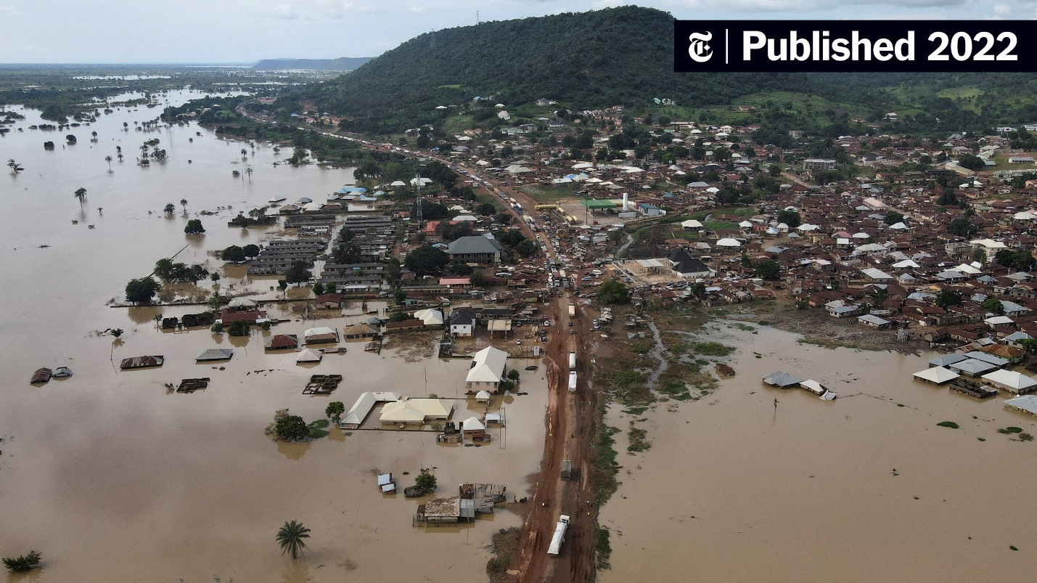
Related Images:
Figure 1: Melting Glacier in Greenland
Figure 2: Flooding caused by Climate Change

Bibliography
1815 eruption of Mount Tambora. (2025, 9 30). Retrieved from Wikipedia: https://en.wikipedia.org/wiki/1815_eruption_of_Mount_Tambora
36 Organizations Helping Solve the Climate Crisis. (2020, 10 22). Retrieved from Food Tank: https://foodtank.com/news/2020/10/36-organizations-helping-solve-the-climate-crisis/
European Union. (2019, 12 11). A European Green Deal. Retrieved from European Commission: https://ec.europa.eu/info/strategy/priorities-2019-2024/european-green-deal_en
Intergovernmental Panel on Climate Change (IPCC). (2013). Climate Change 2013: The Physical Science Basis. Cambridge, United Kingdom: Cambridge University Press.
(2015). Paris Agreement. Bonn, Germany: United Nations Framework Convention on Climate Change (UNFCCC).
United Nations. (1992). United Nations Framework Convention on Climate Change. Rio de Janeiro, Brazil: United Nations.
United Nations. (1997). Kyoto Protocol to the United Nations Framework Convention on Climate Change. Kyoto, Japan: United Nations.

