Mohammad Farhan
roll no: 25K-0538
Program: bcs-1k
section: k
course: ICT Lab
Course instructor: Miss syeda Tehreem gilani

f
Creating a Simple Database in HS Access
Assignment 1 Section 4 task 7

7. Creating a Simple Database in HS Access
Using MS Access, create a simple database to manage
student records. The database should include the
following:
- At least three tables (e.g., Students, Courses, Enrollment).
- Input sample data into each table (at least 10 records per table).

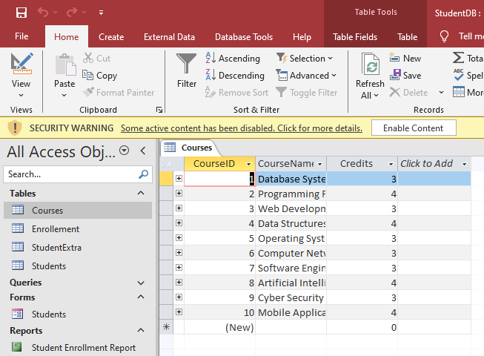

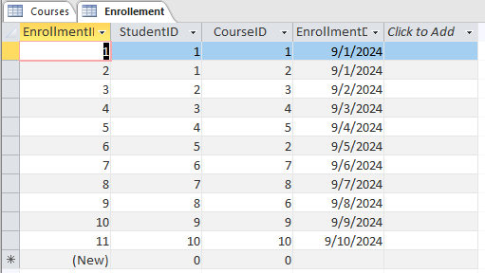
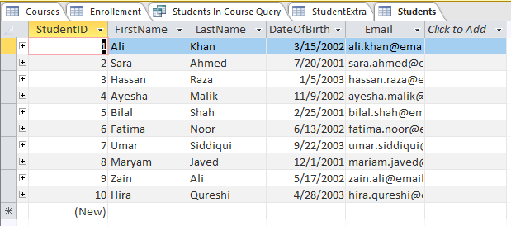
- Define primary keys for each table and set up relationships between the tables.

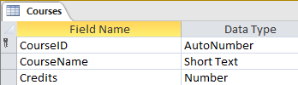
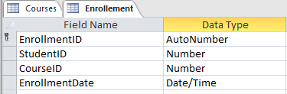
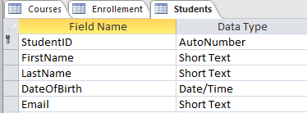
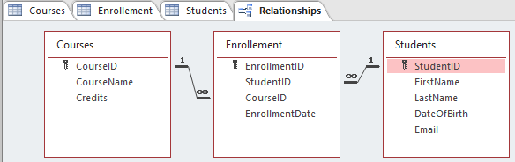
- Design a query to display all students enrolled in a particular course.
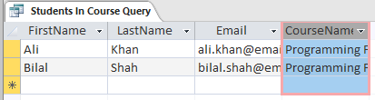
Query of students enrolled in a particular course (programming fundamentals in this case).

- Create a simple form for data entry and a report to display student details.
