Understanding Data Relationships in MS Access

Name: Muhammad Farhan
Roll no: 25K-0538
Program: BCS-1K
Section: K
Course: ICT Lab
Assignment #1, Section 4, Task 8
Course Instructor:
Miss Syeda Tehreem Gilani
Introduction:
Databases are designed to store, organize, and manage information in a structured way. In order to connect data across different tables, relationships are created. A relationship defines how records in one table are linked to records in another, ensuring that information is not duplicated and remains consistent throughout the database.
There are three main types of relationships used in relational databases: One-to-One, One-to-Many, and Many-to-Many. Each type serves a different purpose depending on how the data is structured.
In this report, these relationships will be explained in detail and demonstrated using a student database created in Microsoft Access. Screenshots of the relationships will be included to show how they are set up in Access, along with a discussion on the importance of enforcing referential integrity to maintain accurate and reliable data.

One-to-One Relationship
A One-to-One relationship occurs when a record in one table is linked to exactly one record in another table, and vice versa. This type of relationship is less common but is useful when you want to split a table for organizational or security reasons, or when certain information only applies to some records.
Example: A One-to-One relationship occurs when each record in one table corresponds to exactly one record in another table. In the context of a student database, this could be represented by linking two tables that share the StudentID as a primary key. Each student in the Students table would have exactly one corresponding record in the second table, ensuring a unique and direct association between the two tables.
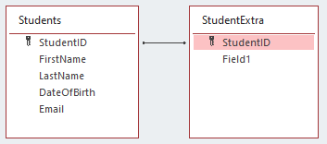
Figure 1: One-to-One Relationship between Students and StudentExtra.
One-to-Many Relationship
A One-to-Many relationship occurs when a single record in one table can be associated with multiple records in another table, but each record in the second table relates to only one record in the first table. This is the most common type of relationship in databases.
Example: In the student database, one student can enroll in multiple courses. The Students table stores each student’s details (StudentID, Name, Department), while the Enrollments table stores the courses each student is enrolled in (EnrollmentID, StudentID, CourseID). Here, StudentID in the Enrollments table is a foreign key linking back to Students, creating a one-to-many relationship: one student many enrollments.

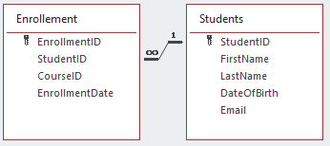
Figure 2: One-to-Many Relationship between Students Enrollment
Many-to-Many Relationship
A Many-to-Many relationship occurs when a record in one table can relate to multiple records in another table, and vice versa. This type of relationship cannot be created directly between two tables in Access; instead, it is implemented using a junction table (also called a linking table).
Example: In the student database, many students can enroll in many courses. The Students table stores student details, and the Courses table stores course details. The Enrollments table acts as a junction table linking Students and Courses, with fields like EnrollmentID, StudentID, and CourseID. This allows:
- One student to enroll in multiple courses
- One course to have multiple students
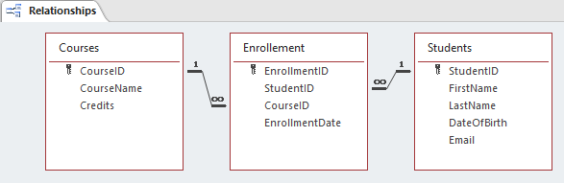

Figure 3: Many-to-Many Relationship between Students and Courses using the Enrollments junction table.
Referential Integrity
Referential integrity is a set of rules in a relational database that ensures relationships between tables remain consistent. It prevents invalid or orphaned records from being created, keeping the database accurate and reliable.
Importance:
- Ensures that a foreign key in one table always corresponds to a valid primary key in the related table.
  - Example: You cannot have an enrollment record in the Enrollments table referencing a StudentID that does not exist in the Students table.

- Prevents accidental deletion of related data.
  - With Cascade Delete, deleting a student can automatically remove all their enrollment records.

- Maintains data consistency across the database, which is crucial for reporting, queries, and analysis.
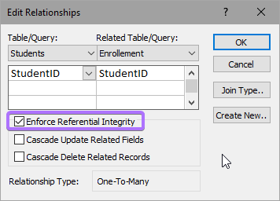
Figure 4: Enforcing Referential Integrity in MS Access to maintain consistent and accurate data.
Conclusion
In this report, the three main types of database relationships; One-to-One, One-to-Many, and Many-to-Many, have been demonstrated using a student database in Microsoft Access. Screenshots show how these relationships are established and visually represented in Access.
Additionally, the importance of referential integrity has been highlighted, showing how it ensures that data remains consistent, accurate, and free from invalid or orphaned records. Properly defining relationships and enforcing referential integrity is essential for building reliable databases that support accurate data management, queries, and reporting.

