ICT assignment
Section 5: Basic SQL
Name: Muhammad Farhan
Roll no: 25K-0538
Program: BCS-1K
Section: 1K
ICT Assignment: Section 5: Basic SQL
Course Instructor: Miss Syeda Tehreem Gilani
- Write a query to list the names of all employees along with their department names. Include the employee's ID, full name, and department name.

SELECT
employees.employee_id,
employees.First_name,
employees.Last_name,
departments.department_name
from Employees
join departments
on employees.department_id = departments.department_id;

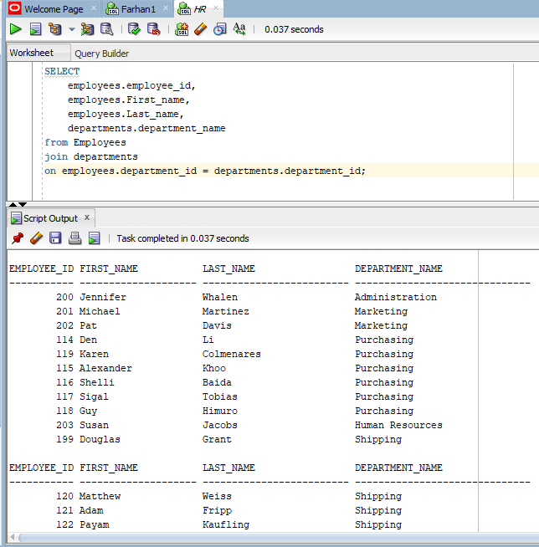

- Write a query to count the number of employees in each department. Include the department name and the number of employees.

SELECT
departments.department_name,
COUNT(employees.employee_id) AS number_of_employees
FROM employees
JOIN departments
ON employees.department_id = departments.department_id
GROUP BY departments.department_name;

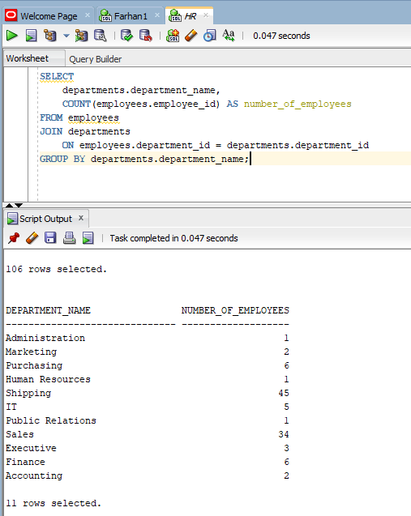
- Write a query to list all job titles available in the company.

SELECT job_title
FROM jobs;

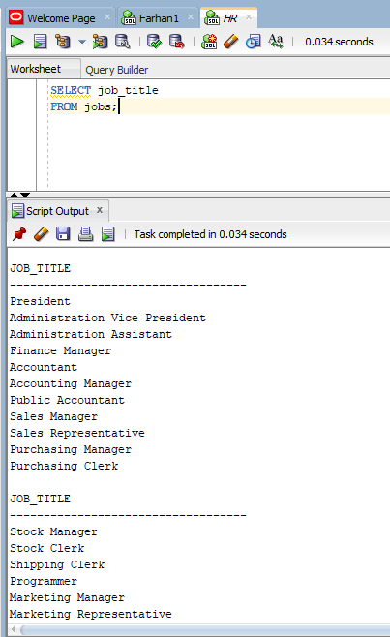
- Write a query to find all employees who earn more than $5000 per month. Include the employee's ID, full name, and salary.

SELECT
employee_id,
first_name,
last_name,
salary
FROM employees
where salary > 5000;
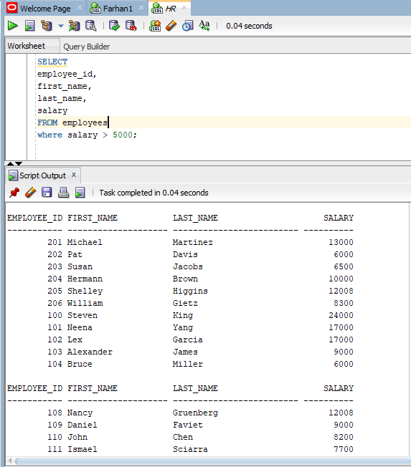

- Write a query to list the names of all departments along with their location.

SELECT
departments.department_name,
locations.state_province,
locations.city,
locations.street_address
FROM departments
JOIN locations
ON departments.location_id = locations.location_id;

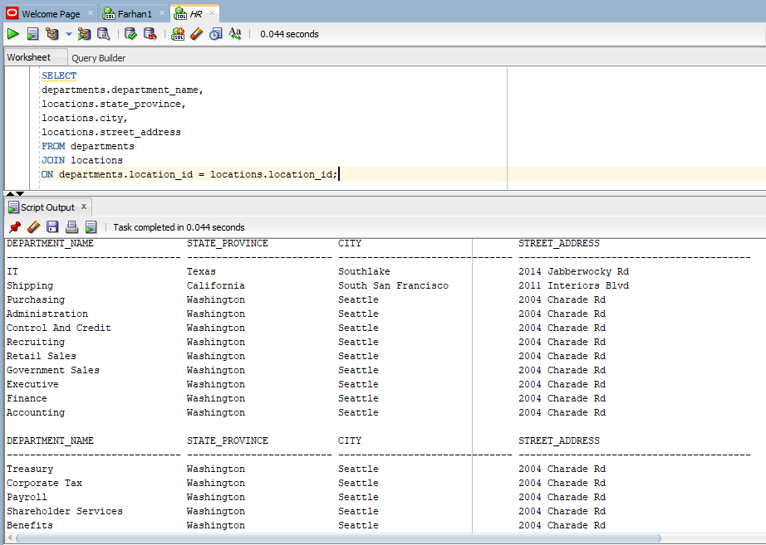

- Write a query to find the earliest hire date in the company. Just show the date.

SELECT
MIN (hire_date)
FROM employees;

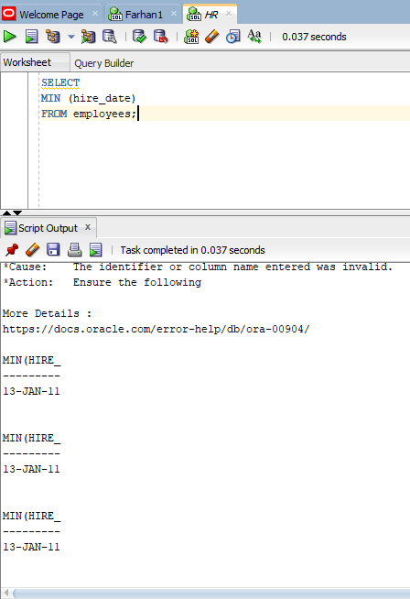

- Write a query to list all employees who were hired after January 1, 2010. Include the employee's ID, full name, and hire date.

SELECT
employee_id,
first_name,
last_name,
hire_date
FROM employees
WHERE hire_date > TO_DATE('2010-01-01', 'YYYY-MM-DD');
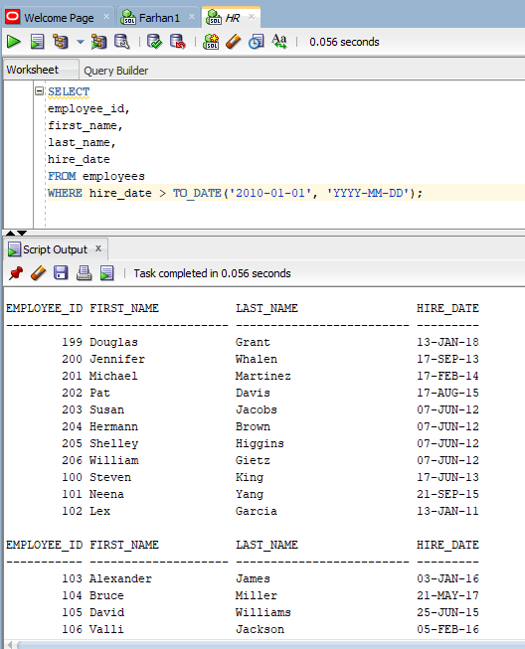

- Write a query to calculate the average salary of all employees in the company.

SELECT
AVG(salary) AS average_salary
FROM employees;

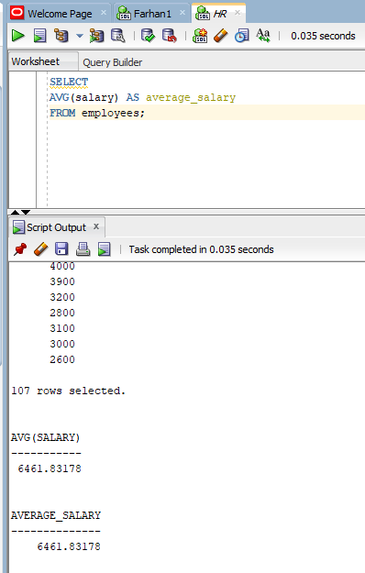
- Write a query to list all department names.

SELECT
department_name
FROM departments;

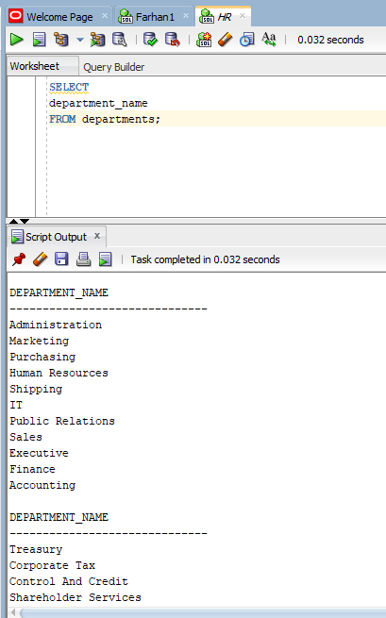

- Write a query to find all employees with the job title 'Sales Representative'. Include the employee's ID, full name, and job title.

SELECT
employees.employee_id,
employees.first_name,
employees.last_name,
jobs.job_title
FROM employees
JOIN jobs
ON employees.job_id = jobs.job_id
WHERE jobs.job_title = 'Sales Representative';
