ICT Lab 11
Tasks

Name: Muhammad Farhan
Roll no: 25K-0538
Section: BCS-1K
Course: Information and Communication Technology
Course Instructor: Miss Syeda Tehreem Gilani
Task 1:
#include <iostream>
using namespace std;

class Person
{
public:
string name;
int age;
void display()
{
cout << "\n\nName: " << name << "\nAge: "<< age << endl;
}
};

class student : public Person
{
public:
int RollNumber;
void showRoll()
{
cout << "Roll Number: " << RollNumber << endl;
}
};

int main()
{
student Stud;
cout << "\nEnter Student Name: " << "\n";
cin >> Stud.name;
cout << "\nEnter Student Age: " << "\n";
cin >> Stud.age;
cout << "\nEnter Student Roll Number: " << "\n";
cin >> Stud.RollNumber;
Stud.display();
Stud.showRoll();
return 0;
}
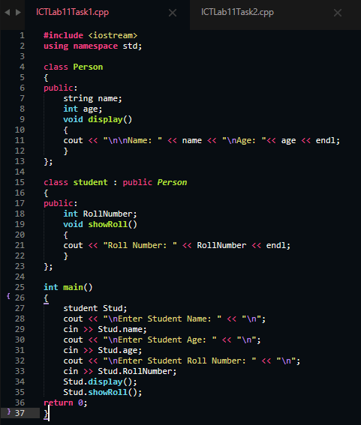

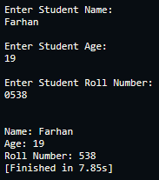
Task 2:
#include <iostream>
using namespace std;
class Employee
{
public:
void work()
{
cout << "\nEmployee is working"<< endl;
}
};

class Manager : public Employee
{
public:
void work()
{
cout << "\nManager is managing work"<< endl;
}
};

int main()
{
Employee Emp;
Manager Manag;

Emp.work();
Manag.work();
return 0;
}
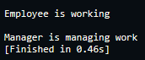
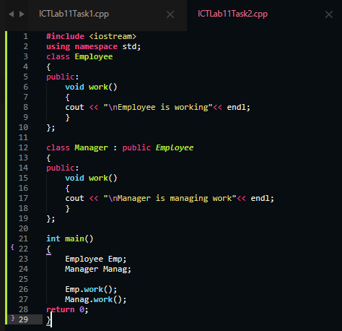

Task 3:
#include <iostream>
using namespace std;

class Employees
{
public:
string name;
int salary;
void virtual calculateBonus()
{
cout << "\nBase Employee bonus is 1000." << endl;
}
};

class Manager : public Employees
{
public:
void virtual calculateBonus()
{
cout << "\nManager bonus is 5000." << endl;
}
};

class Developer : public Employees
{
public:
void virtual calculateBonus()
{
cout << "\nDeveloper bonus is 3000." << endl;
}
};

int main()
{
Employees* emps[2];
Developer dev;
Manager manag;
emps[0] = &manag;
emps[1] = &dev;

for (int i = 0; i < 2; ++i)
{
cout << "\nEnter Employee#" << i+1 << " Name: " << endl;
cin >> emps[i]->name;
cout << "\nEnter Employee#" << i+1 << " salary: " << endl;
cin >> emps[i]->salary;
}

for (int i = 0; i < 2; ++i)
{
cout << "\nEnter Employee#" << i+1 << " Name: " << emps[i]->name << endl;
cout << "\nEnter Employee#" << i+1 << " Salary: " << emps[i]->salary << endl;
emps[i] -> calculateBonus();
}
return 0;
}
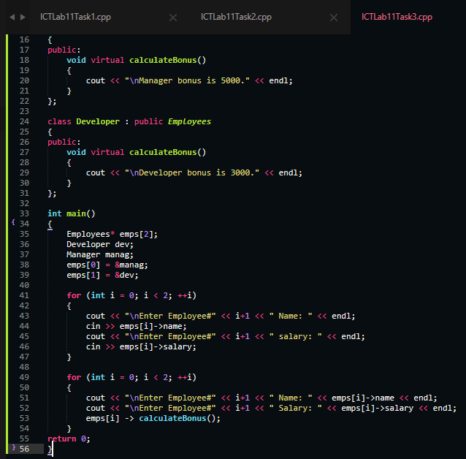

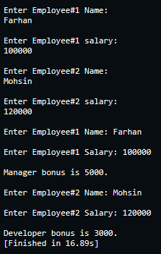

Unrelated Note: The Text Editor used is “Sublime Text”. Rather than Dev C++ or VS Code.
Its similar to Dev C++ but very modern, updated and much faster, its also known as the fastest text editor in the entire market. Its specialty is that it can even open huge files and codes almost instantly and without lagging.

