
PRogramming fundamentals lab

Name: Muhammad Farhan
Roll no: 25K-0538
Class: Bcs-1K
Programming Fundamentals Lab#3
Assignment (3 tasks)
Course Instructor: Sir Sheeraz Iqbal
Task #1: Create a GitHub Repository
Objective:
● Create a GitHub account (if not already created).
● Create a new repository with the name C-Programming-Lab.
● Add a README.md file and write a short description about the repository.

Profile Link: https://github.com/MF4rhan/C-Programming-Lab./tree/0025860dca17fb7e03068e0cc00b81f465d8b6bd

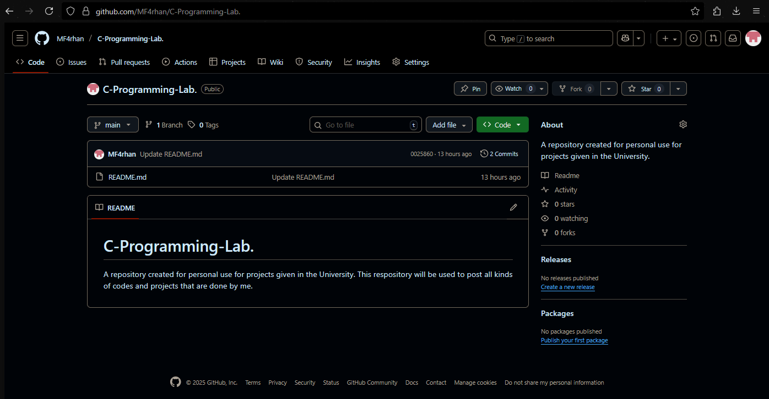

Task #2: Write a “Hello World” Program in C
Objective:
● Open Dev-C++ and create a new project.
● Compile and run the program. Take a screenshot of the output.
Code:
#include <stdio.h>
#include <conio.h>
int main() {
printf("Hello World");
getch();
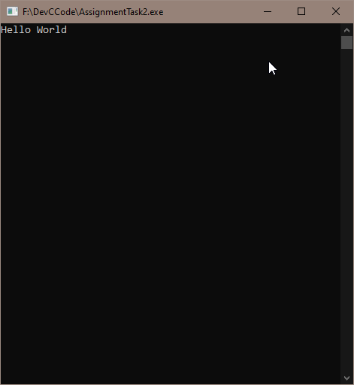
return 0; }

Task #3: Write a C Program to Swap Two Numbers (Temp Variable)
Objective:
Create a program that takes two integers from the user, swaps their values, and displays the
result.
Code:
#include <stdio.h>
#include <conio.h>
int main() {
int a,b,c;
printf("Enter any two numbers (add space between them)\n");
scanf("%d %d", &a, &b);
c=a, a=b, b=c;
printf("%d %d", a, b);
getch();
return 0;
}
