ICT Lab 6
Name: Muhammad Farhan
roll no: 25k-0538
program: bcs-1k
ict lab 6 task
course instructor: Miss syeda tehreem gilani

2025
“Create a single web page using HTML and CSS on the topic “My Personal Portfolio.”
Include all elements discussed in the lab , headings, paragraphs, lists, images, and links.Use both Inline and Internal CSS for styling your page.”

<!DOCTYPE html>
<html lang="en">
<head>
<meta charset="UTF-8">
<meta name="viewport" content="width=device-width, initial-scale=1.0">
<title>Document</title>
<style>
h1
{
background-color: rgba(78, 52, 52, 0.384);
text-align: center;
}
h2
{
background-color: rgba(48, 79, 87, 0.37);
text-align: center;
}
body
{
background-color: black;
}
</style>
</head>
<body>
<h1 style="color: pink;">My Personal Portfolio.</h1>
<hr>
<h2 style="color: aliceblue;">About Me</h2>
<p><i>My name is Muhammad Farhan. I am a Computer Science student. In my free time, I enjoy playing video games.</i></p>
<hr>
<h2 style="color: aliceblue;">Education</h2>
<p><b>I am currently doing my bachelors in Computer Science from FAST Karachi.</b></p>
<hr>
<h2 style="color: aliceblue;">Skills</h2>
<ol>
<li>C Language</li>
<li>IT and General Computer Experience</li>
<li>Basic HTML</li>
<li>Basic CSS</li>
</ol>
<hr>
<h2 style="color: aliceblue;">My Hobbies</h2>
<ul>
<li>Playing Video Games</li>
<li>Watching latest Tech in computers, smartphones, etc</li>
<li>Reading latest news and articles about events in the world</li>
</ul>
<hr>
<img src="FAST-NU-logo.png" alt="My University Logo">
<hr>
<p>If you would like to contact me, you can contact me at:</p>
<a href="mailto:k250538@nu.edu.pk">k250538@nu.edu.pk</a>
<hr>
<footer style="text-align: center;"> Muhammad Farhan 25K-0538 BCS-1k</footer>
</body>
</html>

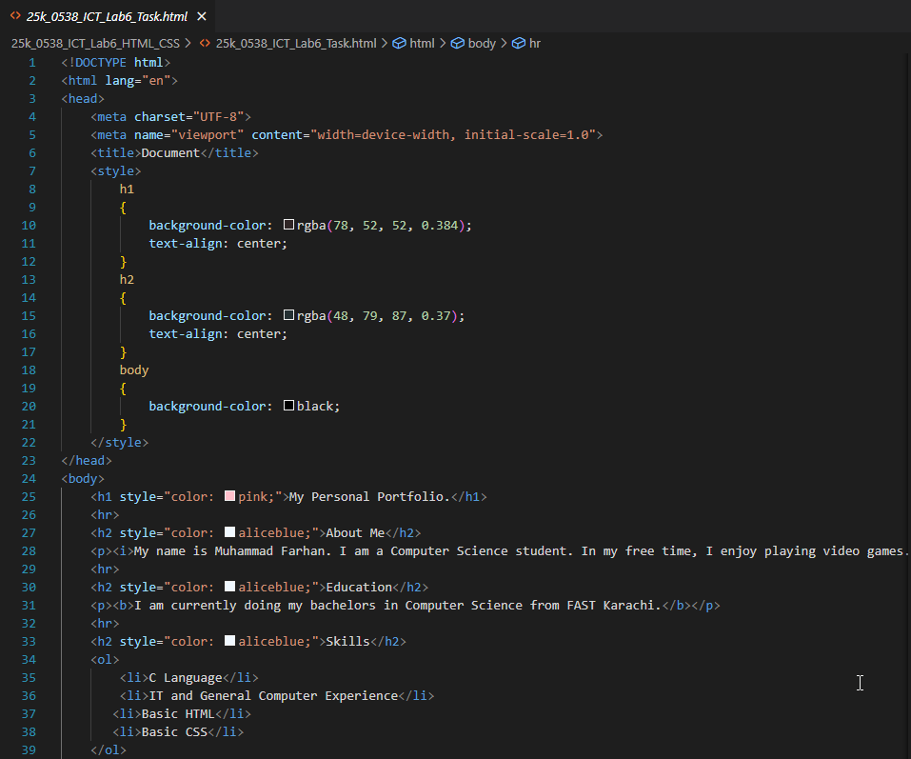
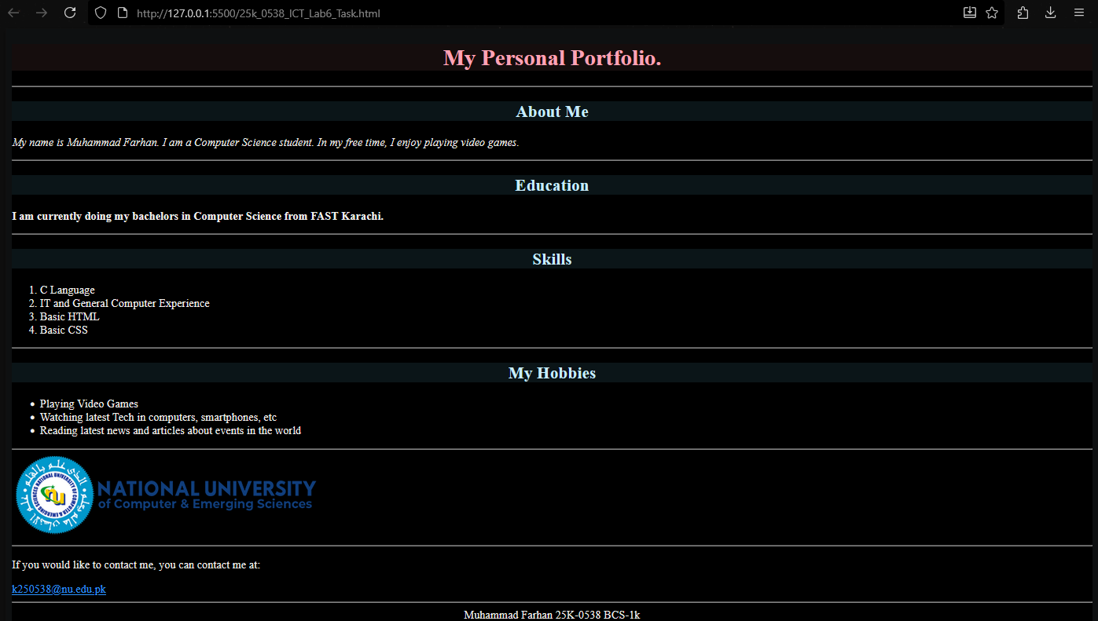
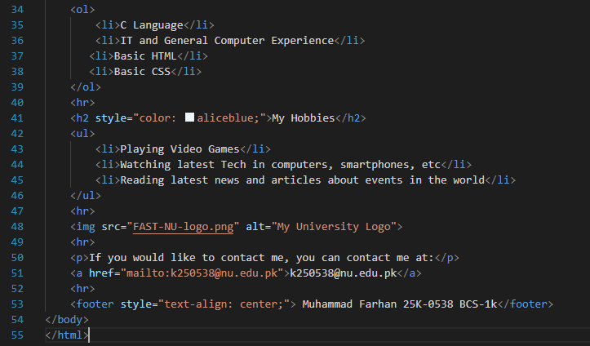

I have also attached a ZIP Folder in GCR containing the code and image.png file just in case.

