Programming Fundamentals Lab 10
Lab Tasks 1-4
Name: Muhammad Farhan
Roll no: 25k-0538
Section: BCS-1K
Course: Programming Fundamentals Lab
Course Instructor: Sir Sheeraz Iqbal

Task 1:
C Code:
#include <stdio.h>
#include <string.h>
int main()
{
char messaginger[100];
printf("Input your sentence:\n");
fgets(messaginger, sizeof(messaginger), stdin);
strcat(messaginger, "Falcon");
printf("The sentence '%s' has %d characters excluding falcon",messaginger, strlen(messaginger)-7);
//strlen(messaginger)-6 if counting \n as a character, if not, then strlen(messaginger)-7.
return 0;
}

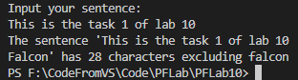
Task 2:
#include <stdio.h>
#include <string.h>
int main()
{
char *pointingthing;
char gamer[10], finder;
printf("Enter your word:\n");
scanf("%s", gamer);
printf("\nEnter the letter you want to find;\n");
scanf(" %c", &finder);
pointingthing = strchr(gamer, finder);
if (strchr(gamer, finder) != NULL)
printf("\nCharacter %c found at position %d (index of array)", finder, pointingthing-gamer);
//the position is technically the index of the array.
else
printf("\nCharacter not Found.");
return 0;
}
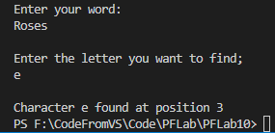

Task 3:

#include <stdio.h>
#include <string.h>
#include <stdlib.h>
int main()
{
char product1[20];
char product2[20];
int compare;
printf("\nEnter your Product Code:");
fgets(product1, sizeof(product1), stdin);
product1[strcspn(product1, "\n")] = 0;
printf("\nEnter the product code to compare:");
fgets(product2, sizeof(product2), stdin);
product1[strcspn(product2, "\n")] = 0;
printf("\nNumber of first letters to comapare:");
scanf("%d", &compare);
if (compare <= 0)
{
printf("\nInvalid Length.");
exit(1);
}
else if (compare > strlen(product1) || compare > strlen(product2))
{
printf("\nYou are comparing more characters than the code contains, exiting program.");
exit(1);
}

if (strncmp(product1, product2, compare))
{
printf("\nThe products are not from the same category.");
}
else
{
printf("\nThe products are from the same category.");
}

return 0;
}
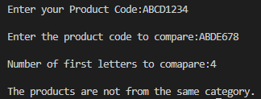
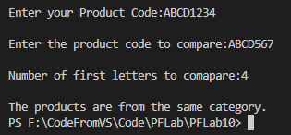
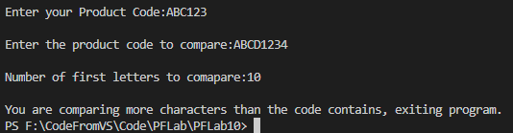
Task 4:

#include <stdio.h>
#include <string.h>
#include <stdlib.h>
int main()
{
int id1, id2, id3;
FILE *lib;
lib = fopen("Library.txt","w");
if(lib == NULL)
{
printf("Error");
exit(1);
}
printf("\nEnter the three book IDS.\n");
scanf("%d %d %d", &id1, &id2, &id3);
fprintf(lib, "%d %d %d", id1, id2, id3);
fclose(lib);

lib = fopen("Library.txt","r");
if(lib == NULL)
{
printf("Error");
exit(1);
}
fscanf(lib, "%d %d %d", &id1, &id2, &id3);
printf("%d %d %d", id1, id2, id3);
return 0;
}
