Programming Fundamentals Lab 10
Lab Tasks 5-10
Name: Muhammad Farhan
Roll no: 25k-0538
Section: BCS-1K
Course: Programming Fundamentals Lab
Course Instructor: Sir Sheeraz Iqbal

Task 5:

#include <stdio.h>
#include <string.h>
int main()
{
char original[100];
char backup[100];
printf("Enter original string: ");
fgets(original, 100, stdin);
original[strcspn(original, "\n")] = 0;
strcpy(backup, original);
printf("The original string is: %s", original);
printf("\nThe backup string is: %s", backup);
return 0;
}

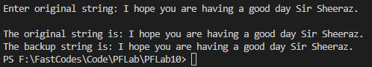

Task 6:

#include <stdio.h>
#include <string.h>
int main()
{
char name1[100];
char name2[50];
printf("Enter name of first person:");
fgets(name1, sizeof(name1), stdin);
name1[strcspn(name1 ,"\n")]='\0';
printf("\nEnter name of second person:");
fgets(name2, sizeof(name1), stdin);
name2[strcspn(name2 ,"\n")]='\0';
strcat(name1, name2);
printf("\n\nThe combined name is %s", name1);
return 0;
}
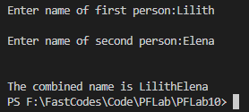

Task 7:

#include <stdio.h>
#include <string.h>
int main()
{
char pass1[100];
char pass2[100];
printf("Enter your password:");
fgets(pass1, sizeof(pass1), stdin);
pass1[strcspn(pass1, "\n")]='\0';
printf("\n\nConfirm your password:");
fgets(pass2, sizeof(pass2), stdin);
pass2[strcspn(pass2, "\n")]='\0';
if (strcmp(pass1, pass2) == 0)
printf("\nPassword Successfully created.\n");
else
printf("\nPasswords do not match, please try again.\n");
return 0;
}
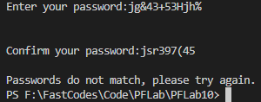
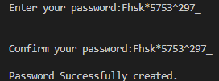

Task 8:

#include <stdio.h>
#include <string.h>
int main()
{
char names[3][20];
for (int i = 0; i < 3; i++)
{
printf("\nEnter the name of studnet #%d:", i+1);
fgets(names[i], 20, stdin);
}
printf("\nThe input usernames are:\n");
for (int i = 0; i < 3; i++)
{
fputs(names[i], stdout);
}
return 0;
}
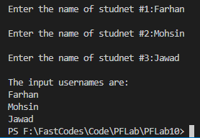

Task 9:

#include <stdio.h>
#include <string.h>
int main()
{
char names[3][20];
for (int i = 0; i < 3; i++)
{
printf("\nEnter the name of studnet #%d:", i+1);
fgets(names[i], 20, stdin);
names[i][strcspn(names[i], "\n")]='\0';
}
printf("\n");
for (int i = 0; i < 3; i++)
{
printf("Characters in name %d:\n", i+1);
for (int j = 0; names[i][j] != '\0'; j++)
printf(" %c ", names[i][j]);
printf("\n\n");
}
return 0;
}

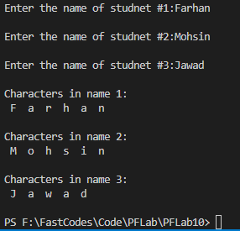
Task 10:

#include <stdio.h>
#include <string.h>
#include <stdlib.h>
int main()
{
char names[5][20];
char search[20];
FILE *lib;
lib = fopen("names.txt", "w");
if (lib == NULL)
{
printf("Error: could not open file.\n");
exit(1);
}
for (int i = 0; i < 5; i++)
{
printf("\nEnter the name of employee #%d:", i+1);
fgets(names[i], 20, stdin);
names[i][strcspn(names[i], "\n")]='\0';
fprintf(lib,"%s\n" ,names[i]);
}
fclose(lib);
lib = fopen("names.txt", "r");
printf("\nEnter a name to search:");
fgets(search, sizeof(search), stdin);
search[strcspn(search, "\n")] = '\0';
int found=0;
char opensearch[20];
int counta=1;
while (fgets(opensearch, sizeof(opensearch), lib))
{
if (strstr(opensearch, search) != NULL)
{
printf("\nThe employee name found at line #%d on the list.",counta);
found=1;
}
counta++;
}
if (found == 0)
{
printf("\nEmployee name not found.");
}
fclose(lib);
return 0;
}
