Programming Fundamentals Lab 11
Lab Tasks 3, 5-10
Name: Muhammad Farhan
Roll no: 25k-0538
Section: BCS-1K
Course: Programming Fundamentals Lab
Course Instructor: Sir Sheeraz Iqbal
Note: All of the Tasks are available on my Github.

Task 3 (from previous 4 tasks):
#include <stdio.h>
#include <string.h>
struct Flight
{
int flight_number;
char departure_city[30];
char destination_city[30];
char date[12];
int avaliable_seats;
};
void bookseat(struct Flight tickets[5], int *current);
void addflight(struct Flight tickets[5], int *current);
void allflights(struct Flight tickets[5], int *current);
int main()
{
struct Flight tickets[5];
int choice, current=0;
do
{
printf("\n\nWelcome to Fight System.");
printf("\n 1. Add a flight.");
printf("\n 2. Book a seat.");
printf("\n 3. Show all flights.");
printf("\n 4. Exit the system.");
printf("\nEnter your choice.\n");
scanf("%d", &choice);
switch (choice)
{
case 1:
addflight(tickets, &current);
break;
case 2:
bookseat(tickets, &current);
break;
case 3:
allflights(tickets, &current);
break;
case 4:
break;
default:
printf("\nInvalid Choice.\n");
break;
}
} while (choice!=4);
printf("\n");
return 0;
}

void addflight(struct Flight tickets[5], int *current)
{
printf("\nEnter your flight number: ");
scanf("%d", &tickets[*current].flight_number);

printf("\nEnter your departure city: ");
getchar();
fgets(tickets[*current].departure_city, sizeof(tickets[*current].departure_city), stdin);
tickets[*current].departure_city[strcspn(tickets[*current].departure_city, "\n")]='\0';

printf("\nEnter your destination city: ");
fgets(tickets[*current].destination_city, sizeof(tickets[*current].destination_city), stdin);
tickets[*current].destination_city[strcspn(tickets[*current].destination_city, "\n")]='\0';

printf("\nEnter your flight date: ");
fgets(tickets[*current].date, sizeof(tickets[*current].date), stdin);
tickets[*current].date[strcspn(tickets[*current].date, "\n")]='\0';

printf("\nEnter the number of avaliable seats: ");
scanf("%d", &tickets[*current].avaliable_seats);

(*current)++;
}

void bookseat(struct Flight tickets[5], int *current)
{
int tempflight, seats;
printf("\nEnter the flight number of the flight: ");
scanf("%d", &tempflight);
for (int i = 0; i < (*current); i++)
{
if (tickets[i].flight_number == tempflight)
{
printf("\nThere are %d seats avaliable, Enter the number of seats to book: ", tickets[i].avaliable_seats);
scanf("%d", &seats);
if (seats <= tickets[i].avaliable_seats)
{
tickets[i].avaliable_seats-=seats;
printf("\nSeats have been booked.\n");
return;
}
else
{
printf("\nNot enough seats avaliable.\n");
return;
}
}
}
printf("\nInvalid flight number.\n");
return;
}

void allflights(struct Flight tickets[5], int *current)
{
printf("\nAll Current Flights\n");
for (int i = 0; i < (*current); ++i)
{
printf("\nFlight Number: %d", tickets[i].flight_number);
printf("\nDeparture City: %s", tickets[i].departure_city);
printf("\nDestination City: %s", tickets[i].destination_city);
printf("\nDate of Flight: %s", tickets[i].date);
printf("\nAvaliable Seats: %d", tickets[i].avaliable_seats);
printf("\n");
}
}

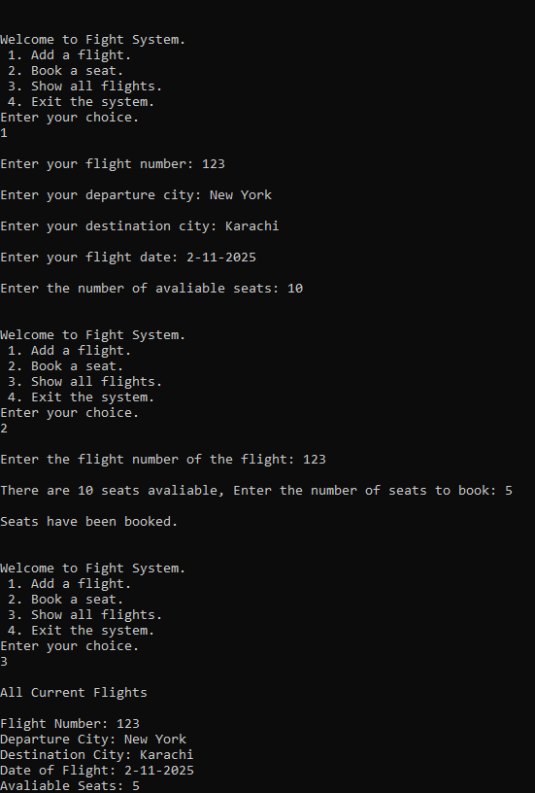

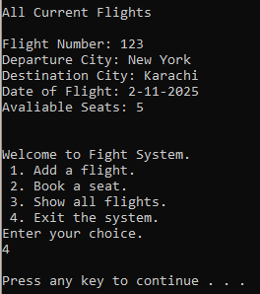

Task 5:
#include <stdio.h>
#include <string.h>
void reverse(char message[100], int len);
int main()
{
char message[100];
int len;
printf("Enter your secret message:\n");
fgets(message, sizeof(message), stdin);
len = strlen(message);
reverse(message, len);
printf("\n");
return 0;
}

void reverse(char message[100], int len)
{
if (len<0)
{
return;
}
printf("%c", message[len]);
reverse(message, len-1);
}

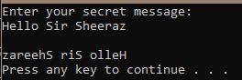

Task 6:
#include <stdio.h>
int expo(int num, int power);
int main()
{
int num, power, final;
printf("Enter the Number: ");
scanf("%d", &num);
printf("\nEnter the exponent: ");
scanf("%d", &power);
final = expo(num, power);
printf("\nThe number is %d", final);
printf("\n");
return 0;
}

int expo(int num, int power)
{
if (power==0)~~
{
return 1;
}
power--;
return num * expo(num,power);
}
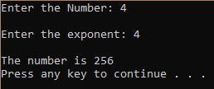
Task 7:
#include <stdio.h>
#include <string.h>
struct department
{
char name[50];
int blocknumber;
};
struct student
{
int id;
char name[50];
float cgpa;
struct department dept;
};

int main()
{
struct student stud;
printf("Enter Student ID: ");
scanf("%d", &stud.id);
printf("\nEnter Student Name: ");
getchar();
fgets(stud.name, sizeof(stud.name), stdin);
printf("\nEnter Student CGPA: ");
scanf("%f", &stud.cgpa);
printf("\nEnter Student department: ");
getchar();
fgets(stud.dept.name, sizeof(stud.dept.name), stdin);
printf("\nEnter Department Block Number: ");
scanf("%d", &stud.dept.blocknumber);

printf("\n\nStudent Data:");
printf("\nStudent ID:\t %d", stud.id);
printf("\nStudent Name:\t %s", stud.name);
printf("\nStudent CGPA:\t %.3f", stud.cgpa);
printf("\nDepartment:\t %s", stud.dept.name);
printf("\nDepartment Block: %d\n", stud.dept.blocknumber);
return 0;
}
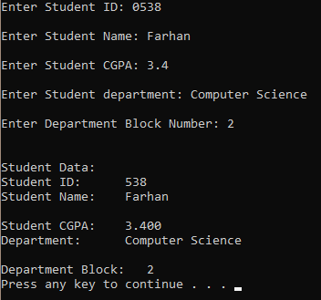
Task 8:
#include <stdio.h>
#include <string.h>

struct employee
{
int id;
char name[50];
int salary;
char position[50];
};

int main()
{
struct employee emps[5];
int i, highest=0, num=0;
for (i = 0; i < 5; ++i)
{
printf("Enter employee#%d ID: ", i+1);
scanf("%d", &emps[i].id);
printf("\nEnter employee#%d name: ", i+1);
getchar();
fgets(emps[i].name, sizeof(emps[i].name), stdin);
printf("\nEnter employee#%d salary: ", i+1);
scanf("%d", &emps[i].salary);
if (emps[i].salary > highest)
{
highest=emps[i].salary;
num=i;
}
printf("\nEnter employee#%d position: ", i+1);
getchar();
fgets(emps[i].position, sizeof(emps[i].position), stdin);
}
printf("\n\nThe highest salary belongs to:");
printf("employee ID:\t%d\nEmployee Name:\t%sSalary:\t%d\nPosition:\t%s\n", emps[num].id,emps[num].name,emps[num].salary,emps[num].position);
return 0;
}

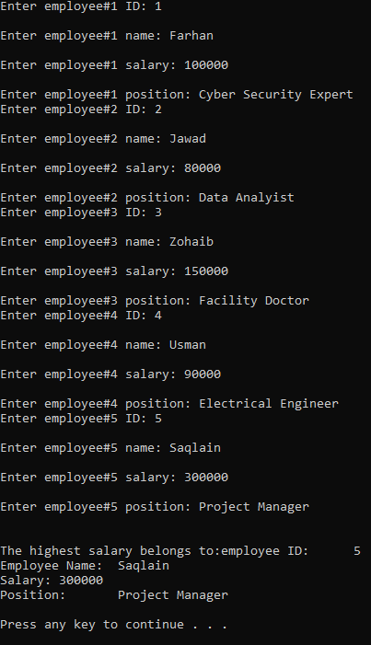
Task 9:
#include <stdio.h>
void check();
int main()
{
int choice;
do
{
printf("\nPress 1 to call function, any other key to exit.\n");
scanf("%d", &choice);
if (choice==1)
{
check();
}
} while (choice == 1);

return 0;
}

void check()
{
static int a=1;
printf("\nThis Function has been called %d times.\n", a);
a++;
}

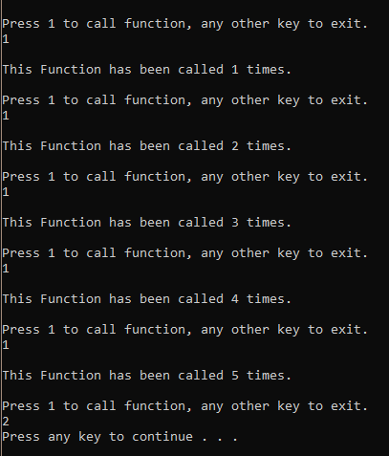

Task 10:
#include <stdio.h>
#include <string.h>
struct director
{
char name[50];
char nationality[50];
};
struct movies
{
char title[50];
char genre[50];
struct director direc;
int release_year;
float rating;
};
void addmovie(struct movies moveee[10], int *currentmoveee);
void searchgenre(struct movies moveee[10], int currentmoveee);
void display(struct movies moveee[10], int currentmoveee);
int main()
{
struct movies moveee[10];
int currentmoveee=0;
int choice;
do
{
printf("\n\n1. Add a new movie.\n2. Search a movie by genre.\n3. Display all movies.\n4. Exit program.\nEnter your choice.\n");
scanf("%d", &choice);
switch (choice)
{
case 1:
addmovie(moveee, &currentmoveee);
printf("\nMovie successfully added.\n");
break;
case 2:
searchgenre(moveee, currentmoveee);
break;
case 3:
display(moveee, currentmoveee);
break;
case 4:
break;
default:
printf("\nInvalid Choice.\n");
}
} while(choice!=4);
printf("\n");
return 0;
}

void addmovie(struct movies moveee[10], int *currentmoveee)
{
printf("\nEnter movie name: ");
getchar();
fgets(moveee[*currentmoveee].title, sizeof(moveee[*currentmoveee].title), stdin);
printf("\nEnter the movie genre: ");
fgets(moveee[*currentmoveee].genre, sizeof(moveee[*currentmoveee].genre), stdin);
printf("\nEnter the Director's Name: ");
fgets(moveee[*currentmoveee].direc.name, sizeof(moveee[*currentmoveee].direc.name), stdin);
printf("\nEnter the Director's nationality: ");
fgets(moveee[*currentmoveee].direc.nationality, sizeof(moveee[*currentmoveee].direc.nationality), stdin);
printf("\nEnter release year: ");
scanf("%d", &moveee[*currentmoveee].release_year);
printf("\nEnter Movie's rating: ");
scanf("%f", &moveee[*currentmoveee].rating);
(*currentmoveee)++;
}

void searchgenre(struct movies moveee[10], int currentmoveee)
{
char searching[50];
int flag=0;
printf("\nEnter the exact genre to search: ");
getchar();
fgets(searching, 50, stdin);
for (int i = 0; i < (currentmoveee); ++i)
{
if (strcmp(moveee[i].genre, searching)==0)
{
printf("\nMovie Title:\t%s", moveee[i].title);
printf("Movie Genre:\t%s", moveee[i].genre);
printf("Movie Director:\t%s", moveee[i].direc.name);
printf("Movie Director nationality:\t%s", moveee[i].direc.nationality);
printf("Release Year:\t%d", moveee[i].release_year);
printf("\nMovie Rating:\t%.1f", moveee[i].rating);
flag=1;
}
}
if (flag==0)
{
printf("\nInvalid Genre or Movie not found.\n");
}
}

void display(struct movies moveee[10], int currentmoveee)
{
for (int i = 0; i < currentmoveee; ++i)
{
printf("\n\nMovie#%d:", i+1);
printf("\nMovie Title:\t%s", moveee[i].title);
printf("Movie Genre:\t%s", moveee[i].genre);
printf("Movie Director:\t%s", moveee[i].direc.name);
printf("Movie Director nationality:\t%s", moveee[i].direc.nationality);
printf("Release Year:\t%d", moveee[i].release_year);
printf("\nMovie Rating:\t%.1f", moveee[i].rating);
}
}
