Name: Muhammad Farhan
Roll no: 25k-0538
Section: BCS-1K

Task 1:
#include <stdio.h>
#include <stdlib.h>

int main()
{
int *ptr = (int*)malloc(5*sizeof(int));
if (ptr == NULL)
{
printf("\nMemory Allocaion Failed.");
return 1;
}
for (int i=0; i<5; ++i)
{
ptr[i]=i+1;
}
for (int i=0; i<6; ++i)
{
printf("\n%d", ptr[i]);
}
//now trying to double free the pointer.
free(ptr);
//free(ptr);
//The result is that, The program still runs for the first time, However, Afterwards the code simply doesn't run and keeps retuning 1 exit status.
//the only way to fix it is to restart Dev C++ and make a new file.
return 0;
}

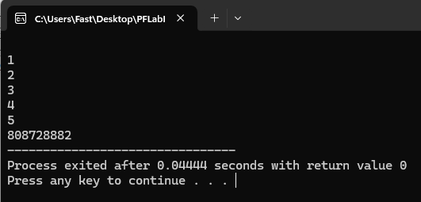

Task 2:
#include <stdio.h>
#include <stdlib.h>

int main()
{
int *ptr = (int*)malloc(5*sizeof(int));
if (ptr == NULL)
{
printf("\nMemory Allocaion Failed.");
return 1;
}
for (int i=0; i<5; ++i)
{
ptr[i]=i+1;
}
for (int i=0; i<6; ++i)
{
printf("\n%d", ptr[i]);
}
//now trying to double free the pointer.
//free(ptr);
//free(ptr);
//The result of using free() two times is that (for me atleast):
//The program still runs for the first time, However, Afterwards the code simply doesn't run and keeps retuning 1 exit status (in my case at least).
//And the only way to fix it is to Restart DevC++ and then replace your file (in my case at least).
//Or turning both pointers into comments so it can store the address again (like sir said in the class).
//using one free() works fine (after I fix the issue above) even after running it multiple times, but using it two times brings the above scenerio.
return 0;
}
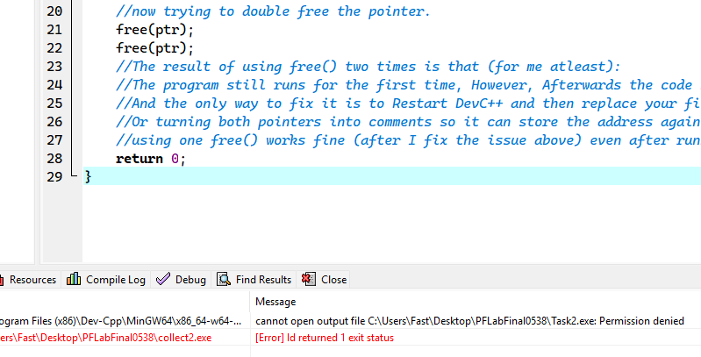
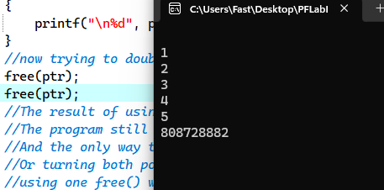
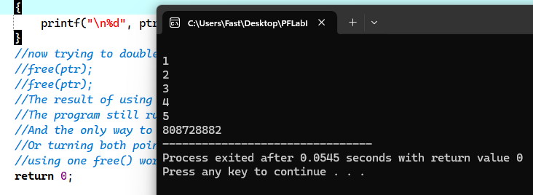
Task 3:
#include <stdio.h>
#include <stdlib.h>
int main()
{
int *ptr = (int*)malloc(5*sizeof(int));
if (ptr == NULL)
{
printf("\nMemory Allocaion Failed.");
return 1;
}
for (int i=0; i<5; ++i)
{
*(ptr+i)=i+1;
}
for (int i=0; i<5; ++i)
{
printf("\n%d", *(ptr+i));
}
return 0;
}
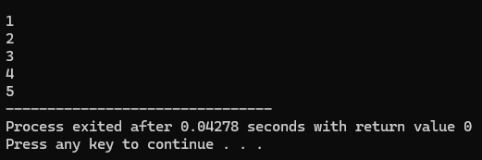
Task 4:
#include <stdio.h>
#include <stdlib.h>

int main()
{
int *ptr = (int*)malloc(3*sizeof(int));
if (ptr == NULL)
{
printf("\nMemory Allocaion Failed.");
return 1;
}
for(int i=0; i<3; ++i)
{
printf("\nEnter value #%d: ", i+1);
scanf("%d", ptr[i]);
}
int arrsize=0;
printf("\nArray is now full, Enter new bigger size of the array: ");
scanf("%d", &arrsize);

ptr = (int*)realloc(ptr, arrsize);

int morenum = arrsize-3;
printf("\nEnter %d more elements.", morenum);
for(int i=3; i<arrsize; ++i)
{
printf("\nEnter value #%d: ", i+1);
scanf("%d", ptr[i]);
}
printf("\nThe final array is:\n");
for(int i=0; i<arrsize; ++i)
{
printf("\nvalue #%d: %d", i+1, ptr[i]);
}
return 0;
}
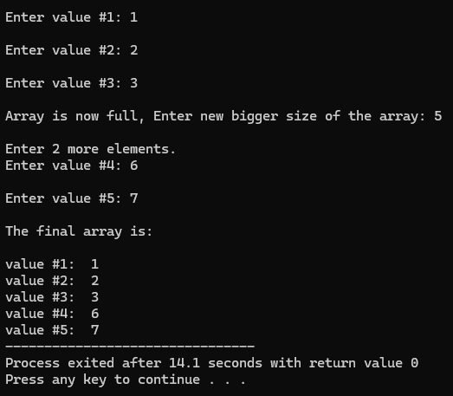

Task 5:
#include <stdio.h>
#include <stdlib.h>

int main() {

int rCount = 3, cCount = 3;

int **grid = (int **)calloc(rCount, sizeof(int*));
if (grid == NULL) {
printf("Memory allocation failed!\n");
return 1;
}

for (int r = 0; r < rCount; r++) {
grid[r] = (int *)calloc(cCount, sizeof(int));
if (grid[r] == NULL) {
printf("Memory allocation failed at row %d!\n", r);
return 1;
}
}

printf("Enter elements:\n");
for (int r = 0; r < rCount; r++) {
for (int c = 0; c < cCount; c++) {
scanf("%d", &grid[r][c]);
}
}

printf("Matrix output:\n");
for (int r = 0; r < rCount; r++) {
for (int c = 0; c < cCount; c++) {
printf("%d ", grid[r][c]);
}
printf("\n");
}

// Free memory
for (int r = 0; r < rCount; r++) {
free(grid[r]);
}
free(grid);
grid = NULL;

return 0;
}

