Name: Muhammad Farhan
Roll No: 25K-0538
Class: BCS-1K
Programming Fundamentals Lab
Assignment (7 Tasks)
Course Instructor: Sir Sheeraz Iqbal

Programming Fundamentals Lab #3

Task #4: Create an Unordered List in Markdown

Objective:
● Edit the README.md file in your GitHub repository.
Add an unordered list of your favorite programming languages using * or -.
Use Markdown preview to confirm it renders correctly.

Link: https://github.com/MF4rhan/C-Programming-Lab./tree/fef3f8f2f90ca2442f0aedca81c7a65e1ab778b6
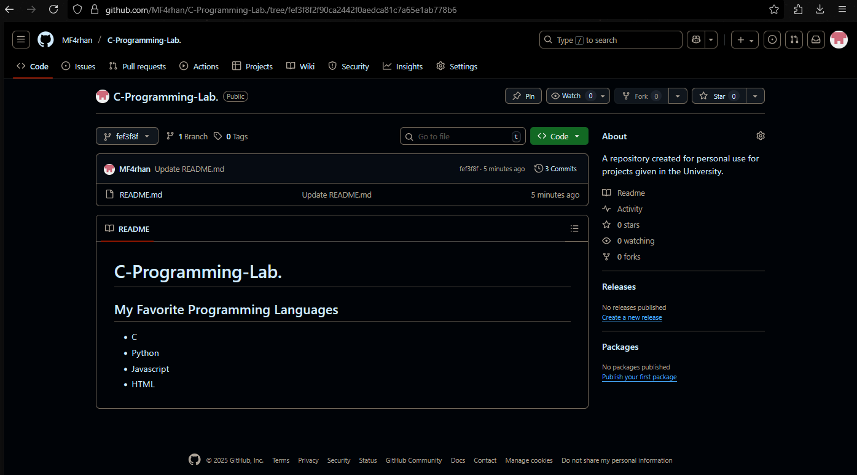

Task #5: Use GitHub Branching and Commit a File
Objective:
● Create a branch in your repository named my-first-branch.
● Create a new file named PROFILE.md.
● Write the text: Programming Fundamentals Fall 2025.
● Commit and push the file to your branch.
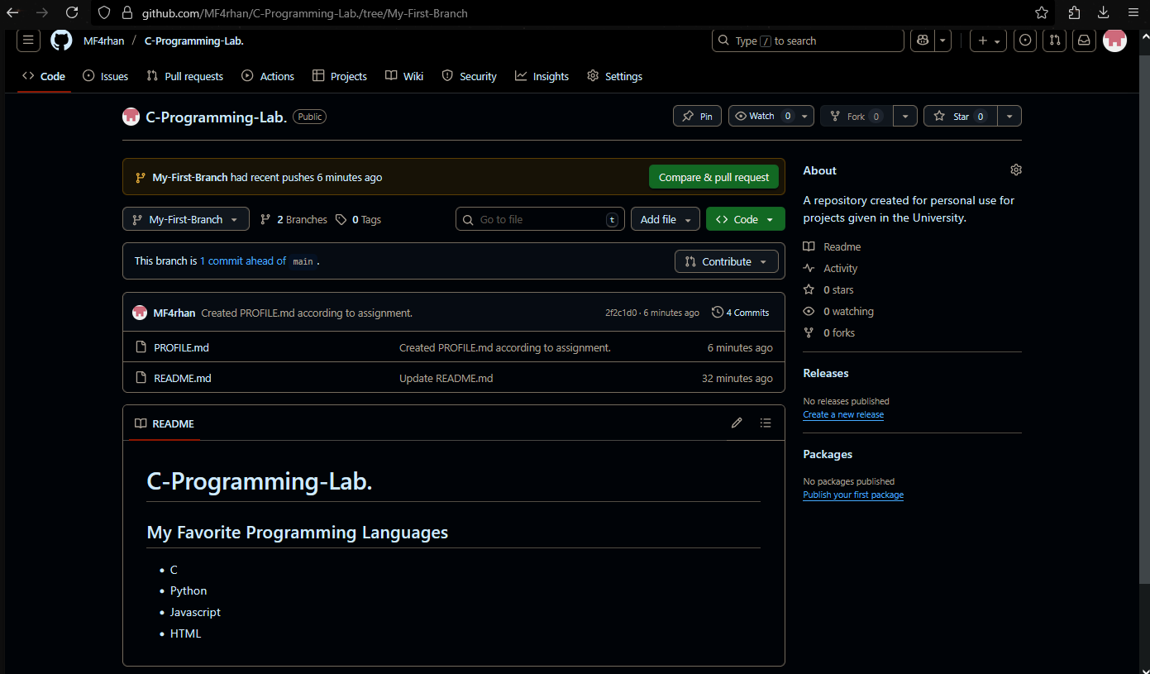
https://github.com/MF4rhan/C-Programming-Lab./commit/2f2c1d0e4f5b6afb287ca6fd624ae7bd28797bd4

Task #6: Create and Format Markdown Elements
Objective:
● Edit the README.md file.
Add at least one of each:
○ A heading (#)
○ Bold and italic text (**bold**, *italic*)
○ A strikethrough (~~text~~)
○ A code block (e.g., git status)
○ A task list

https://github.com/MF4rhan/C-Programming-Lab./tree/e1e82aff1290a9040f677ed121de1527b3ddcff3
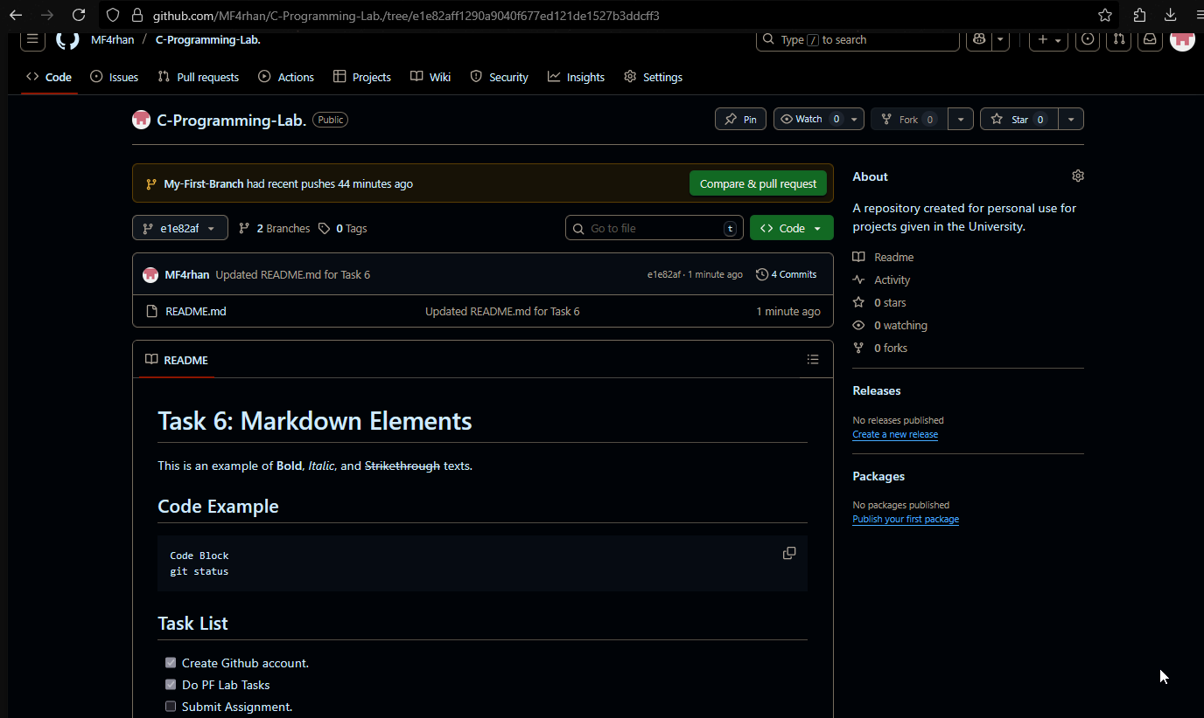

Task #7: Write a C Program with Variables and Input
Objective:
● Write a C program that:
○ Takes user input for age (int) and height (float).
○ Prints the values back using printf with format specifiers and 2-decimal
precision.
● Save and run the program. Share a screenshot of the output.
Code:
#include <stdio.h>
#include<conio.h>
int main() {
int a; float b;
printf("Enter a integer and decimal number\n");
scanf("%d %f",&a,&b);
printf("The integer is %d, and the decimal is %.2f",a,b);
getch();
return 0; }

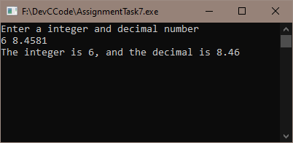

Task #8: Demonstrate Escape Sequences in C
Objective:
● Write a C program using at least 4 different escape sequences, such as:
○ \n, \t, \\, \*;
● Example output should use tabs, newlines, quotes, and backslashes.
● Compile and run the program and include a screenshot of the output.
#include <stdio.h>
int main() {
int a;
printf("Enter a number and ill show if you its divisible by 3 and 2 or not.\n");
scanf("%d",&a); // This will be user input
/*
Wrote a condition that checks if the input number is divisible by BOTH 2 and 3.
If it is, then it will proceed into the IF block.
If it is not, then it will proceed into the ELSE block
*/
if (a%2==0 && a%3==0)
{
printf("It is divisible by 3\t2");
}
else
{
printf("It is not divisible by 3\t2");
}
return 0;
}
Or
#include <stdio.h>
#include <conio.h>
int main() {
int a;
printf("Enter a number and ill show if you its divisible by 3 and 2 or not.\n");
scanf("%d",&a); // This will be user input
/*
Wrote a condition that checks if the input number is divisible by BOTH 2 and 3.
If it is, then it will proceed into the IF block.
If it is not, then it will proceed into the ELSE block
*/
printf(a%2==0 && a%3==0?"It is Divisible by 2\t3":"It is Not Divisible by 2\t3");
getch();
return 0;
}
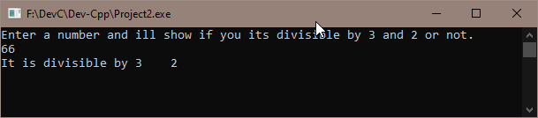

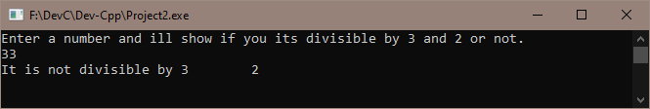

Task #9: Write a C Program to Calculate Age
Objective:
Create a C program that:
● Asks the user for their birth year.
● Asks the user for the current year.
● Calculates and displays the user’s age using simple subtraction.

#include <stdio.h>
#include <conio.h>
int main() {
int BYear, CYear;
printf("I will calculate your Age.\n");
printf("Enter your Birth Year\n");
scanf("%d", &BYear);
printf("Enter Current Year\n");
scanf("%d", &CYear);
printf("Your Age is %d", CYear-BYear);
getch();
return 0; }
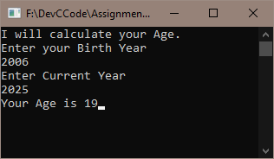

Task #10: Write a C Program to Convert Age into Months and Days
Objective:
Create a program that asks the user for their age in years and converts it into: Months & Days.

#include <stdio.h>
#include <conio.h>
int main() {
int Age, Month, Days;
printf("Hello. Enter your age and i will tell you in Months and Days.\n");
printf("Enter your Age.\n");
scanf("%d", &Age); // User Age Input
Month=Age*12; // Converting from years to months.
Days=Month%30; // converting remaining days of the current month to days.
printf("Your age in Months and Days is %d Months and %d Days", Month, Days); // Output
getch();
return 0; }

