- Name: Muhammad Farhan
- Roll no: 25K-0538
- Program & Section: BCS-1K
- Assignment#4
- Course instructor: Sir Sheeraz Iqbal
Programming Fundamentals Lab#4
Task # 1: Check Voting Eligibility

Write a program that asks the user for their age and prints whether they are eligible to vote or not.
- Use if-else statement.
#include <stdio.h>
int main() {
int Age;
printf("Enter your age to check for your eligibility to Vote.\n");
scanf("%d", &Age);
if (Age>=18)
{
printf("You are eligibile to Vote.");
}
else
{
printf("You are not eligibile to Vote.");
}
return 0;
}
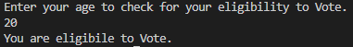

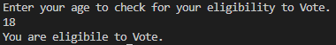

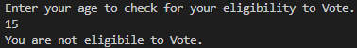
Task # 2: Odd or Even Number
Write a program to check if a number entered by the user is odd or even.
- Use if statement with the modulus operator.
#include <stdio.h>
int main() {
int Num;
printf("Enter any number to check if its Even or Odd.\n");
scanf("%d", &Num);
if (Num%2==0)
{
printf("It is an Even Number.");
}
else
{
printf("It is an Odd Number.");
}
return 0;
}
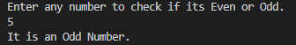

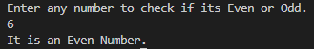

Task # 3: Find Largest Among Three Numbers
Write a program to find the largest number among three numbers input by the user.
- Use if-else if-else statements.
#include <stdio.h>
int main()
{
int Num1,Num2,Num3;
printf("Enter three numbers (separated by a space) to show the largest.\n");
scanf("%d %d %d",&Num1,&Num2,&Num3);
if (Num1>Num2 && Num1>Num3)
{
printf("%d is the largest number.",Num1);
}
else if (Num2>Num1 && Num2>Num3)
{
printf("%d is the largest number.",Num2);
}
else if (Num3>Num1 && Num3>Num2)
{
printf("%d is the largest number.",Num3);
}
else
{
printf("All three numbers are equal.");
}
return 0;
}
