Task # 4: Grade Calculator

Create a program that takes a student’s score as input and prints the grade based on the following:
- 90 and above: A
- 80 to 89: B
- 70 to 79: C
- 60 to 69: D
- Below 60: F
- Use if-else if-else structure.
#include <stdio.h>
int main()
{
int Marks;
printf("Enter your Marks.\n");
scanf("%d",&Marks);
if (Marks>=90)
{
printf("You have obtained A grade.");
}
else if (Marks>=80 && Marks<90)
{
printf("You have obtained B grade.");
}
else if (Marks>=70 && Marks<80)
{
printf("You have obtained C grade.");
}
else if (Marks>=60 && Marks<70)
{
printf("You have obtained D grade.");
}
else
{
printf("You have obtained F grade.");
}
return 0;
}
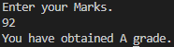

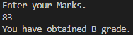

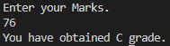

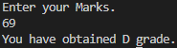

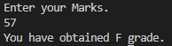

Task # 5: Traffic Signal Control

Simulate a traffic light where the user inputs a color (1 for Red, 2 for Yellow, 3 for Green). The program prints the
action to be taken: “Stop”, “Ready” or “Go”.
- Use switch-case.
#include <stdio.h>
int main()
{
int color;
printf("Enter 1 for Red, 2 for Yellow, 3 for Green.\n");
scanf("%d", &color);
switch (color)
{
case 1:
printf("Stop.\n");
break;
case 2:
printf("Ready.\n");
break;
case 3:
printf("Go.\n");
break;
default:
printf("Invalid Input, Please enter 1 or 2 or 3.");
break;
}
return 0;
}
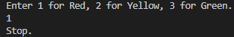

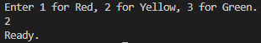

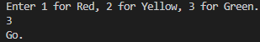

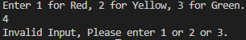

Task # 6: Basic Calculator

Write a program that takes two numbers and an operator (+, -, *, /) as input and performs the corresponding arithmetic operation.
- Use switch-case statement.
#include <stdio.h>
int main()
{
int Op;
float Num1, Num2;
printf("Enter any two numbers (seperated by space).\n");
scanf("%f %f", &Num1, &Num2);
printf("Enter 1 for Addition, 2 for Subtraction, 3 for Product and 4 for Division.\n");
scanf("%d", &Op);
switch (Op)
{
case 1:
printf("The sum of %.2f and %.2f is %.2f.\n", Num1, Num2, Num1+Num2);
break;
case 2:
printf("The difference of %.2f and %.2f is %.2f.\n", Num1, Num2, Num1-Num2);
break;
case 3:
printf("The product of %.2f and %.2f is %.2f.\n", Num1, Num2, Num1*Num2);
break;
case 4:
printf("The quotient of %.2f and %.2f is %.2f.\n", Num1, Num2, Num1/Num2);
break;
default:
printf("Invalid Operation Number, Please Enter 1, 2, 3 or 4 only.");
break;
}
return 0;
}
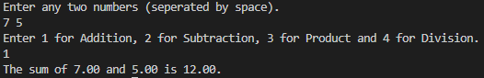

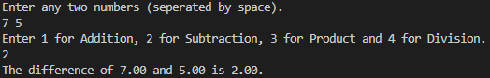

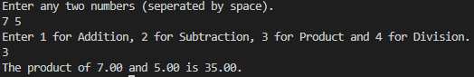

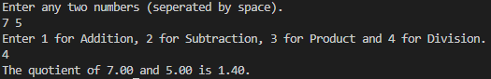

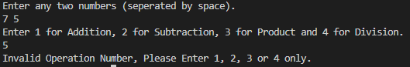

Task # 7: Leap Year Check
Create a program to check if a year entered by the user is a leap year or not.
- Use if-else with logical operators.
#include <stdio.h>
int main()
{
int year;
printf("Enter a Year to check if its a Leap Year.\n");
scanf("%d", &year);
if (year%400==0 || year%4==0 && year%100!=0)
{
printf("It is a Leap Year.");
}
else
{
printf("It is Not a Leap Year.");
}
return 0;
}
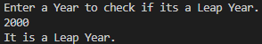
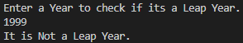

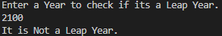
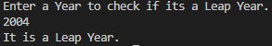

Task # 8: Number Sign Checker
Write a program to check if a number is positive, negative, or zero.
- Use if-else if-else statement.
#include <stdio.h>
int main()
{
int Num;
printf("Enter a number and I will check if it is positive, negative, or zero.\n");
scanf("%d", &Num);
if (Num>0)
{
printf("%d is a Positive Number.", Num);
}
else if (Num<0)
{
printf("%d is a Negative Number.", Num);
}
else
{
printf("The input number is Zero.");
}
return 0;
}

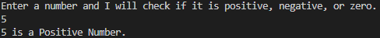

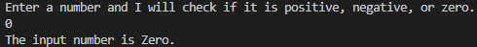

Task # 9: Day Name from Number

Write a program where the user enters a number (1-7), and the program prints the corresponding day of the week.
- Use switch-case.
#include <stdio.h>
int main()
{
int Day;
printf("Enter a number (1-7) to get the respective day of the week.\n");
scanf("%d",&Day);
switch (Day)
{
case 1:
printf("Monday.\n");
break;
case 2:
printf("Tuesday.\n");
break;
case 3:
printf("Wednesday.\n");
break;
case 4:
printf("Thursday.\n");
break;
case 5:
printf("Friday.\n");
break;
case 6:
printf("Saturday.\n");
break;
case 7:
printf("Sunday.\n");
break;
default:
printf("Invalid Input, Please enter a number 1 - 7.");
break;
}
return 0;
}
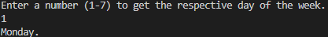

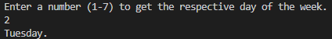

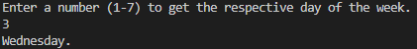

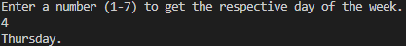

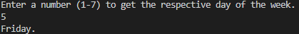

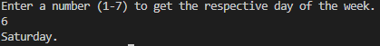

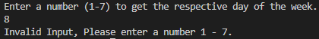
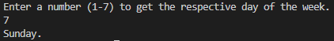
Task # 10. Simple Password Validator

Ask the user to enter a password (integer). If the password matches a predefined value, print “Access Granted” else print “Access Denied”, do it by using if-else.
#include <stdio.h>
int main()
{
int Pass;
printf("Enter your Password (Integers Only).\n");
scanf("%d",&Pass);
if (Pass==0000) // 0000 could be any predefined value.
{
printf("Access Granted.");
}
else
{
printf("Acess Denied.");
}
return 0;
}
