Programming Fundamentals Lab 05
Name: Muhammad Farhan
Roll no: 25K-0538
Program: BCS-1k
Section: 1K
Lab 05 Assignment
Course Instructor:
Sir Muhammad Sheeraz Iqbal
Task 1: Operator Precedence in Expressions

Write a program that demonstrates operator precedence in a complex expression.
Instructions:
1. Accept two integer inputs from the user (a, b).
2. Write an expression involving multiple operators (e.g., a + b * (a - b) / 2).
3. Display the result of the expression and explain why the result came out as it did based on
operator precedence.

C Code:

#include <stdio.h>
int main()
{
int a, b;
printf("Enter the first number.\n");
scanf("%d", &a);
printf("Enter the second number.\n");
scanf("%d", &b);
printf("The output is %d \n", a+b*(a-b)/2);
printf("Here the Parenthesis () have the highest precedence and will be the very first thing that happens, which has subtraction in it: %d \n ", (a-b));
printf("next, Multiply * has equal precedence as Divide /, but * is first in order from left to right, so it will happen first: %d \n ", b*(a-b));
printf("Next, Divide / has the highest precedence, so that will happen next: %d \n", b*(a-b)/2);
printf("And finally, Addition + will happen last: %d \n", a+b*(a-b)/2);
return 0;
}

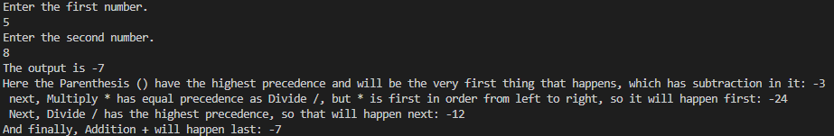
Output:

Task 2: Logical Operators

Use logical operators to evaluate multiple conditions.
Instructions:
1. Take two integer inputs (x, y) from the user.
2. Evaluate the following conditions using logical operators and print the results:
- (x &gt; 5) &amp;&amp; (y &lt; 10)
- (x == 10) || (y == 5)
- !(x == y)

C Code:
#include <stdio.h>
int main()
{
int x, y;
printf("Enter the first number.\n");
scanf("%d", &x);
printf("Enter the second number.\n");
scanf("%d", &y);
printf("%d\n", x>5 && y<100);
printf("%d\n", x==10 || y==5);
printf("%d\n", !(x==y));
return 0;
}

Output:
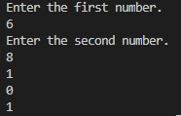

Task 3: Math Library Functions (Square Root)
Use math library functions to calculate the square root of a number.
Instructions:
1. Prompt the user to input a number.
2. Use the sqrt() function from the math library to calculate and display the square root of the
number.

C Code:
#include <stdio.h>
#include <math.h>
int main()
{
float num;
printf("Enter any number to get its square root.\n");
scanf("%f", &num);
printf("%.4f", sqrt(num));
return 0;
}

Output:

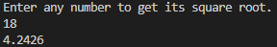

Task 4: Ternary Operator for Largest of Two Numbers

Use a ternary operator to determine the larger of two numbers.
Instructions:
1. Take two integer inputs from the user (m, n).
2. Use the ternary operator to print the larger of the two numbers in a single line.
Example Input:
m = 5, n = 8
Expected Output:
8 is greater than 5

C Code:
#include <stdio.h>
int main()
{
int a, b;
printf("Enter the first number.\n");
scanf("%d", &a);
printf("Enter the second number.\n");
scanf("%d", &b);
(a>b)?printf("%d is greater than %d", a, b):printf("%d is greater than %d", b, a);
return 0;
}

Output:
