Task 5: Nested Switch-Case for Country Listing
Programming Fundamentals Lab 05
Name: Muhammad Farhan
Roll no: 25K-0538
Program: BCS-1k
Section: 1K
Lab 05 Assignment
Course Instructor:
Sir Muhammad Sheeraz Iqbal

Write a C program that implements the Nested Switch-Case for a School Grading System as
described.
Instructions:
1. Prompt the user to enter a course number (1, 2, or 3).
2. Based on the course number, prompt for a letter grade ( ‘A’, ‘B’, ‘C’, ‘D’, or ‘F’).
3. Using a nested switch-case structure, print the appropriate message for the student’s
performance in that specific course.
4. Include a default case in both the outer and inner switch statements to handle invalid
inputs.

C Code:
#include <stdio.h>
int main()
{
char num, grade;
printf("Enter your course number(1, 2 or 3).\n");
scanf(" %c", &num);
switch (num)
{
case '1':
printf("Enter your grade (A, B, C, D, or F).\n");
scanf(" %c", &grade);
switch (grade)
{
case 'A':
printf("Your performance was Excellent.\n");
break;
case 'B':
printf("Your performance was Good.\n");
break;
case 'C':
printf("Your performance was mediocre.\n");
break;
case 'D':
printf("Your performance was Lacking, More practice and study needed.\n");
break;
case 'F':
printf("You Failed, The course needs to be repeated.\n");
break;
default:
printf("invalid grade input, please try again.\n");
break;
}
break;
case '2':
printf("Enter your grade (A, B, C, D, or F).\n");
scanf(" %c", &grade);
switch (grade)
{
case 'A':
printf("Your performance was Excellent.\n");
break;
case 'B':
printf("Your performance was Good.\n");
break;
case 'C':
printf("Your performance was mediocre.\n");
break;
case 'D':
printf("Your performance was Lacking, More practice and study needed.\n");
break;
case 'F':
printf("You Failed, The course needs to be repeated.\n");
break;
default:
printf("invalid grade input, please try again.\n");
break;
}
break;
case '3':
printf("Enter your grade (A, B, C, D, or F).\n");
scanf(" %c", &grade);
switch (grade)
{
case 'A':
printf("Your performance was Excellent.\n");
break;
case 'B':
printf("Your performance was Good.\n");
break;
case 'C':
printf("Your performance was mediocre.\n");
break;
case 'D':
printf("Your performance was Lacking, More practice and study needed.\n");
break;
case 'F':
printf("You Failed, The course needs to be repeated.\n");
break;
default:
printf("invalid grade input, please try again.\n");
break;
}
break;
default:
printf("Invalid number input, please try again.\n");
break;
}
return 0;
}

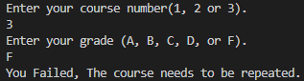
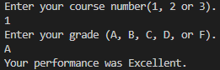
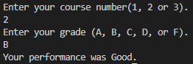
Task 6: Nested Ternary Operator for Maximum Value
Use nested ternary operators to find the maximum of three numbers.
Instructions:
1. Take three integer inputs from the user (x, y, z).
2. Use nested ternary operators to find and display the largest of the three numbers.

C Code:
#include <stdio.h>
int main()
{
int num1, num2, num3;
printf("Enter the first number.\n");
scanf("%d", &num1);
printf("Enter the second number.\n");
scanf("%d", &num2);
printf("Enter the third number.\n");
scanf("%d", &num3);
(num1>num2)?(num1>num3)?printf("%d is the largest.", num1):printf("%d is the largest.", num3):(num2>num3)?printf("%d is the largest.", num2):printf("%d is the largest.", num3);
return 0;
}

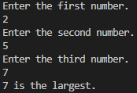
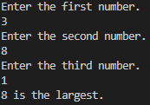
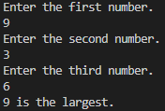
Task 7: Arithmetic Operators

Write a program that accepts two integers and performs various arithmetic operations on them.
Instructions:
1. Take two integer inputs from the user (a, b).
2. Use arithmetic operators to calculate and display:
o Sum of a and b
o Difference between a and b
o Product of a and b
o Quotient of a and b
o Remainder when a is divided by b

C Code:
#include <stdio.h>
int main()
{
int a, b;
printf("Enter the first number.\n");
scanf("%d", &a);
printf("Enter the second number.\n");
scanf("%d", &b);
printf("The sum of %d and %d is %d.\n", a, b, a+b);
printf("The difference of %d and %d is %d.\n", a, b, a-b);
printf("The product of %d and %d is %d.\n", a, b, a*b);
printf("The quotient of %d and %d is %d.\n", a, b, a/b);
printf("The remainder when %d divided by %d is %d.\n", a, b, a%b);
return 0;
}

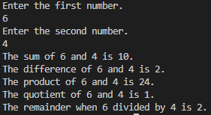

Task 8: Relational Operators

Demonstrate the use of relational operators by comparing two user-entered integers.
Instructions:
1. Accept two integer inputs from the user (a, b).
2. Use relational operators to compare the two values and display the results of the following
comparisons:
o a == b
o a > b
o a < b
o a != b
o a >= b
o a <= b
Example Input:
a = 10, b = 5
Expected Output:
a > b: 1 (True)
a < b: 0 (False)
a == b: 0 (False)

C Code:
#include <stdio.h>
int main()
{
int A, B;
printf("Enter the First number.\n");
scanf("%d",&A);
printf("Enter the Second number.\n");
scanf("%d",&B);
printf("The result of using the realational operator == is %d\n", A==B);
printf("The result of using the realational operator > is %d\n", A>B);
printf("The result of using the realational operator < is %d\n", A<B);
printf("The result of using the realational operator != is %d\n", A!=B);
printf("The result of using the realational operator >= is %d\n", A>=B);
printf("The result of using the realational operator <= is %d\n", A<=B);
return 0;
}

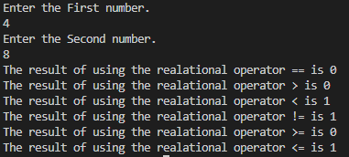

Task 9: Use Bitwise Operators

Practice using bitwise operators by writing a program that performs bitwise operations on two
integers.
Instructions:
1. Take two integers (a and b) as input from the user.
2. Perform and display the following bitwise operations:
o a &amp; b (Bitwise AND)
o a | b (Bitwise OR)
o a ^ b (Bitwise XOR)
o ~a (Bitwise NOT)
o a << 1 (Shift left)
o a >> 1 (Shift right)

C Code:
#include <stdio.h>
int main()
{
int A, B;
printf("Enter the First number.\n");
scanf("%d",&A);
printf("Enter the Second number.\n");
scanf("%d",&B);
printf("The result of using the BitWise operator & is %d\n", A&B);
printf("The result of using the BitWise operator | is %d\n", A|B);
printf("The result of using the BitWise operator ~ on %d is %d\n", A, ~A);
printf("The result of using the BitWise operator << is %d\n", A<<1);
printf("The result of using the BitWise operator >> is %d\n", A>>1);
return 0;
}

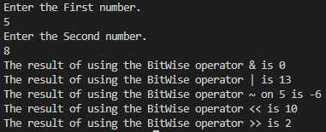
Task 10: Nested If-Else for Largest of Three Numbers

Practice using nested if-else statements by writing a program that finds the largest of three user-
entered numbers.
Instructions:
1. Take three integer inputs from the user (x, y, z).
2. Use a nested if-else structure to determine which number is the largest.
3. Display the largest number.

C Code:
#include <stdio.h>
int main()
{
int x, y, z;
printf("Enter the First number.\n");
scanf("%d", &x);
printf("Enter the Second number.\n");
scanf("%d", &y);
printf("Enter the Third number.\n");
scanf("%d", &z);
if (x>y && x>z)
{
printf("%d is the largest.\n", x);
}
else if (y>x && y>z)
{
printf("%d is the largest.\n", y);
}
else if (z>x && z>y)
{
printf("%d is the largest.\n", z);
}
else
{
printf("The numbers are equal.\n");
}
return 0;
}

