Name: Muhammad Farhan
Roll no: 25K-0538
Programming Fundamentals Lab 7
Course Instructor: Sir Sheeraz Iqbal

Task 1:

#include <stdio.h>
int main()
{
int array1[10];
int tempovar,sumnum=0;
for (int i=1;i<=10;i++)
{
printf("Enter %d(st/nd/rd/th) number.\n", i);
scanf("%d", &array1[i-1]);
}
printf("Original Array:");
for(int i=0;i<=9;i++)
printf("%d ", array1[i]);

for (int i=0;i<=4;i++)
{
tempovar=array1[9-i];
array1[9-i]=array1[i];
array1[i]=tempovar;
}
printf("\nReverse Array:");
for (int i=0; i<=9; i++)
printf("%d ", array1[i]);
printf("\nThe sum is: ");
for (int i=0; i<=9; i++)
sumnum+=array1[i];
printf("%d",sumnum);
return 0;
}

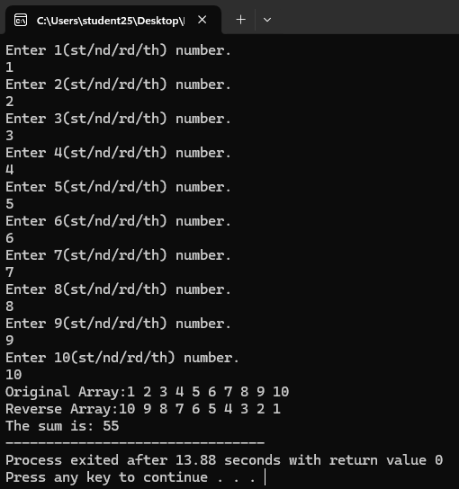
Task 2:
#include <stdio.h>
int main()
{
int array[10];
int sume=0, sumo=0;
for (int i=1;i<=10;i++)
{
printf("Enter %d(st/nd/rd/th) number.\n", i);
scanf("%d", &array[i-1]);
}
for(int i=0;i<=9;i++)
{
if(array[i]%2==0)
{
sume+=array[i];
}
else if (array[i]%2==1)
{
sumo+=array[i];
}
else
{
printf("%d is neither even nor odd.\n", array[i]);
}
}
printf("Even Sum: %d", sume);
printf("\nOdd Sum: %d", sumo);
return 0;
}

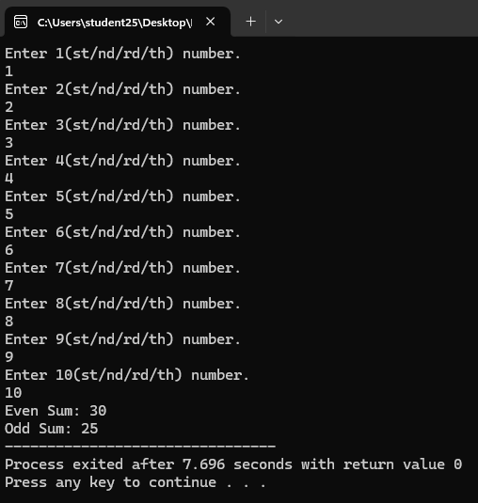

Task 3:
#include <stdio.h>
int main()
{
char array[20];
char target;
int targetcount=0;
printf("Enter your word/string.\n");
fgets(array, sizeof(array), stdin);
printf("Enter your target letter.\n");
scanf(" %c", &target);
for (int i=0; i<=19; i++)
{
if (array[i]==target)
targetcount++;
}
if (targetcount==0)
printf("The target letter does not exist in your input string.\n");
else
printf("There were %d occurences of %c in your input string.",targetcount, target);
}

