10/18/2025
Programming Fundamentals LAB #7
Lab Tasks 4-7
Mohammad Farhan
roll no: 25k-0538
section: bcs-1k
programming fundamentals lab 7
course instructor: Sir sheeraz iqbal
note: my github account link is at the last page

Task 4: Find the Median Value of an Array

Code:
#include <stdio.h>
int main()
{
//Name: Muhammad Farhan, Roll no: 25k-0538, BCS-1k.
int temp, mid1=0, mid2=0, k, m;
float avg=0;
/*
Asking user how many student scores they want to input in Total.
The Task itself states 10 integers.
However, that would always end up with the Even Median formula.
Therefore, I have added this Extra functionality after learning it from Task 10.
In this way, the user can try the Odd median formula as well if they want.
*/
printf("How many student scores do you want to input in total? (Task states 10)\n");
scanf("%d", &m);
int score[m];
//Taking user input for the student scores in any order.
for (k = 0; k <m; k++)
{
printf("Enter your student score #%d:\n", k+1);
scanf(" %d", &score[k]);
}
//Below is the ascending order sorting algorithm that I have made.
for (int i = 0; i <m; i++)
{
for (int j = i+1; j <m; j++)
{
if (score[i]>score[j])
{
temp=score[j];
score[j]=score[i];
score[i]=temp;
}
}

}
//print sorted array.
printf("The sorted scores are:\n");
for (int i = 0; i < m; i++)
printf("%d ", score[i]);
printf("\n");
//Median calculation section.
if (m==1)
printf("\nThe median is %d.", score[0]);
else if (m%2==1)
{
mid1=score[m/2];
printf("\nThe median is %d.", mid1);
}
else
{
mid1=score[(m/2)-1];
mid2=score[m/2];
avg=(mid1+mid2)/2.0;
printf("\nThe median is %.3f.", avg);
}

return 0;
}

Output:
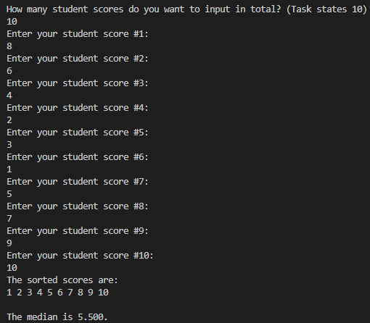
Task 5: Store Student Grades and Calculate Average

Code:
#include <stdio.h>
int main()
{
//Name: Muhammad Farhan, Roll no: 25k-0538, BCS-1k.
int score[10];
int avgup=0, highest=0, lowest=0, highindex, lowindex, modscore;
//Taking user input for the student grades in any order and storing the highest/lowest score for later use.
for (int i = 0; i <=9; i++)
{
printf("Enter your student grade #%d (total 10 student grades).\n", i+1);
scanf(" %d", &score[i]);
if (i==0)
{
highest=score[i];
highindex=i;
lowest=score[i];
lowindex=i;
}
if (score[i]>highest)
{
highest=score[i];
highindex=i;
}
else if (score[i]<lowest)
{
lowest=score[i];
lowindex=i;
}

}
//printing student grades and summing all scores for numerator for average calculation in next step.
printf("\n\n Student \tGrade");
for (int i = 0; i <=9 ; i++)
{
printf("\nStudent #%d\t %d",i+1, score[i]);
avgup+=score[i];
}
//printing average, highest grade, lowest grade, and their indices.
printf("\nTotal Class Average = %.3f", avgup/10.0);
printf("\nHighest grade = %d\t index = %d", highest, highindex);
printf("\nLowest Grade = %d\t index = %d", lowest, lowindex);
//asking for the new modfied/replacement for the lowest score in class and resetting the average.
printf("\n\nEnter your desired score to modify(replace) the lowest score of the class.\n");
scanf("%d", &modscore);
score[lowindex]=modscore;
avgup=0;
//Recalculating the new average numerator, highest grade, lowest grade and their indices.
for (int i = 0; i <= 9; i++)
{
avgup+=score[i];
if (i==0)
{
highest=score[i];
highindex=i;
lowest=score[i];
lowindex=i;
}
if (score[i]>highest)
{
highest=score[i];
highindex=i;
}
else if (score[i]<lowest)
{
lowest=score[i];
lowindex=i;
}
}
//printing the new updated scores, average, highest, lowest and their indices.
printf("\n\nUpdated Class Grades:\n");
printf("\n\n Student \tGrade");
for (int i = 0; i <=9 ; i++)
printf("\nStudent #%d\t %d",i+1, score[i]);
printf("\nUpdated Total Class Average = %.3f", avgup/10.0);
printf("\nUpdated Highest grade = %d\t index = %d", highest, highindex);
printf("\nUpdated Lowest Grade = %d\t index = %d", lowest, lowindex);
return 0;
}

Output:

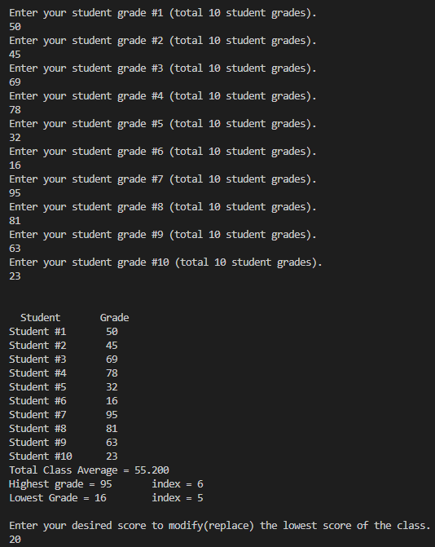
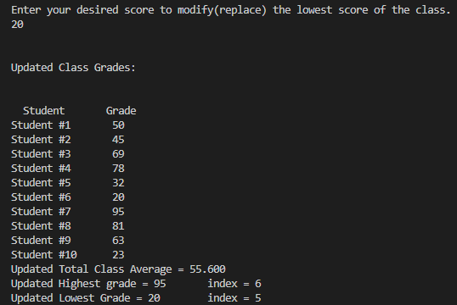
Task 6: Implement a Simple Calculator Using Arrays

Code:
#include <stdio.h>
int main()
{
//Name: Muhammad Farhan, Roll no: 25k-0538, BCS-1k.
int num1[5]={0}, num2[5]={0};
//Taking input for the 5 numbers.
for (int i = 0; i <=4; i++)
{
printf("Enter your (%d)number (Total 5 numbers).\n", i+1);
scanf(" %d", &num1[i]);
}
//Calculating the 2nd array and printing.
printf("Original Numbers \t Updated Numbers");
for (int i = 0; i <= 4; i++)
{
num2[i]=(num1[i]+10-5)*2;
printf("\n\t%d\t\t\t%d", num1[i], num2[i]);
}
return 0;
}

Output:

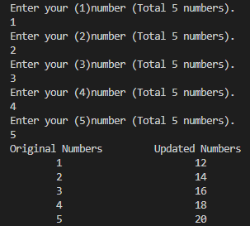
Task 7: Remove All Occurrences of a Specific Value from an Array

Code:
#include <stdio.h>
int main()
{
//Name: Muhammad Farhan, Roll no: 25k-0538, BCS-1k.
int productID[10];
int removalID, temp;
//Input for the 10 Product IDs.
for (int i = 0; i <=9; i++)
{
printf("Enter your product ID #%d.\n", i+1);
scanf(" %d", &productID[i]);
}
//Input for the ID to Remove from the Array.
printf("\nEnter the product ID you want to remove from the database.\n");
scanf(" %d", &removalID);
//Assigning 0 to the specified ID to be removed from the array.
for (int i = 0; i <= 9; i++)
{
if (productID[i]==removalID)
productID[i] = 0;
}
//The algorithm I have made to move all 0s to the very back of the Array, ensuring no gaps between other IDs.
for (int i = 0; i <= 9; i++)
{
if (productID[i]==0)
{
for (int j = i+1; j <=9; j++)
{
if (productID[j]!=0)
{
temp=productID[j];
productID[j]=productID[i];
productID[i]=temp;
break;
}

}

}
/*
And finally, printing the updated product ID list.
Also, if we want, we can declare a int variable=0,
And then make it increment inside the final loop of the shifting algorithm,
that will count the number of times 0 is present in the array,
And then in the end printing loop, we can put <=9-count in the loop condition,
This will make it so that we won’t print the 0s in the output if we desired.
*/
}
printf("The Updated List of Product IDs is:\n");
for (int i = 0; i <=9; i++)
printf("%d ", productID[i]);
return 0;
}

Output:

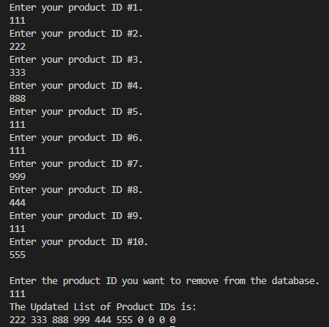

Task 8: Manipulate a String by Changing Vowels to Uppercase

Code:
#include <stdio.h>
int main()
{
//Name: Muhammad Farhan, Roll no: 25k-0538, BCS-1k.
char string[100];
int n=0;
printf("Enter your String.\n");
fgets(string,sizeof(string), stdin);
for (int i = 0; i <sizeof(string); i++)
{
switch (string[i])
{
case 'a': string[i]='A'; break;
case 'e': string[i]='E'; break;
case 'i': string[i]='I'; break;
case 'o': string[i]='O'; break;
case 'u': string[i]='U'; break;
default:
break;
}
}
printf("%s", string);
return 0;
}

Output:
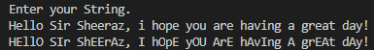
Task 9: Merge Two Arrays into One

Code:
#include <stdio.h>
int main()
{
//Name: Muhammad Farhan, Roll no: 25k-0538, BCS-1k.
int array1[5], array2[5], array3[10];
//input for first array.
for (int i = 0; i <=4; i++)
{
printf("Enter (%d)number for the first set.\n", i+1);
scanf(" %d", &array1[i]);
}
//input for second array.
printf("\n");
for (int i = 0; i <=4; i++)
{
printf("Enter number(%d) for the second set.\n", i+1);
scanf(" %d", &array2[i]);
}
//combining first and second array.
for (int i = 0; i <= 4; i++)
{
array3[i]=array1[i];
array3[i+5]=array2[i];
}
//printing the final merged array.
printf("The merged survery results are:\n");
for (int i = 0; i <=9; i++)
printf("%d ", array3[i]);
return 0;
}

Output:
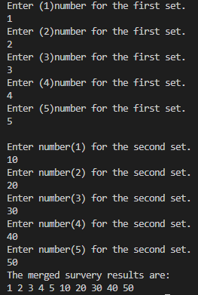
Task 10: Implement an Array with User Input for Size
Code:
#include <stdio.h>
int main()
{
//Name: Muhammad Farhan, Roll no: 25k-0538, BCS-1k.
int n, index, mod;
//input for the number of elements for array size.
printf("How many elements do you want to input?\n");
scanf("%d", &n);
//declaring the array with specified size.
int array[n];
//inputting elements into array.
for (int i = 0; i < n; i++)
{
printf("Enter element#%d.\n", i+1);
scanf("%d", &array[i]);
}
//printing the contents of array.
printf("The contents of the array are: \n");
for (int i = 0; i < n; i++)
{
printf("%d ", array[i]);
}
//asking for the index to modify that element and with what integer to modify it with.
do
{
printf("\n\nWhat element do you want to modify? (specify the index 0 - %d)\n", n-1);
scanf("%d", &index);
if (index<0 || index>=n)
{
printf("Invalid Input, Please try again.\n\n");
}
} while (index<0 || index>=n);
printf("Input the integer you want to modify it with.\n");
scanf("%d", &mod);
array[index]=mod;
//printing the updated contents.
printf("The updated contents of the array are: \n");
for (int i = 0; i < n; i++)
{
printf("%d ", array[i]);
}
return 0;
}

Output:
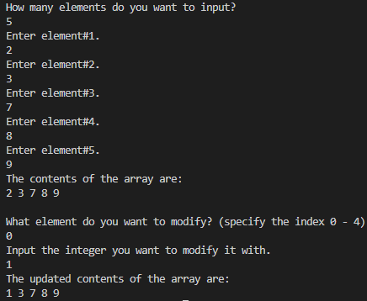

My GITHUB Account Repository where all my codes are uploaded:
https://github.com/MF4rhan/FAST-PF-BSCS-LabTasks-Assignments-Codes-1st-Semester
Side Note:
Sir I hope you are satisfied with the extra effort I have put into these tasks, I actually really enjoyed doing them as they were all actually useful and made me learn something, so thank you for being so thoughtful for us and making such great tasks for us. Thank you, Sir. Have a great day/night.

