Name: Muhammad Farhan
Roll no: 25k-0538
section: BCs-1k
pf lab 8, lab tasks 4 to 7.
course instructor: Sir sheeraz iqbal
Lab Tasks: Task 4 to Task 10
Programming Fundamentals Lab 8
2025
Task 4: Upper and Lower Triangular Matrix Check.

#include <stdio.h>
int main()
{
int matrix[3][3], upper=0, lower=0;
for (int i = 0; i < 3; i++)
{
for (int j = 0; j < 3; j++)
{
printf("Enter the element of (%d)row, (%d)column of the matrix.\n", i+1, j+1);
scanf("%d", &matrix[i][j]);
if (i>j && matrix[i][j]==0)
upper++;
if (i<j && matrix[i][j]==0)
lower++;

}

}
if (upper==3 && lower==3)
printf("\n\nThe input matrix is a Both a Upper and Lower Triangular Matrix.\n");
else if (upper==3)
printf("\n\nThe input matrix is a Upper Triangular Matrix.\n");
else if (lower==3)
printf("\n\nThe input matrix is a Lower Triangular Matrix.\n");
else
printf("\n\nThe input matrix is not a Triangular Matrix.\n");
return 0;
}
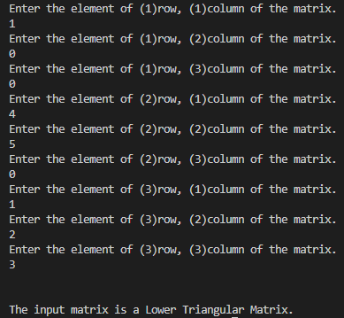
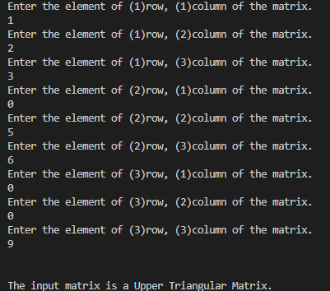
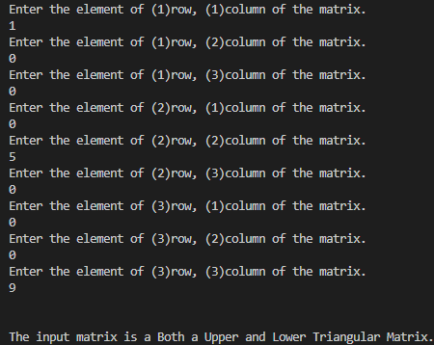
Task 5: Diamond Pattern of Stars
Note: For this Tasks, I have made 2 different codes for the diamond pattern.
The end results of both are diamond pattern made of stars, but the arrangement of stars inside them are different.
Version 1:
#include <stdio.h>
int main()
{
int k=0, rows, totalrows;
printf("Enter the number of rows of the top half of the diamond.\n");
scanf("%d", &rows);
totalrows=rows*2-1;
for (int i=1; i<=totalrows; i++)
{
i<=rows?k++:k--;
for(int j=1; j<=totalrows; j++)
{
if (j>=rows+1-k && j<=rows-1+k)
{
printf("*");
}
else
{
printf(" ");
}

}
printf("\n");
}
return 0;
}
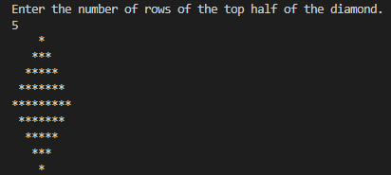

Version 2:
#include <stdio.h>
int main()
{
int rows, totalrows, spaces, stars;
printf("Enter the number of rows for the upper half of the diamond.\n");
scanf("%d", &rows);
printf("\n");
totalrows=rows*2-1;
spaces=rows-1;
for (int i = 1; i <= totalrows; i++)
{
i<=rows?stars=i:stars--;
for (int s=1;s<=spaces;s++)
{
printf(" ");
}
for (int j = 1; j <= stars ; j++)
{
printf("* ");
}
printf("\n");
i<rows?spaces--:spaces++;
}
return 0;
}

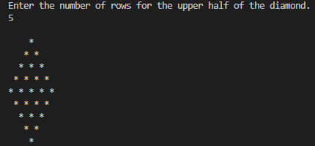

Task 6: Transpose of a Matrix

#include <stdio.h>
int main()
{
int matrix[3][3], transpose[3][3];
for (int i = 0; i < 3; i++)
{
for (int j = 0; j < 3; j++)
{
printf("Enter the element of (%d)row, (%d)column of the matrix.\n", i+1, j+1);
scanf("%d", &matrix[i][j]);
transpose[j][i]=matrix[i][j];
}

}
printf("\nThe Original Matrix\n");
for (int i = 0; i < 3; i++)
{
for (int j = 0; j < 3; j++)
{
printf("%d\t", matrix[i][j]);
}
printf("\n\n");
}
printf("\nTranspose of the Matrix\n");
for (int i = 0; i < 3; i++)
{
for (int j = 0; j < 3; j++)
{
printf("%d\t", transpose[i][j]);
}
printf("\n\n");
}
return 0;
}
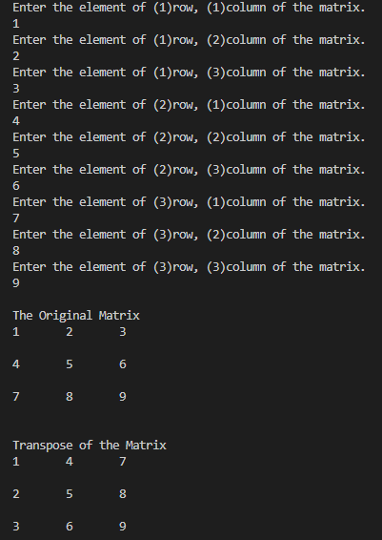

Task 7: Multiply Two Matrices

#include <stdio.h>
int main()
{
int size;
printf("Enter 2 for a 2x2 Matrix or 3 for a 3x3 Matrix.\n");
scanf("%d", &size);
int matrix1[size][size], matrix2[size][size], matrix3[size][size];
for (int i = 0; i < size; i++)
{
for (int j = 0; j < size; j++)
{
matrix3[i][j]=0;
}

}
printf("\n");
for (int i = 0; i < size; i++)
{
for (int j = 0; j < size; j++)
{
printf("Enter the element of (%d)row, (%d)column of the first matrix.\n", i+1, j+1);
scanf("%d", &matrix1[i][j]);
}

}
printf("\n");
for (int i = 0; i < size; i++)
{
for (int j = 0; j < size; j++)
{
printf("Enter the element of (%d)row, (%d)column of the second matrix.\n", i+1, j+1);
scanf("%d", &matrix2[i][j]);
}

}
printf("\n");
for (int i=0; i < size; i++)
{
for (int j = 0; j < size; j++)
{
for (int k = 0; k < size; k++)
{
matrix3[i][j]+=matrix1[i][k]*matrix2[k][j];
}

}
}
printf("Multiplication of both Matrices\n");
for (int i = 0; i < size; i++)
{
for (int j = 0; j < size; j++)
{
printf("%d\t", matrix3[i][j]);
}
printf("\n\n");
}

return 0;
}
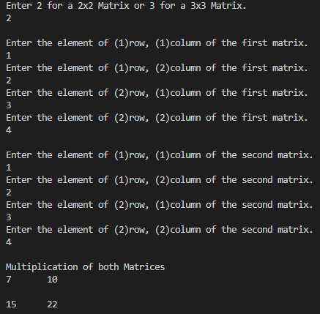

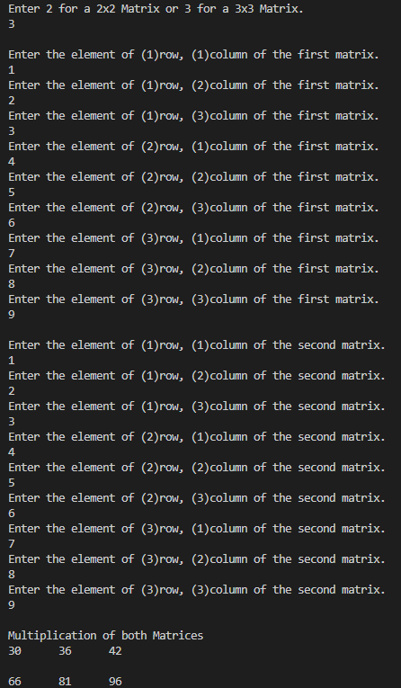
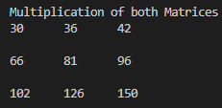
Task 8: Analyze Matrix Elements — Count Even, Odd, Positive, Negative, and Zeros

#include <stdio.h>
int main()
{
int matrix[3][3];
int counteven=0, countodd=0, countzero=0, countneg=0, countpos=0;
for (int i = 0; i < 3; i++)
{
for (int j = 0; j < 3; j++)
{
printf("Enter the element of (%d)row, (%d)column of the matrix.\n", i+1, j+1);
scanf("%d", &matrix[i][j]);
if (matrix[i][j]>0) countpos++;
if (matrix[i][j]%2!=0) countodd++;
if (matrix[i][j]%2==0) counteven++;
if (matrix[i][j]==0) countzero++;
if (matrix[i][j]<0) countneg++;
}

}
printf("\n");
printf("There are %d positive elements in the matrix.\n", countpos);
printf("There are %d negative elements in the matrix.\n", countneg);
printf("There are %d zero elements in the matrix.\n", countzero);
printf("There are %d even elements in the matrix.\n", counteven);
printf("There are %d odd elements in the matrix.\n", countodd);
return 0;
}

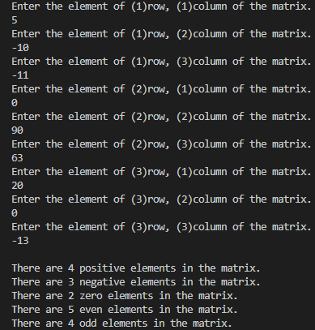

Task 9: Rotate a Matrix by 90 Degrees Clockwise

#include <stdio.h>
int main()
{
int matrix[3][3], transposerotate[3][3], tempo, counta=0;
for (int i = 0; i < 3; i++)
{
for (int j = 0; j < 3; j++)
{
printf("Enter the element of (%d)row, (%d)column of the 3x3 matrix.\n", i+1, j+1);
scanf("%d", &matrix[i][j]);
transposerotate[j][i]=matrix[i][j];
}

}
for (int i = 0; i < 3; i++)
{
tempo=transposerotate[i][0];
transposerotate[i][0]=transposerotate[i][2];
transposerotate[i][2]=tempo;
for (int j = 0; j < 3; j++)
{
if (transposerotate[i][j]==matrix[i][j])
{
counta++;
}
}

}
printf("\nThe Original Matrix\n");
for (int i = 0; i < 3; i++)
{
for (int j = 0; j < 3; j++)
{
printf("%d\t", matrix[i][j]);
}
printf("\n\n");
}
printf("\nRotated of the Matrix\n");
for (int i = 0; i < 3; i++)
{
for (int j = 0; j < 3; j++)
{
printf("%d\t", transposerotate[i][j]);
}
printf("\n\n");
}
if (counta==9) printf("The matrix's rotation is same as the original matrix.\n");
return 0;
}

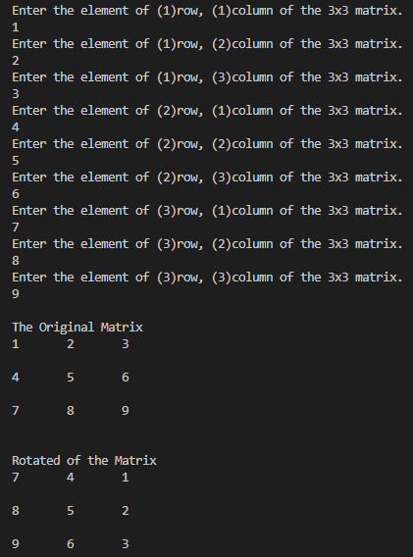
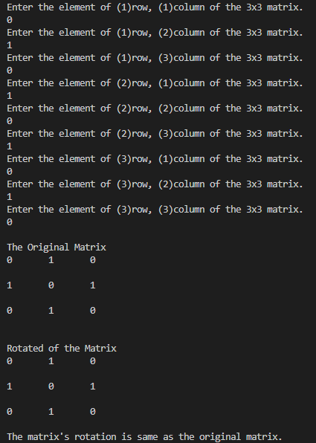
Task 10: Pascal’s Triangle Pattern

#include <stdio.h>
int main()
{
int nfactorial=1, nrfactorial=1, rfactorial=1, ncr, nr, rows;
printf("Enter the number of rows for the Pascal Triangle.\n");
scanf("%d", &rows);
printf("\n");
for (int i = 0; i < rows; i++) //printing number of rows
{
nfactorial=1; //resetting n! to 1 for fresh value of n! for each row
for (int n = 1; n <= i; n++) //calculating n!
{
nfactorial*=n;
}
for (int k = rows-1-i; k >0; k--) //printing spaces for centering, which are totalrows-1
{
printf(" ");
}
for (int j = 0; j <= i ; j++)
{
nr=i-j; //calculating (n-r)
for (int r=1; r <= nr; r++) //calculating (n-r)!
{
nrfactorial*=r;
}
for (int r=1; r <= j; r++) //calculating r!
{
rfactorial*=r;
}

ncr=nfactorial/(rfactorial*nrfactorial); //calulating nCr
printf("%d ", ncr); //printing nCr
nrfactorial=1; //reseting (n-r)! and r! to 1 for a fresh calculation for next element
rfactorial=1;
}
printf("\n"); //going to next line
}
return 0;
}

