Name: Muhammad Farhan
Roll no: 25k-0538
Section: BCS_1k

Task1:
#include <stdio.h>
int main()
{
int array[3][3], temparray[3][3];
int a,b,c,d;
int count1=0;
for(a=0;a<3;a++)
{
for(b=0; b<3;b++)
{
printf("Enter the value for %d row %d column for matrix\n", a+1, b+1);
scanf("%d", &array[a][b]);
temparray[b][a]=array[a][b];
}
}
for(c=0;c<3;c++)
{
for(d=0; d<3;d++)
{
if(array[c][d]==temparray[c][d])
{
count1++;
}
}
}
if(count1==9)
printf("The matrix is symmetric.\n");
else
printf("The matrix is not symmetric.\n");
return 0;
}

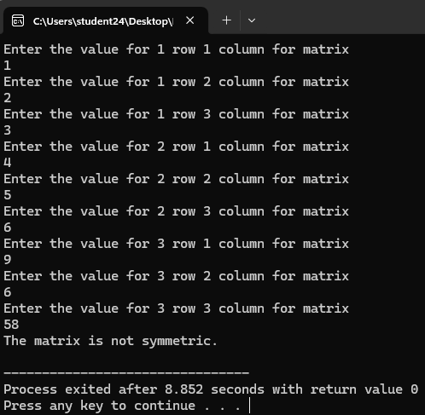

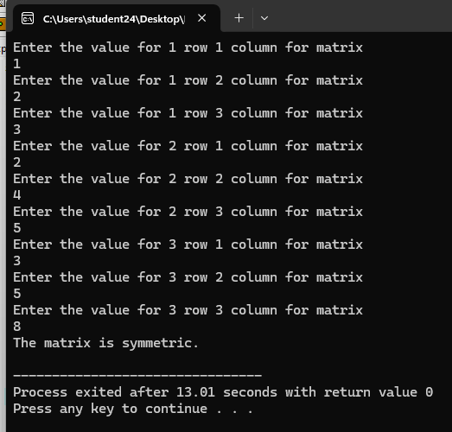

Task 2:
#include <stdio.h>
int main()
{
int size, a, b, c;
printf("Enter the size of the triangle.\n");
scanf("%d", &size);
int tempo=size-1;
for(a=1; a<=size; a++)
{
for(b=tempo; b>=1;b--)
{
printf(" ");
}
for (c=1; c<=a;c++)
{
printf("%d", c);
}
printf("\n");
tempo--;
}
}
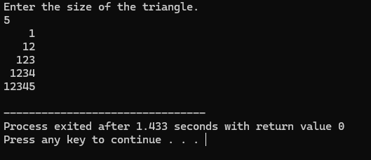

Task 3:
#include <stdio.h>
int main()
{

int size, sump=0, sums=0, sumall=0;
printf("Enter the size of square matrix.\n");
scanf("%d", &size);
int matrix[size][size];
for(int a=0;a<size;a++)
{
for(int b=0; b<size;b++)
{
printf("Enter the element of %d row and %d column of square matrix.\n", a+1, b+1);
scanf("%d", &matrix[a][b]);
if(a==b)
sump+=matrix[a][b];
if(a+b==size-1)
sums+=matrix[a][b];
}
}
sumall=sump+sums;
if (size%2!=0)
{
sumall = sumall-matrix[size/2][size/2];
}
printf("The sum of the primary diagonal is %d\n", sump);
printf("The sum of the secondary diagonal is %d\n", sums);
printf("The total sum of both diagonals is %d\n", sumall);

return 0;
}
