Name: Muhammad Farhan
Roll no: 25k-0538
Section: BCS-1K
PF Lab 9: 6 Lab Tasks
Course Instructor: Sir Sheeraz Iqbal

Programming fundamentals lab 9

Task 5:
#include <stdio.h>
void swap(int *, int *);
int main()
{
int num1,num2;
printf("Enter two numbers.\n");
scanf("%d %d", &num1, &num2);
printf("\nThe original numbers are: %d, %d\n", num1, num2);
swap(&num1, &num2);
return 0;
}

void swap(int *a, int *b)
{
int t;
t=*a;
*a=*b;
*b=t;
printf("The swapped numbers are: %d, %d\n", *a, *b);
}

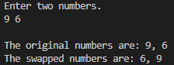
Task 6:
#include <stdio.h>
void calculate(int a, int b, int *totalsum, float *totalavg);
int main()
{
int num1, num2, sum;
float avg;
printf("Enter two numbers.\n");
scanf("%d %d", &num1, &num2);
calculate(num1, num2, &sum, &avg);
printf("\nThe sum of both numbers is: %d", sum);
printf("\nThe average of both numbers is: %.2f", avg);
return 0;
}

void calculate(int a, int b, int *totalsum, float *totalavg)
{
*totalsum = a + b;
*totalavg = *totalsum/2.0;
}

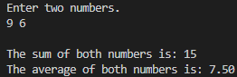
Task 7:
#include <stdio.h>
int main()
{
int *p=NULL;
if (p==NULL)
{
printf("The pointer doesn't reference to any valid memory.\n");
}
else
{
printf("The pointer references to a particular memory.\n");
}
return 0;
}

Task 8:
#include <stdio.h>
int main()
{
int integer=22;
float number=3.14;
char letter='F';
void *ptr;
ptr = &integer;
printf("The value in int variable is: %d\n", *(int *)ptr);
ptr = &number;
printf("The value in float variable is: %f\n", *(float *)ptr);
ptr = &letter;
printf("The value in char variable is: %c\n", *(char *)ptr);
return 0;
}

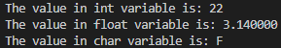
Task 9:
#include <stdio.h>
#include <stdlib.h>
int add(int a, int b);
int sub(int a, int b);
int multi(int a, int b);
int divide(int a, int b);
int main()
{
int num1, num2, choice, result;
int (*operation)(int, int);
printf("\n1. Addition\n2. Subtraction\n3. Multiplication\n4. Division\n5. Exit\nEnter your choice.\n");
scanf("%d", &choice);
if (choice==5)
{
exit(0);
}
printf("\nEnter two numbers.\n");
scanf("%d %d", &num1, &num2);
switch (choice)
{
case 1:
operation = &add;
break;
case 2:
operation = &sub;
break;
case 3:
operation = &multi;
break;
case 4:
operation = &divide;
break;
default:
printf("invalid choice.\n");
return 1;
}
result = operation(num1, num2);
printf("Result: %d", result);
return 0;
}
int add(int a, int b)
{
return a+b;
}
int sub(int a, int b)
{
return a-b;
}
int multi(int a, int b)
{
return a*b;
}
int divide(int a, int b)
{
return b==0?0:a/b;
}
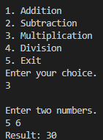
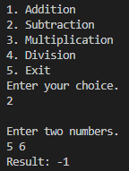
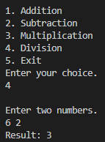
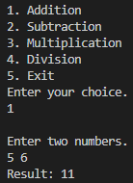

Task 10:
#include <stdio.h>
float average(int a, int b, int c);
int main()
{
int num1=5, num2=16, num3=78;
printf("%f", average(num1, num2, num3));
}

float average(int a, int b, int c)
{
return (a+b+c)/3.0;
}

