Name: Muhammad Farhan
Roll no: 25k-0538
PF Lab 9
4 tasks

Task 1:
#include <stdio.h>
int square(int a);
int main()
{
int a;
printf("enter a number to get its square.\n");
scanf("%d", &a);
printf("\nThe Square is %d", square(a));
return 0;
}
int square(int a)
{
return a*a;
}

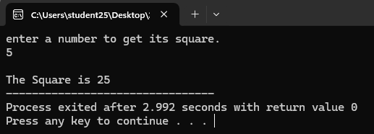

Task 2:
#include <stdio.h>

int main()
{
int arr[5];
for(int j=0;j<5;j++)
{
printf("Enter the %d element of array.\n", j+1);
scanf("%d", &arr[j]);
}
int *p = arr;
for(int i=0;i<5;i++)
printf("\nAddress of arr[%d] : %d, value: %d\n",i, (p+i), *(p+i));
return 0;
}
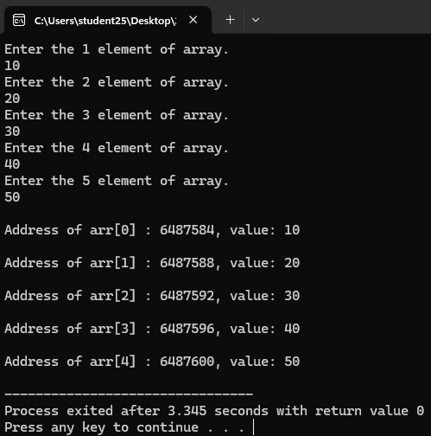
Task 3:
#include <stdio.h>
void displayMatrix(int arr[2][3]);
int calculateSum(int arr[2][3]);
float calculateAverage(int arr[2][3]);
int findMax(int arr[2][3]);
float sumg;
int main()
{
int matrix[2][3] =
{
{4,5,0},
{1,9,3}
};
sumg=calculateSum(matrix);
displayMatrix(matrix);
printf("\n\n");
printf("The sum of all Elemets is %d", calculateSum(matrix));
printf("\n\n");
printf("The average is %.3f", calculateAverage(matrix));
printf("\n\n");
printf("the maximum number is %d", findMax(matrix));
}

void displayMatrix(int arr[2][3])
{
for(int i=0;i<2;i++)
{
for (int j=0; j<3;j++)
{
printf("%d ",arr[i][j]);
}
printf("\n");
}
}

int calculateSum(int arr[2][3])
{
int sum=0;
for(int i=0;i<2;i++)
{
for (int j=0; j<3;j++)
{
sum+=arr[i][j];
}
}
sumg=sum;
return sum;
}

float calculateAverage(int arr[2][3])
{
float avg=0;
avg=(sumg/6);
return avg;
}

int findMax(int arr[2][3])
{
int max=0;
for(int i=0;i<2;i++)
{
for (int j=0; j<3;j++)
{
if(arr[i][j]>max)
max=arr[i][j];
}
}
return max;
}

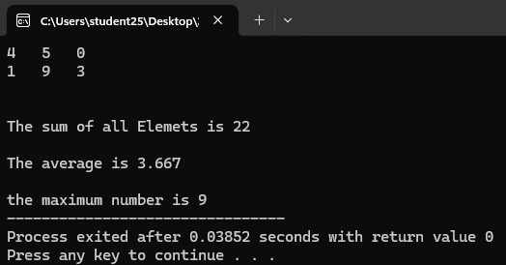

Task 4:
#include <stdio.h>
int findMax(int arr[10]);
int main()
{
int matrix[10]={12, 85, 73, 94, 63, 25, 96, 19,57, 49};
printf("The maximum value is %d.", findMax(matrix));
return 0;
}

int findMax(int arr[10])
{
int max=0;
for(int i=0;i<10;i++)
{
if (arr[i]>max)
max=arr[i];
}
return max;
}

