LeetCode Solutions
LeetCode Assigned Problems
Name: Muhammad Farhan
Roll no: 25K-0538
Section: BCS-1K
Course: Programming Fundamentals Lab
Course Instructor: Sir Sheeraz Iqbal

1480. Running sum of 1d Array.
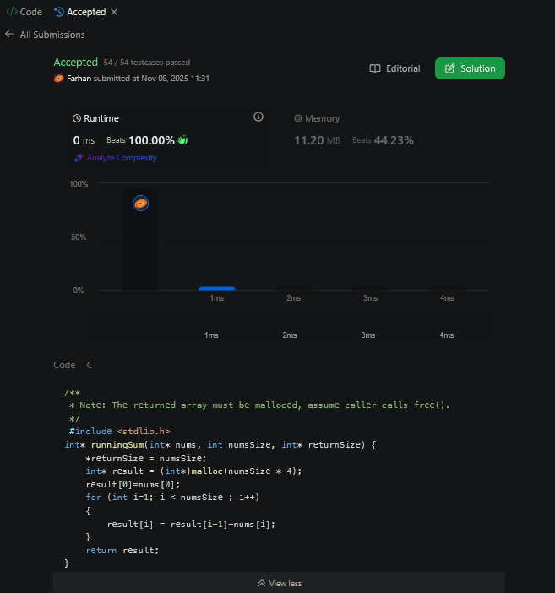

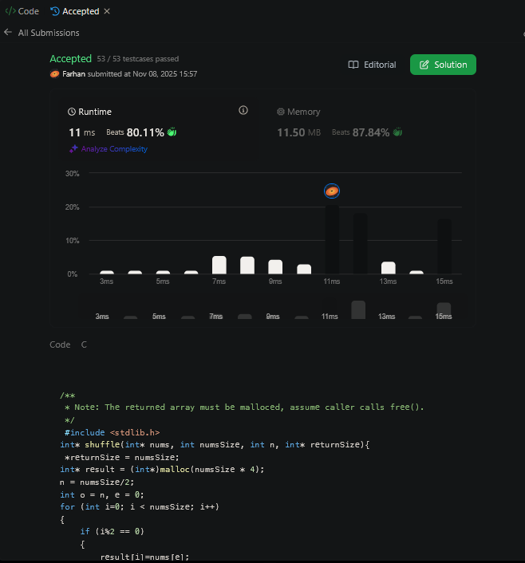
1470. Shuffle the Array.

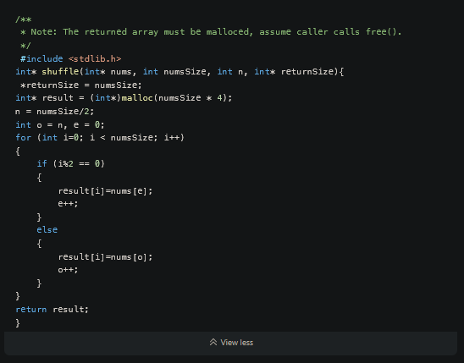
3467. Transform Array by Parity
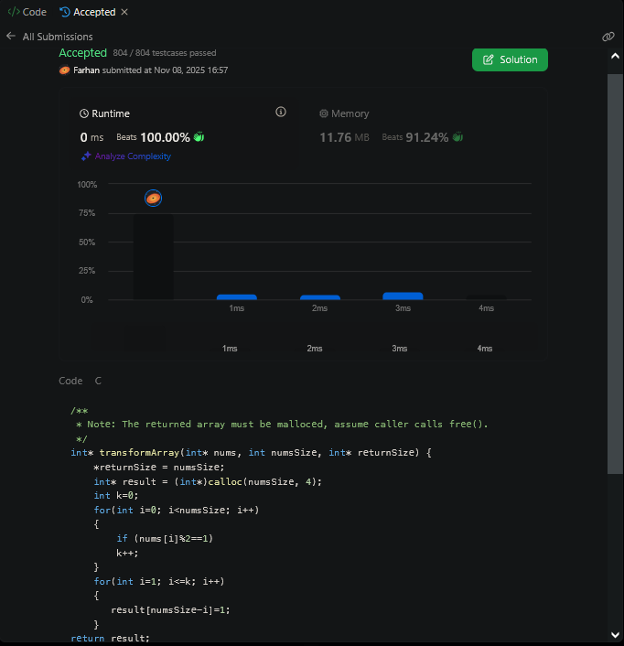

26. Remove Duplicates from Sorted Array.

Initial and first Attempt:
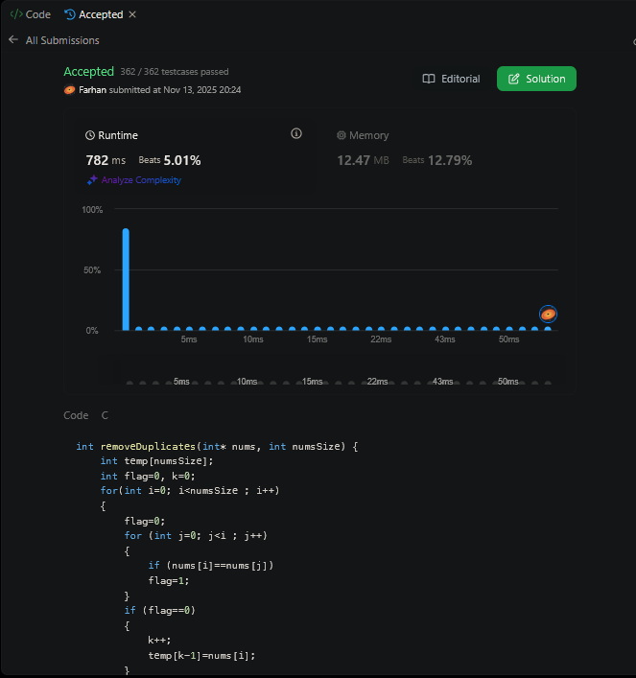

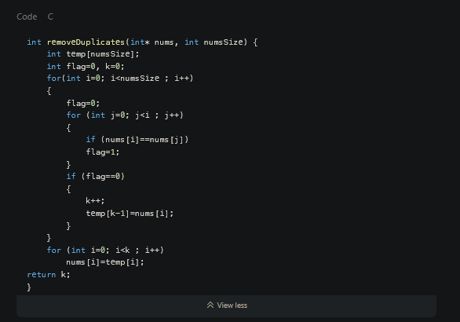

Second Attempt:

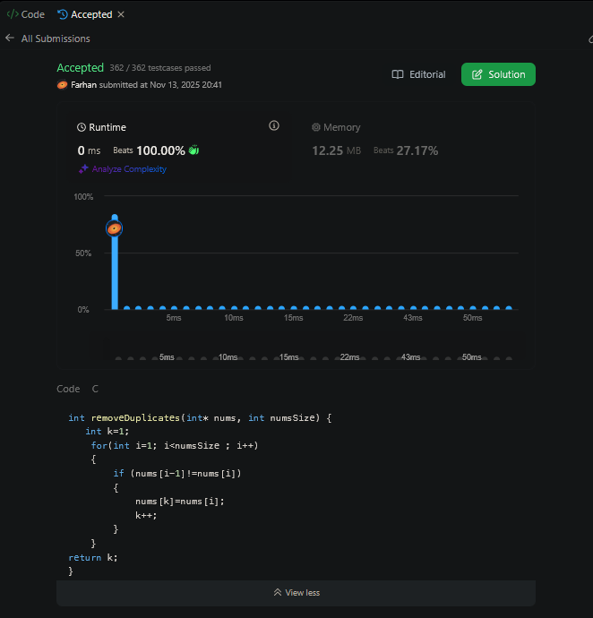
344. Reverse String
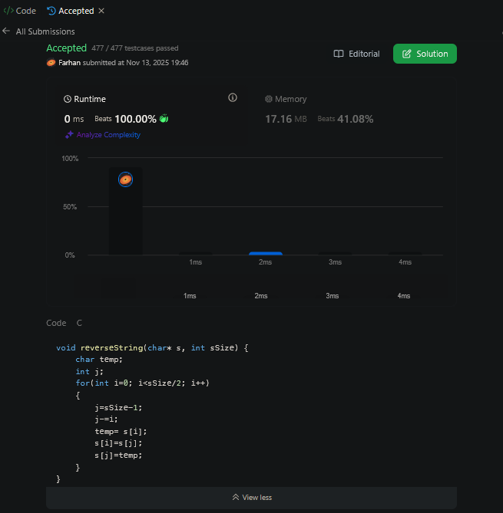

283. Move Zeroes.
