LeetCode Solutions
LeetCode Assigned Problems
Name: Muhammad Farhan
Roll no: 25K-0538
Section: BCS-1K
Course: Programming Fundamentals Lab
Course Instructor: Sir Sheeraz Iqbal

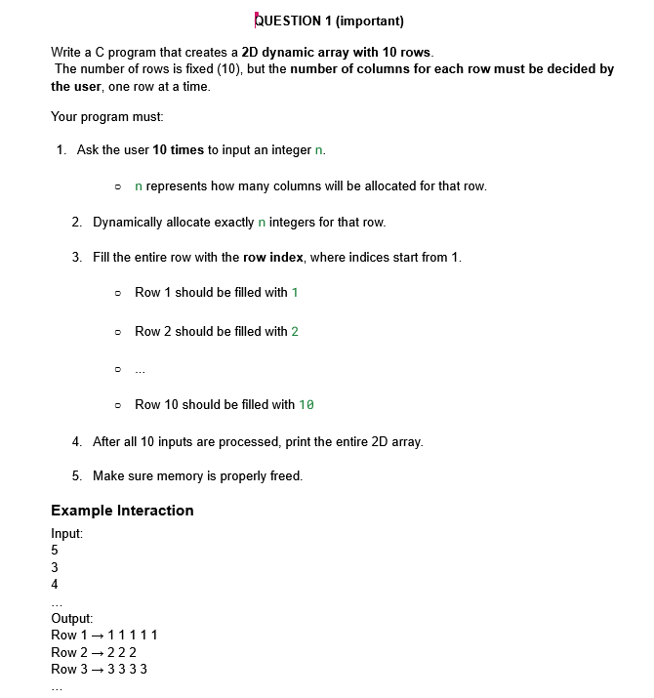

#include <stdio.h>
#include <stdlib.h>

int main()
{

int rows=10;
int** array = (int**)malloc(rows * sizeof(int*));
int* cols = (int*)malloc(rows * sizeof(int));

for (int i = 0; i < rows; ++i)
{
printf("\nInput number of colums for row %d: ", i+1);
scanf("%d", &cols[i]);
array[i] = (int*)malloc(cols[i] * sizeof(int));
}

for (int i = 0; i < rows; ++i)
{
for (int j = 0; j < cols[i]; ++j)
{
array[i][j] = i+1;
}
}
printf("\n\n");
for (int i = 0; i < rows; ++i)
{
for (int j = 0; j < cols[i]; ++j)
{
printf("%d ", array[i][j]);
}
printf("\n");
}
for (int i = 0; i < rows; ++i)
{
free(array[i]);
}
free(array);
free(cols);
array = NULL;
cols = NULL;
return 0;

}

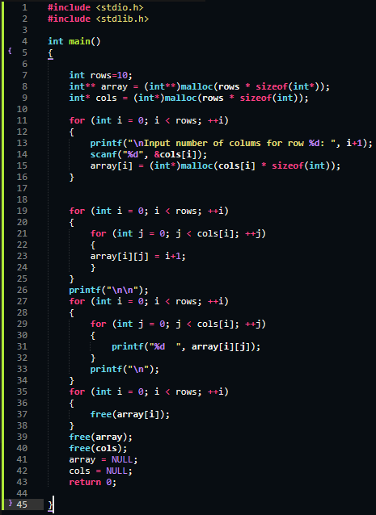
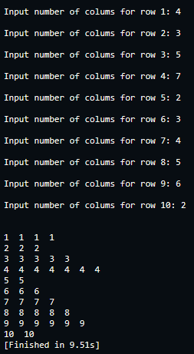

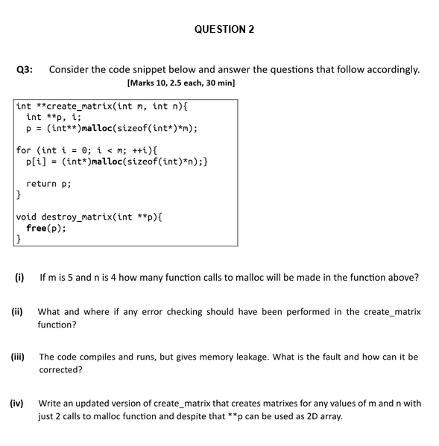

- 6 function calls to Malloc will be made.
- Adding the if (p == NULL) just below the p = (int**)malloc(sizeof(int*)*m); and (p[i] == NULL) inside the loop, below the p[i] = (int*)malloc(sizeof(int)*n), both conditions with warning, freeing all memory and then exit(1); should have been added in order to make sure none of the memory allocation had failed.
- There is a memory leak because in the destroy_matrix function, we only freed the spine/array which holds each row together, we didn’t free the rows. It can be corrected by first looping and freeing each and every row, before finally freeing the spine/frame.
- The Code and screenshot is below:

#include <stdio.h>
#include <stdlib.h>

int** create_matrix(int m, int n);
void destroy_matrix(int** p);

int main()
{
int rows, cols;
int** array = NULL;
printf("\nEnter number of Rows for array: ");
scanf("%d", &rows);
printf("\nEnter number of Columns for array: ");
scanf("%d", &cols);
array = create_matrix(rows, cols);

destroy_matrix(array);
return 0;
}

int** create_matrix(int m, int n)
{
int **p = (int**)malloc(m*sizeof(int*));
if (p == NULL)
{
printf("\nMalloc Failed.");
exit(1);
}
int* ptr = (int*)malloc(m*n*sizeof(int));
if (ptr == NULL)
{
printf("\nMalloc Failed.");
free(p);
exit(1);
}
for (int i = 0; i < m; ++i)
{
p[i] = &ptr[i*n];
}
return p;
}

void destroy_matrix(int** p)
{
free(p[0]);
free(p);
}

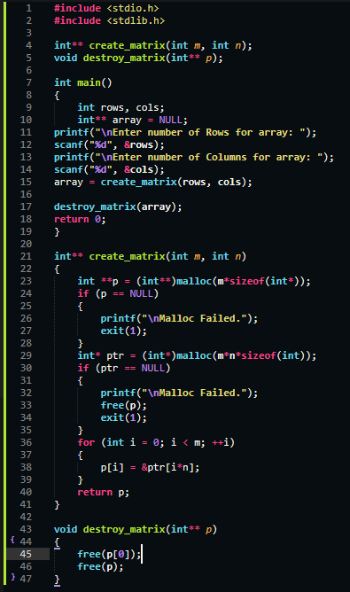

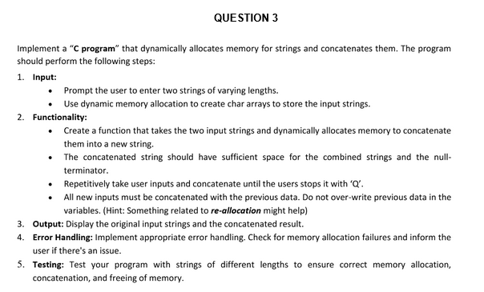

#include <stdio.h>
#include <string.h>
#include <stdlib.h>

int main()
{
int capacity = 2;
int count = 0;
char** storage = (char**)calloc(capacity, sizeof(char*));
if (storage == NULL)
{
printf("\nStorage memory allocation failed.");
exit(1);
}
char* concat = NULL;
char* tempo = NULL;
char** tempoo = NULL;
char temp[20];
int size;
printf("\nEnter your first string: ");
scanf("%s", temp);
size = strlen(temp)+1;
concat = (char*)malloc(size*sizeof(char));
if (concat == NULL)
{
printf("\nConcate memory allocation failed.");
free(storage);
exit(1);
}
tempo = (char*)malloc(size*sizeof(char));
if (tempo == NULL)
{
printf("\nStorage First string Malloc failed.");
exit(1);
}
storage[count] = tempo;
tempo = NULL;
strcpy(storage[count], temp);
strcpy(concat, temp);
count++;
while(1)
{
printf("\nEnter new String or press Q to exit: ");
scanf("%s", temp);

if (strcmp(temp, "Q")== 0)
{
break;
}

size = strlen(temp);

tempo = (char *)realloc(concat, strlen(concat)+size+1);
if (tempo == NULL)
{
printf("\nConcate Realloc Failed");
break;
}
concat = tempo;
tempo = NULL;
if (count >= capacity)
{
tempoo = (char**)realloc(storage, sizeof(char*)*(capacity+1));
if (tempoo == NULL)
{
printf("\nStorage Realloc Failed.");
break;
}
storage = tempoo;

tempoo = NULL;
capacity++;
}
tempo = (char*)malloc((size+1)*sizeof(char));
if (tempo == NULL)
{
printf("\nNew Storage string Malloc failed.");
break;
}
storage[count] = tempo;
tempo = NULL;
strcat(concat, temp);
strcpy(storage[count], temp);
count++;
}
printf("\n\nOriginal String inputs:\n");
for (int i = 0; i < count; ++i)
{
printf("%s\n", storage[i]);
}

printf("\nFinal Concatenated String:\n");
printf("\n%s", concat);

for (int i = 0; i < count; ++i)
{
free(storage[i]);
}
free(storage);
free(concat);
return 0;
}

