LeetCode Solutions
LeetCode Assigned Problems
Name: Muhammad Farhan
Roll no: 25K-0538
Section: BCS-1K
Course: Programming Fundamentals Lab
Course Instructor: Sir Sheeraz Iqbal

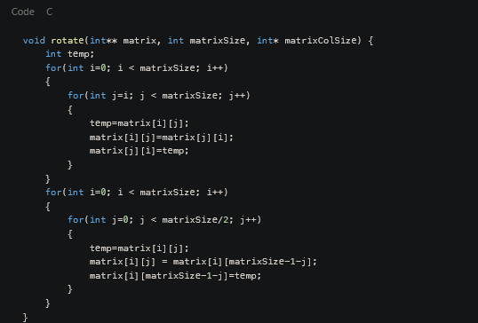
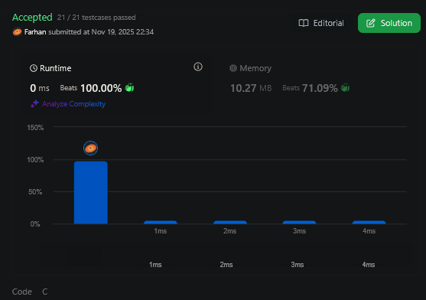
48. Rotate Image

2108. Find First Plaindromic String in the Array

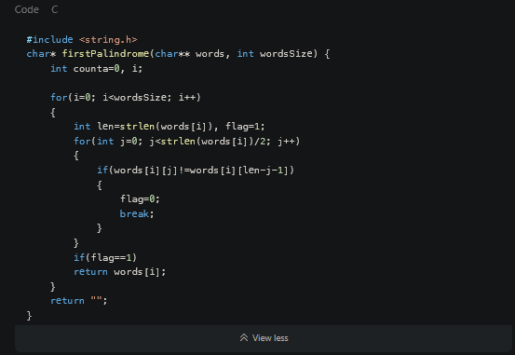
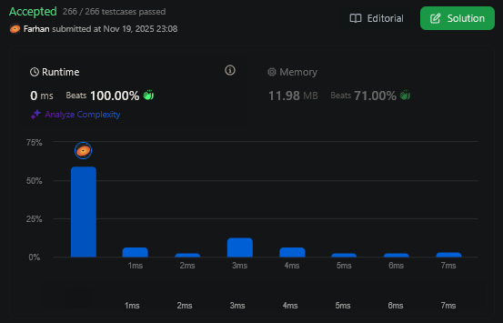
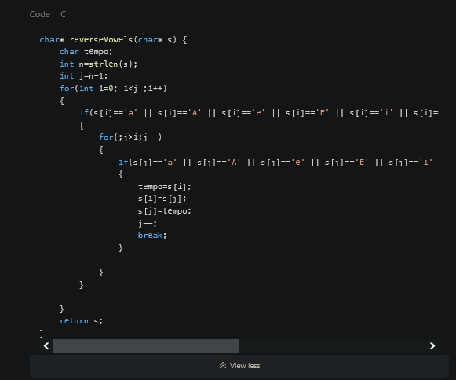
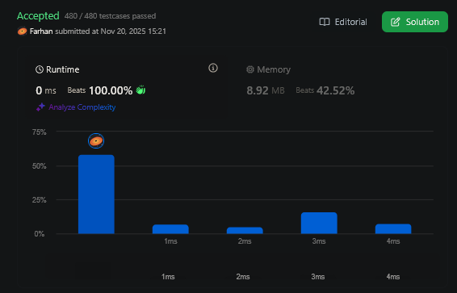
345. Reverse Vowels of a String

