10/28/2025
Programming Fundamentals
Assignment #2
Name: Muhammad Farhan
Roll no: 25K-0538
Section: BCS-1k
Assignment #2
Course: Programming Fundamentals
Course Instructor: Miss Uzma Raza

Note: This PDF contains only the screenshots of the outputs of the code and programs themselves, not the code. The codes are uploaded to GCR in a .ZIP file, as well as my GitHub account link where I post all my PF Assignment Codes and PF Lab Tasks.
Therefore, for the code itself, please download and open the .ZIP file or go to my GitHub account, both of which are uploaded to GCR alongside this PDF.
The Directions for the screenshots if there is more than one on the slide at once is: Read from Left to Right.

Question 1:
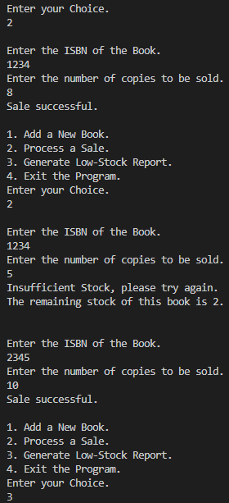
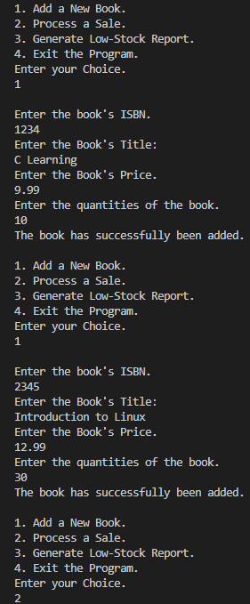

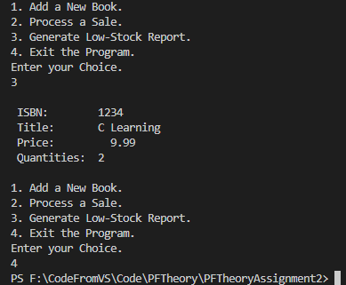

Question 2:

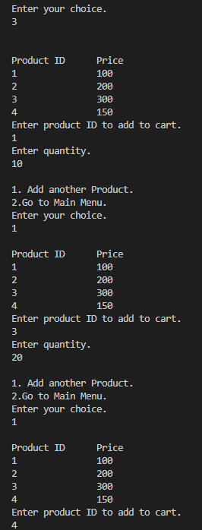
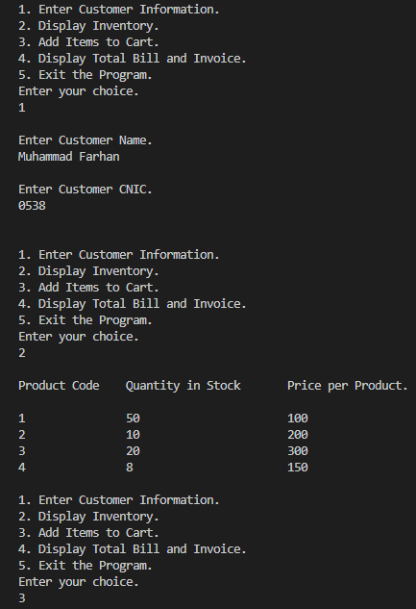
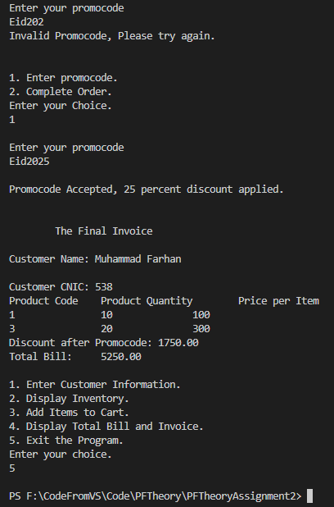
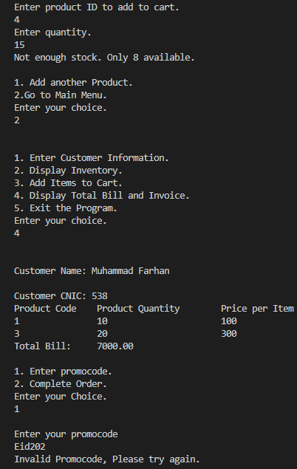

Question 3:
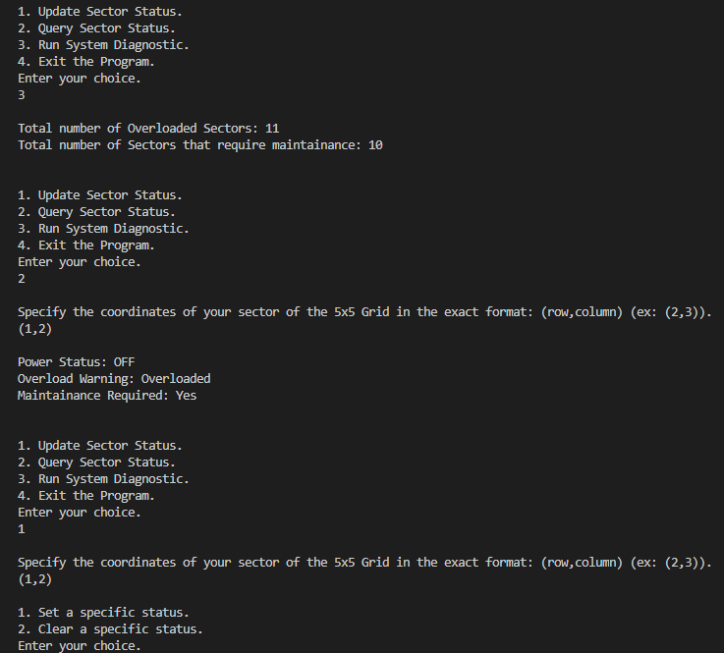

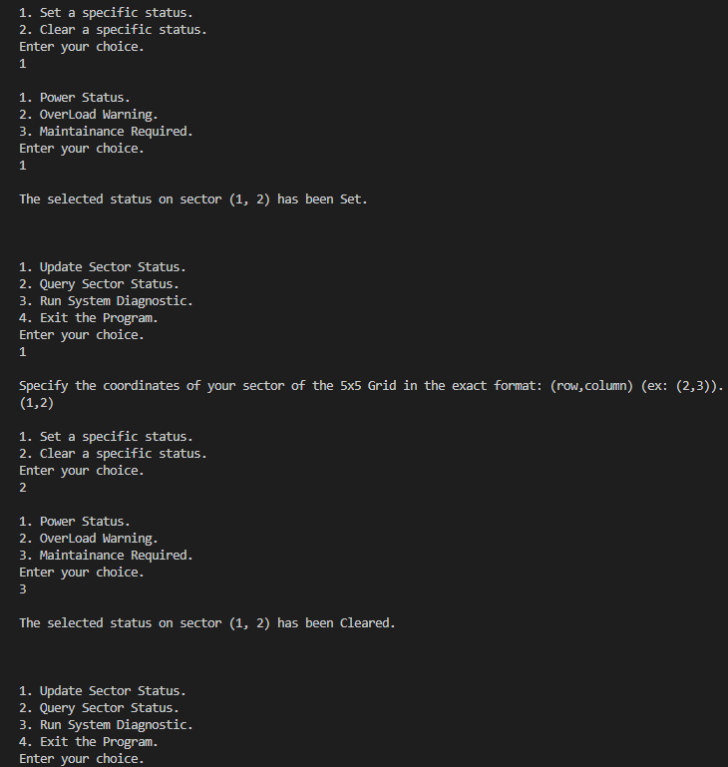

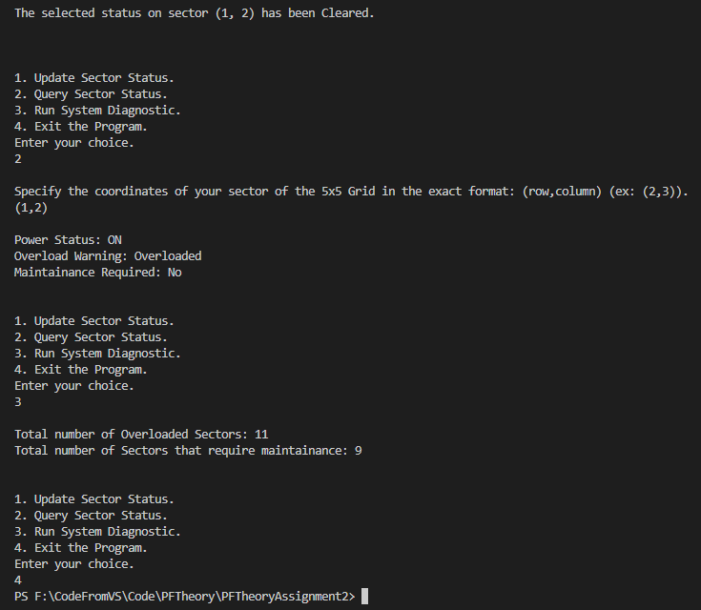

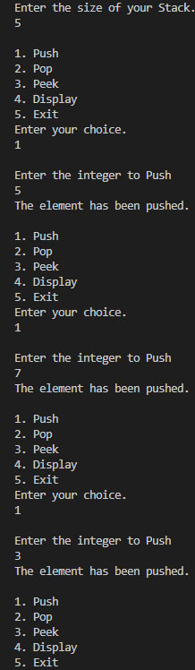
Question 4:
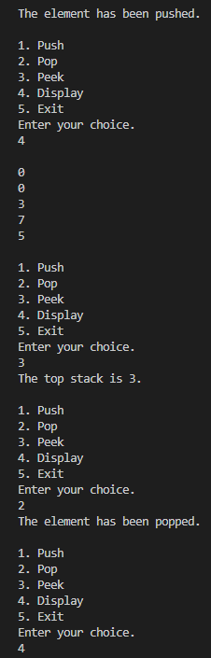
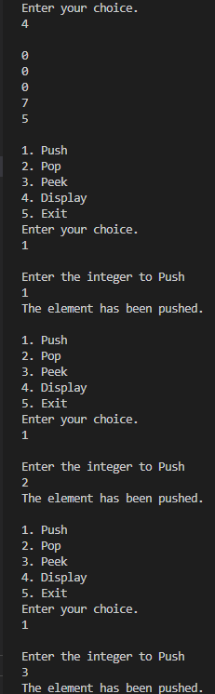

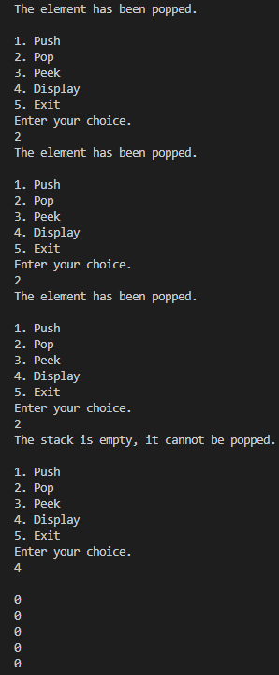
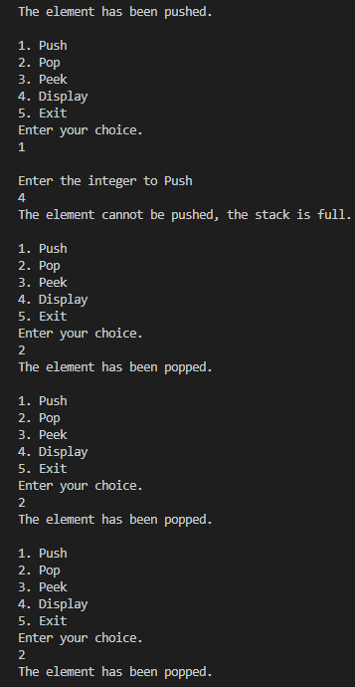
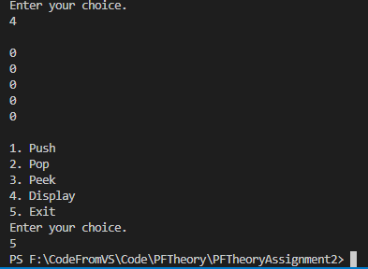
Question 5:
