Programming Fundamentals Theory
Assignment 3: Outputs and Explanations

Name: Muhammad Farhan
Roll no: 25K-0538
Section: BCS-1K
Course: Programming Fundamentals Theory
Course Instructor: Miss Uzma Raza
Question 1:
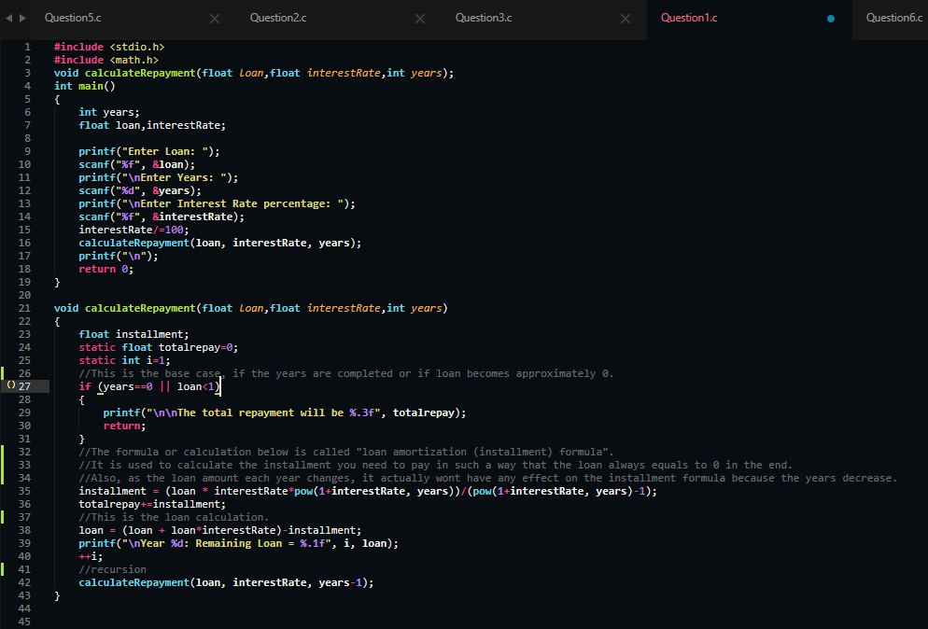

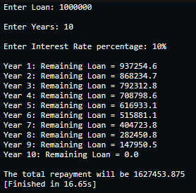

Explanation:
The program is explained by the comments in the
code.
The function calls itself (recursion) and each call
decreases the year by 1 until the years are over or
until the loan is fully paid.

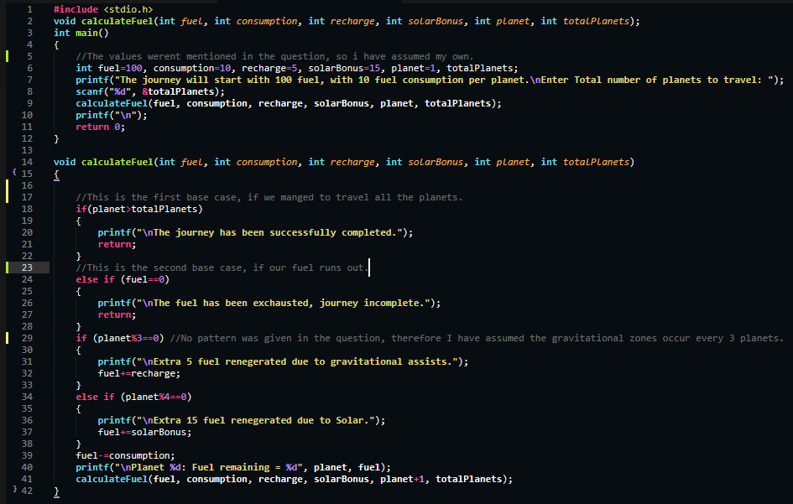
Question 2:

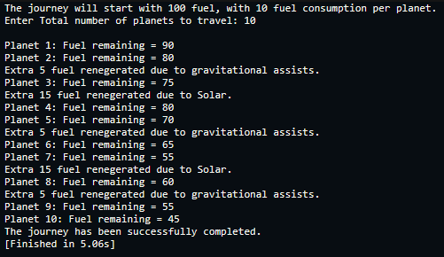
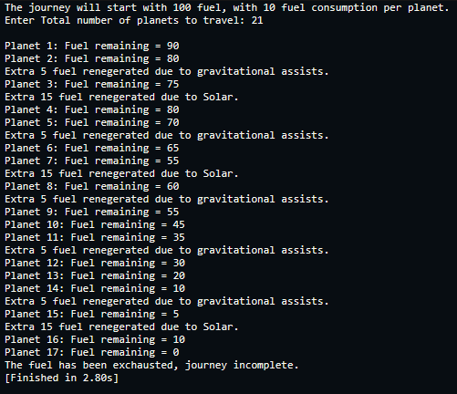

Explanation:
The code is explained by the comments. The function calls itself with increasing count of current number of planets traveled. The recursion ends when we have traveled all planets or the fuel has ran out.

Question 3:
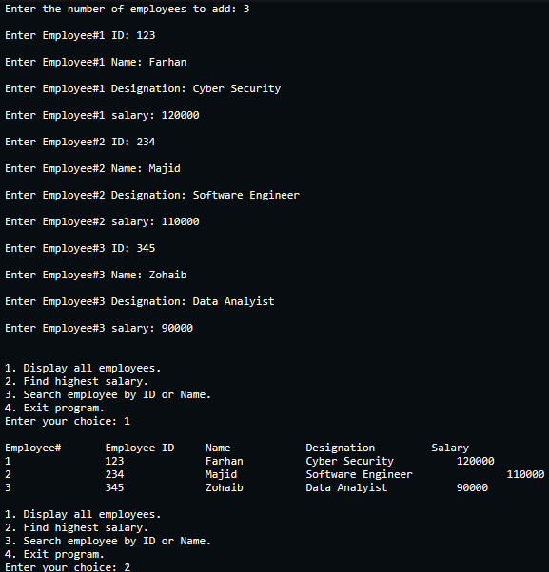
(The programs now are too large to include screenshots of, it would take 4 screenshots or more, so I will just be putting the output here and explaining the code if necessary (the code already has a lot of comments explaining it), The code is included in the .zip file.)

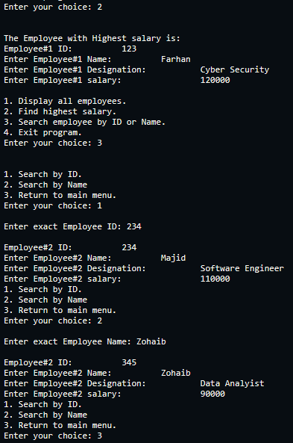
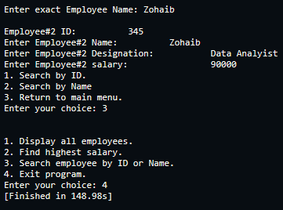

Explanation:
The entire code is basically explained in the comments of the code, so I request the reader to check them. Theres not much else to explain here in this PDF.
Here I will explain the last part of the question: “If the company later wants to give a 10% salary bonus to employees whose salary is below a certain threshold (say, 50,000), Explain how you could modify your existing program using a function with structure arrays passed by reference to update salaries directly.”
If the company later wants to give a 10% salary bonus to employees whose salary is below a certain threshold (say, 50,000), Explain how you could modify your existing program using a function with structure arrays passed by reference to update salaries directly.
To do this, I would create a new function for this, void updateSalary(struct employeeData employees[], int n).
use a if condition inside a loop to go through each employee whose salary is lower than, say 50000.
then if a employee's salary is lower than 50000, i will use employee[i].salary += (employee[i].salary)*0.10
Here we are not using pointers because, the array by default returns a address and works like a pointer, unlike a normal variable.
This will update the salaries directly without having to return anything.

Question 4:
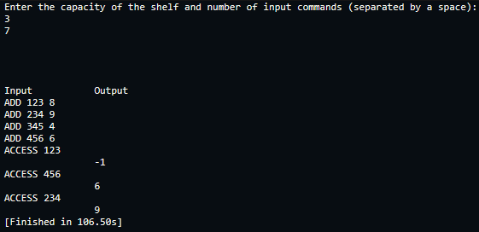

Explanation:
Again, the entire code is explained in the comments inside the code, so I request the reader to check the code. Although one thing, I couldn’t make the input line up exactly with the output, because you have to press Enter in order to give the input, which puts a newline by default.
So…the output line will always be 1 line lower than the input line.

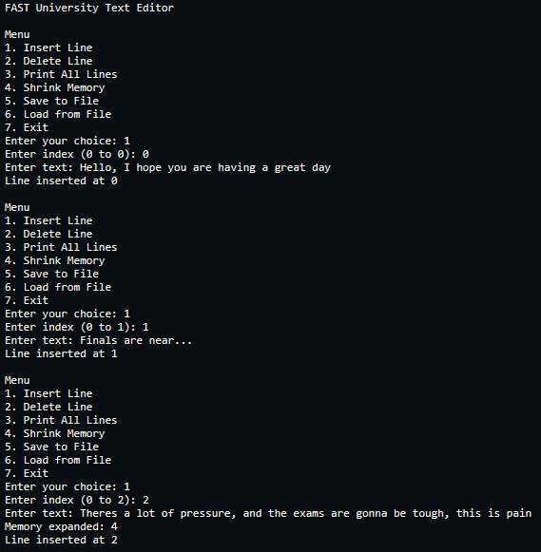
Question 5:

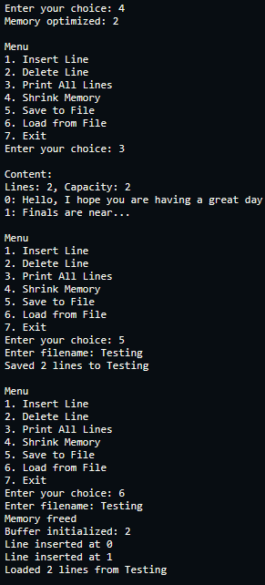
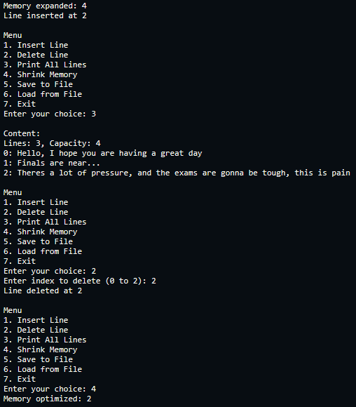

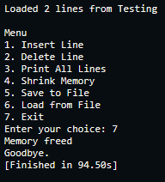

Explanation:
Again, there are many comments inside the code that explain a lot of what the code is doing.
But ill explain it here as a paragraph as well.
So this program creates a dynamic text editor by treating the document as a flexible list of strings instead of a fixed grid like arrays do. The main part of the system is the SheetData structure, which manages an array of pointers (lines), where each pointer corresponds to a single row of text. This design is efficient because it allows the program to use memory only for the lines that actually exist, and each line takes up exactly as many bytes as it needs.
Inside the functions, the logic relies heavily on standard memory management tools. For instance, insertLine first checks if the array is full; if it is, it uses realloc to double the capacity. Once there is enough space, memmove shifts the existing pointers down to create a specific gap at the target index. The function then uses malloc to allocate the exact amount of memory needed for the new string and copies the text into that slot. In contrast, deleteLine starts by freeing the memory of the target string to prevent leaks, and then it uses memmove to shift the remaining pointers up, closing the gap in the array.
To manage data storage, the saveFile and loadFile functions handle the transfer between RAM and the hard drive. saveFile is simple, it opens a file in write mode and goes through the lines array, writing each string to the file followed by a newline character. loadFile is a bit more complex, it first calls freeSheet to clear any existing data in memory to avoid mixing documents. It then reads the file line by line into a temporary buffer. Importantly, it reuses the insertLine function for each line read from the file, allowing the program to automatically handle all the memory allocation and array resizing just like the user was typing the lines in manually.

Question 6:
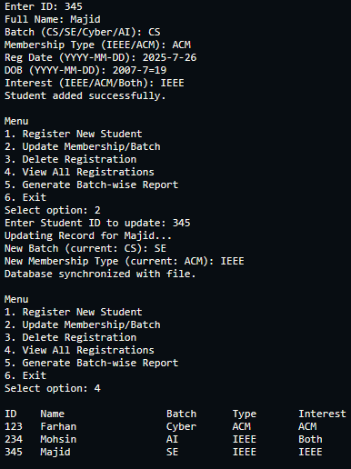
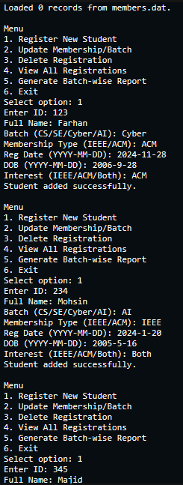

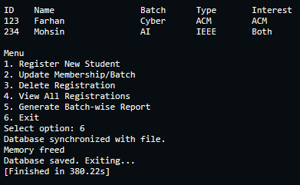
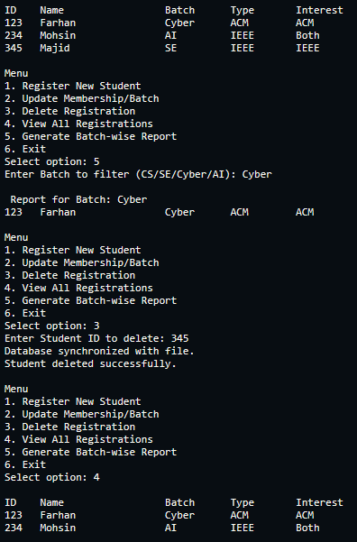

Explanation:
Again, there are a lot of comments in the code explaining the things as well alongside here.
So, this program works as a student registration manager that uses a dynamic array to handle records effectively. The system's main part is the Database structure, which doesn't store data directly but manages a pointer to the Student array. This setup allows the program to allocate memory on the heap using malloc and expand the list as needed, rather than being limited to a fixed size of 100 like in an array.
Inside the functions, the memory management happens automatically. For example, addStudent first checks if the current array is full. If it is, it uses realloc to double the capacity, ensuring there is always room for new students. When removing a student, deleteStudent finds the specific ID and uses a loop to shift all the following records one position to the left. This action effectively overwrites the deleted entry and fills the gap in the list without leaving empty spaces.
To ensure data is saved between sessions, the saveDatabase and loadDatabase functions handle binary file input and output. loadDatabase runs at the start of the program, reading the raw struct data from members.dat directly into the allocated memory to restore the previous session. saveDatabase is called whenever a change occurs, like adding, updating, or removing a student, to update the file with the current contents of memory, keeping the file and RAM in sync.

