Name: Muhammad Farhan

Roll no: 25K-0538

Section: BCS-2K

Course: Digital Logic Design
Course Instructor: Sir Ashir Mahboob

Exercise # 4
Create a 2-bit binary multiplier along with its truth table and multiply the number 11 and 11.
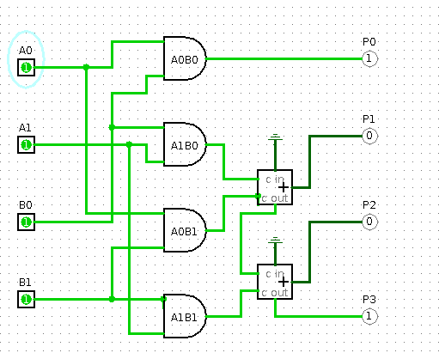

A1A0 | B1B0 | Decimal A | Decimal B | Decimal Product | Output
00 | 00 | 0 | 0 | 0 | 0000
00 | 01 | 0 | 1 | 0 | 0000
00 | 10 | 0 | 2 | 0 | 0000
00 | 11 | 0 | 3 | 0 | 0000
01 | 00 | 1 | 0 | 0 | 0000
01 | 01 | 1 | 1 | 1 | 0001
01 | 10 | 1 | 2 | 2 | 0010
01 | 11 | 1 | 3 | 3 | 0011
10 | 00 | 2 | 0 | 0 | 0000
10 | 01 | 2 | 1 | 2 | 0010
10 | 10 | 2 | 2 | 4 | 0100
10 | 11 | 2 | 3 | 6 | 0110
11 | 00 | 3 | 0 | 0 | 0000
11 | 01 | 3 | 1 | 3 | 0011
11 | 10 | 3 | 2 | 6 | 0110
11 | 11 | 3 | 3 | 9 | 1001

The multiplication of 11 x 11 is shown in the screenshot of the circuit.
Exercise # 5
Design 3*3 Bit Binary Multiplier Circuit in Logisim/Logic Works

OR

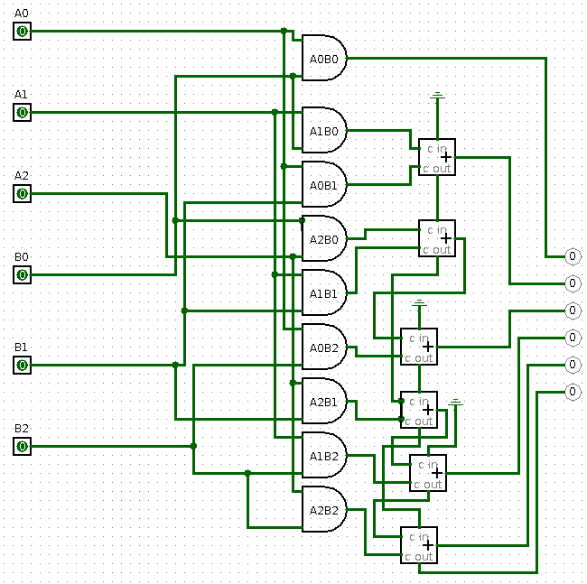
OR
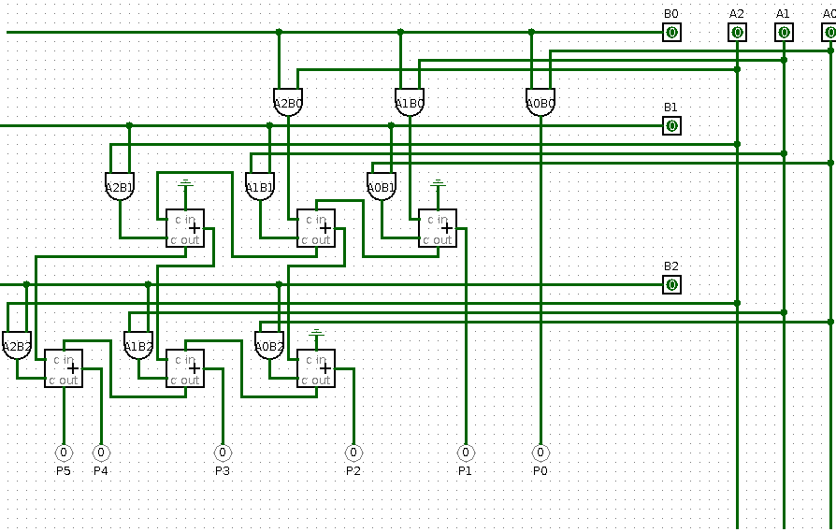

Exercise # 6
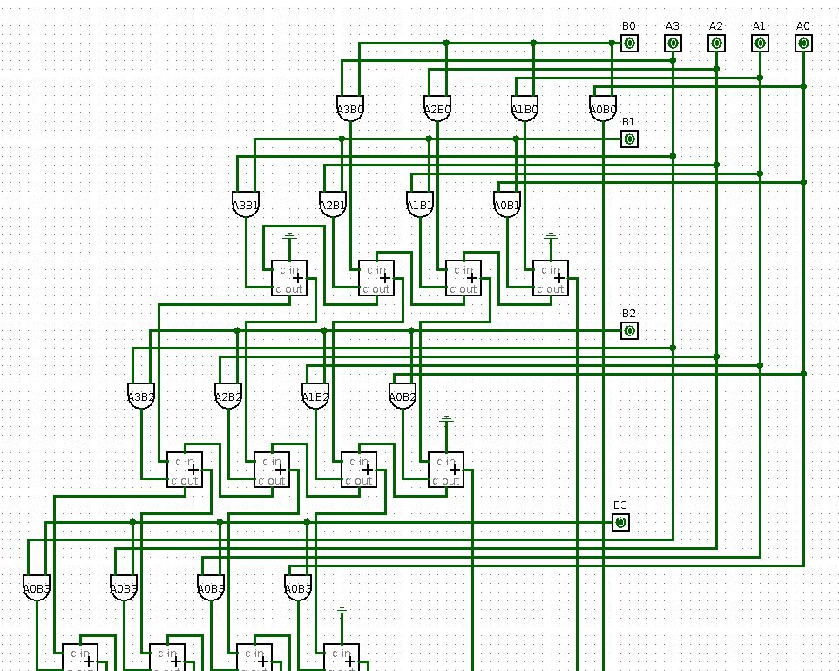
Design 4*4 Bit Binary Multiplier Circuit in Logic Works.
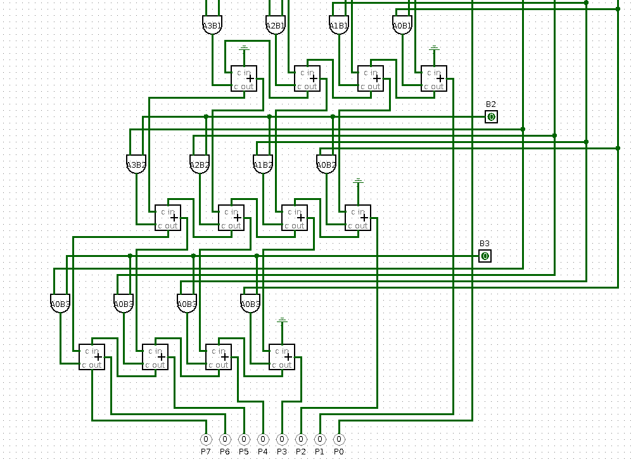
Part 1
Part 2

