PakWheels Car Marketplace System
OOP Assignment 2 Documentation
Student ID: 25K0538
Course: Object-Oriented Programming

Website Replication : PakWheels.com
This program replicates key features of the PakWheels vehicle marketplace (www.pakwheels.com). For each feature, the PakWheels website screenshot is shown first, followed by the corresponding code implementation and reasoning.

Feature 1: Vehicle Listings
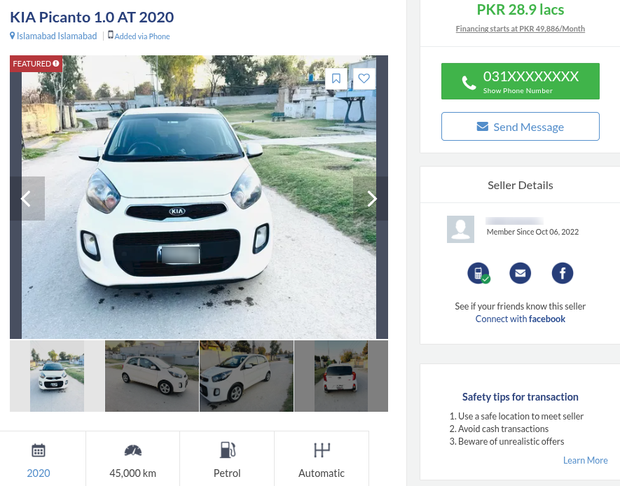

My Implementation: The AdListing class replicates a vehicle listing. It stores brand, model, year, price, and location as private members, linked to the seller who posted it.
// AdListing.h
string vehicleBrand;
string vehicleModel;
int vehicleYear;
double askingPrice;
string listingLocation;

// main, posting a new listing
ads[adCount] = new AdListing(currentSeller, price, loc, brand, model, year);
pakWheels.addListing(ads[adCount]);

Feature 2: Search & Filter

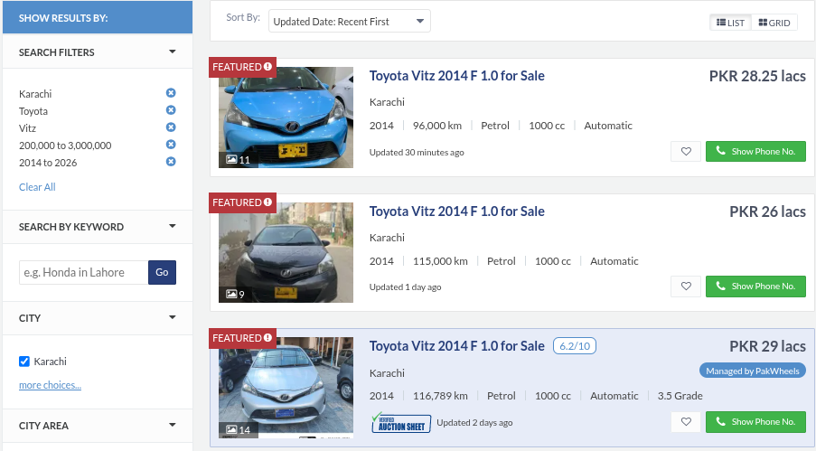

My Implementation: The Marketplace class provides searchByBrand(), filterByLocation(), filterByMaxPrice(), and filterByMinYear(). Looping through allListings[ ] and printing matches.
void Marketplace::searchByBrand(string brand)
{
for (int i = 0; i < listingCount; i++)
if (allListings[i]->getVehicleBrand() == brand)
// print listing details
}
void Marketplace::filterByMaxPrice(double maxPrice)
{
for (int i = 0; i < listingCount; i++)
if (allListings[i]->getAskingPrice() <= maxPrice)
// print listing details
}

Feature 3: Seller Profile

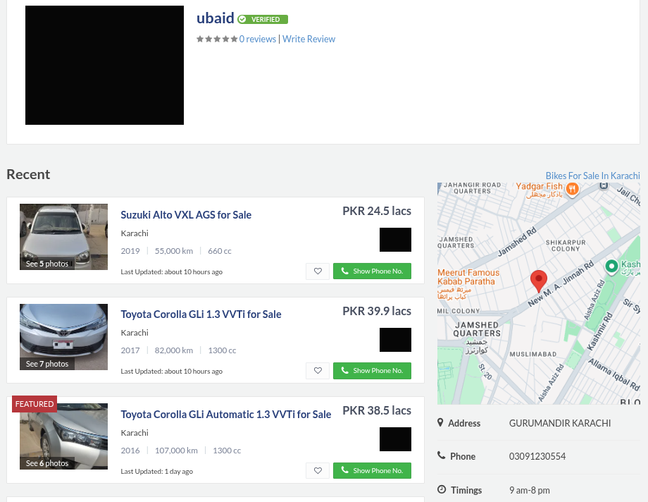

My Implementation: The Seller class stores name, contactNumber, locationAddress, and activeAdsCount. The count is maintained automatically by incrementing when an ad is posted and decrementing when sold.
// Seller.h
string name; string contactNumber;
string locationAddress; int activeAdsCount;

// AdListing.cpp — on posting
if (sellerref != nullptr) sellerref->incrementActiveAds();
// AdListing.cpp — on sold
if (sellerref != nullptr) sellerref->decrementActiveAds();

Feature 4: Saved / Favorite Listings

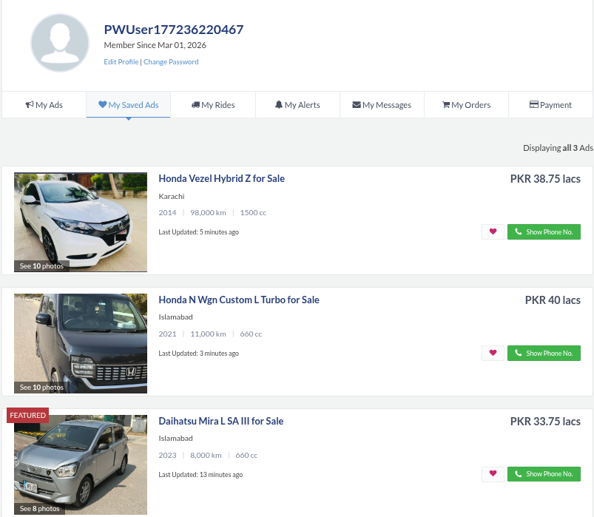

My Implementation: Buyer stores an array of AdListing pointers as favorites. Buyers can add, view, and remove listings from their favorites.
// Buyer.h
AdListing* favoriteAds[10]; // aggregation

// Buyer.cpp
void Buyer::addToFavorites(AdListing* ad)
{
if (favoriteCount >= 10) { cout << "List is full." << endl; return; }
favoriteAds[favoriteCount++] = ad;
cout << "Listing added to Favorites." << endl;
}

Feature 5: Buyer-Seller Messaging

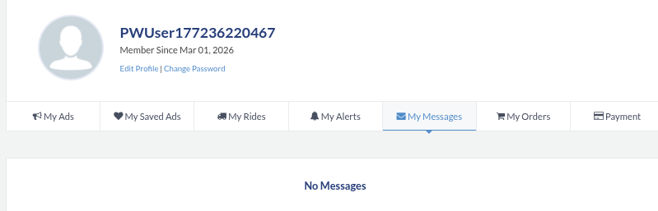

My Implementation: Buyers send full messages via draftMessage(). Sellers view their inbox and reply. Replies are routed to the correct buyer using getSenderIDByMessageID().
// Buyer.cpp
void Buyer::draftMessage(Seller* seller, string text)
{
Message* msg = new Message(buyerID, seller->getSellerID(), text, "Now");
seller->receiveMessage(msg);
}

// main — routing reply to correct buyer
int senderID = sellers[i]->getSenderIDByMessageID(mID);
Buyer* targetBuyer = nullptr;
for(int j = 0; j < bCount; j++)
if(buyers[j]->getBuyerID() == senderID)
targetBuyer = buyers[j];
sellers[i]->replyToMessage(mID, reply, targetBuyer);

Feature 6: Admin / Listing Moderation
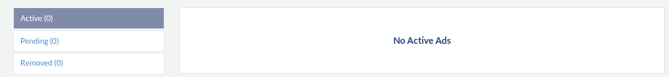

My Implementation: The Admin class can approve listings before they go live and forcefully remove any listing. A clearance level controls what actions are permitted.
void Admin::approveListing(AdListing& listing)
{
if (listing.getIsApproved()) { cout << "Already approved." << endl; return; }
listing.setIsApproved(true);
cout << "Listing approved by Admin " << username << endl;
actionsLogged++;
}
void Admin::removeListing(AdListing& listing)
{
listing.markAsSold();
cout << "Listing removed by Admin " << username << endl;
actionsLogged++;
}

Feature 7: Seller Reviews
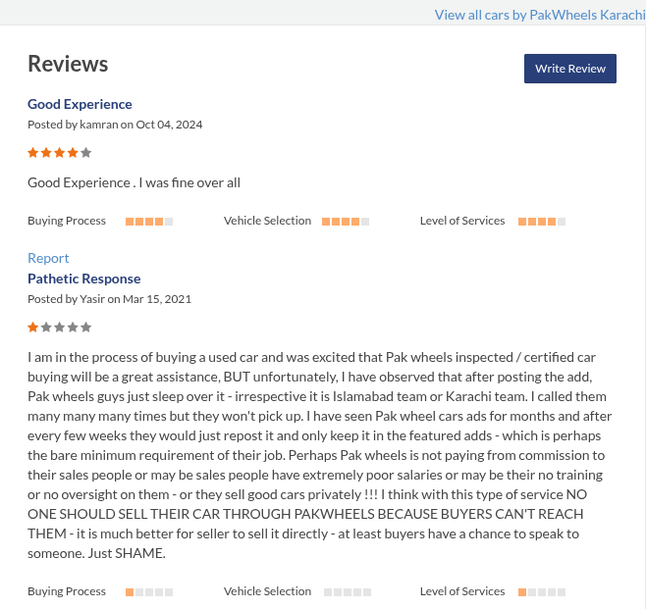


My Implementation: The Review class replicates buyer reviews for sellers. Buyers can leave a star rating and comment, reviews can be edited, flagged as inappropriate, and the Admin can review flagged content. Reviews are stored directly inside the Seller as a composition array.
// Review.h
int reviewID; int reviewerID; int targetSellerID;
int rating; string comment; bool isFlagged;

// Seller.h reviews stored directly inside Seller (composition)
Review reviews[10]; int reviewCount;

// Review.cpp flagging a review for Admin
void Review::flagAsInappropriate()
{ isFlagged = true; cout << "Review flagged for Admin review." << endl; }

// Admin.cpp reviewing flagged content
void Admin::reviewFlaggedContent(Review flaggedReview)
{
if (flaggedReview.getIsFlagged())
flaggedReview.displayReview();
}

1. Classes
The system implements 10 classes, each modelling a real world aspect/feature from the PakWheels platform. Every class has 5-6 private data members and at least 4 member functions beyond getters and setters.

1.1 VehicleCore
It stores the core technical specifications shared by all vehicle types. It is used as a composition member inside both Car and Bike, avoiding code duplication.
Data Members | brand, model, modelYear, mileage, chassisNumber (const), engineCC
Key Methods | calculateAge(), getConditionCategory(), displayCoreSpecs(), isLocallyManufactured()

1.2 Car
It represents a car listing. It composes a VehicleCore object for base specs and adds car specific attributes.
Data Members | baseSpecs (VehicleCore), transmission, hasSunroof, trunkCapacityLitres, assemblyType
Key Methods | generateListingTitle(), comparePerformance(), checkTaxStatus(), evaluateFamilySuitability()

1.3 Bike
It represents a motorcycle listing. It composes VehicleCore and adds bike specific fields.
Data Members | baseSpecs (VehicleCore), bikeType, dryWeightKg, hasDiscBrakes, coolingSystem
Key Methods | generateListingTitle(), requiresLicenseCategory(), calculatePowerToWeightRatio(), evaluateCommuterSuitability()

1.4 Seller
It represents a vehicle seller. It manages an inbox of messages (aggregation) and an object array of reviews (composition).
Data Members | sellerID (const), name, contactNumber, locationAddress, activeAdsCount, totalRegisteredSellers (static), inbox[10], inboxCount, reviews[10], reviewCount
Key Methods | determineSellerType(), canOfferFinancing(), receiveMessage(), replyToMessage(), getSenderIDByMessageID()

1.5 Buyer
It represents a buyer. It stores favorite ads and an inbox of received messages.
Data Members | buyerID (const), name, phoneNumber, joinDate, favoriteAds[10], favoriteCount, totalRegisteredBuyers (static), inbox[10], inboxCount
Key Methods | addToFavorites(), removeFromFavorites(), displayFavorites(), draftMessage(), receiveMessage(), viewInbox()

1.6 AdListing
It is the central feature/class, an advertisement posted by a seller. It holds a seller pointer (aggregation) and tracks vehicle details, price, and approval status.
Data Members | listingID (const), sellerRef (Seller*), askingPrice, postDate, listingLocation, isSold, totalActiveListings (static), vehicleBrand, vehicleModel, isApproved, vehicleYear
Key Methods | updatePrice(), markAsSold(), bumpListing(), applyDiscount(), comparePrice()

1.7 Message
It represents a message between buyer and seller.
Data Members | messageID, senderID, receiverID, content, timestamp, isRead, totalMessages (static)
Key Methods | markAsRead(), getPreview(), calculateTimeSinceSent(), formatMessageThread()

1.8 Review
A buyer review left for a seller. It supports flagging for Admin’s attention.
Data Members | reviewID, reviewerID, targetSellerID, rating, comment, isFlagged, totalReviews (static)
Key Methods | editReview(), validateRating(), displayReview(), flagAsInappropriate()

1.9 Admin
Platform administrator. It can approve/remove listings, ban users, and generate reports.
Data Members | adminID, username, clearanceLevel, actionsLogged, systemUpTime
Key Methods | reviewFlaggedContent(), banUser(), generateSystemReport(), approveListing(), removeListing()

1.10 Marketplace
It is the top level container. It holds arrays of listings, buyers, and sellers and provides all search/filter functionality.
Data Members | systemName, allListings[50], registeredBuyers[50], registeredSellers[50], platformAdmin (const Admin*), maxCapacity, listingCount, buyerCount, sellerCount
Key Methods | searchByBrand(), filterByLocation(), filterByMaxPrice(), filterByMinYear(), verifyAndApplyPromo(), displayMarketplaceRules() (static)

2. Constructors, Setters & Getters
Every class uses default and parameterized constructors. Copy constructors are used where objects are passed or returned by value. Constructor overloading is used in AdListing for featured listings.

2.1 Default Constructors
Its used to create placeholder or empty objects. Its necessary for declaring arrays of objects (e.g. Review reviews[10] inside Seller). Example from Seller:
Seller::Seller()
: sellerID(totalRegisteredSellers++), name("Unknown"),
contactNumber("None"), locationAddress("N/A"),
activeAdsCount(0), inboxCount(0), reviewCount(0)
{ for (int i = 0; i < 10; ++i) inbox[i] = nullptr; }

2.2 Parameterized Constructors
Its used to create fully initialized objects. The AdListing constructor immediately links the listing to its seller and increments their active ad count:
AdListing::AdListing(Seller* s, double a, string LL, string brand, string model, int year)
: listingID(totalActiveListings++), sellerref(s), askingPrice(a),
postDate("Pending"), listingLocation(LL), isSold(false),
vehicleBrand(brand), vehicleModel(model), isApproved(false), vehicleYear(year)
{
if (sellerref != nullptr) sellerref->incrementActiveAds();
}

2.3 Copy Constructors
Its used in Car, Bike, and VehicleCore since these are returned by value from getters. VehicleCore requires an explicit copy constructor because it has a const member (chassisNumber):
VehicleCore::VehicleCore(const VehicleCore& other)
: brand(other.brand), model(other.model), modelYear(other.modelYear),
mileage(other.mileage), chassisNumber(other.chassisNumber), engineCC(other.engineCC)
{}

2.4 Constructor Overloading: AdListing
AdListing has a third constructor for featured listings that immediately bumps the listing date, avoiding a separate method call after construction:
AdListing::AdListing(Seller* s, double a, string LL,
string brand, string model, int year, bool isFeatured)
{
if (sellerref != nullptr) sellerref->incrementActiveAds();
if (isFeatured) bumpListing("Today");
}

2.5 Setters and Getters
- Seller has setNumber() and setAddress() because contact info can legitimately change.
- Car has no setters because vehicle specs cannot change once posted as an ad.
- AdListing has setIsApproved() for Admin use only. Price changes go through updatePrice() which includes validation.
- Const members (listingID, buyerID, sellerID) have only getters because they must never change.

3. Constants & Constant Functions

3.1 Constant Data Members
AdListing::listingID | const int → a listing ID must never change once assigned.
Seller::sellerID | const int → a seller's identity is fixed at registration.
Buyer::buyerID | const int → same reasoning as sellerID.
VehicleCore::chassisNumber | const string → a chassis number is a permanent physical identifier.
Marketplace::platformAdmin | const Admin* → the admin pointer should not be reassigned after platform creation.

3.2 Constant Member Functions
All getter functions and any function that only reads data are marked as const. This prevents accidental modification and allows them to be called on const objects:
int getListingID() const;
int getSellerID() const;
string getName() const;
int calculateAge(int currentYear) const;
void displayCoreSpecs() const;
int getSenderIDByMessageID(int messageID) const;

4. Static Members

4.1 Static Data Members
AdListing::totalActiveListings | Platform wide count of active listings. Incremented in constructors, decremented in markAsSold().
Seller::totalRegisteredSellers | Platform wide seller count. Used to assign unique sequential IDs.
Buyer::totalRegisteredBuyers | Same reasoning as totalRegisteredSellers.
Message::totalMessages | Platform wide message count for ID assignment.
Review::totalReviews | Platform wide review count for ID assignment.

4.2 Why Static?
As we know, a static variable declared is used for the entire class. Hence it is used to efficiently track the number of ads and buyers and sellers, as well as being efficient in loops to avoid unnecessary iterations or hardcoding.

4.3 Static Member Functions
static int getTotalActiveListings(); // AdListing
static int getTotalRegisteredSellers(); // Seller
static int getTotalRegisteredBuyers(); // Buyer
static int getTotalMessages(); // Message
static int getTotalReviews(); // Review
static void displayMarketplaceRules(); // Marketplace
displayMarketplaceRules() is static because it prints fixed platform rules that have nothing to do with any specific Marketplace instance, no object is needed to call it.

5. Composition and Aggregation

5.1 Composition
The contained object's lifetime is tied to the outer class. It is stored directly inside and destroyed when the outer class is destroyed.

Car / Bike → VehicleCore
Both classes store VehicleCore as a direct member. It is created with the Car/Bike and destroyed with it. A car's specs cannot exist without the car itself.
class Car {private: VehicleCore baseSpecs;};
class Bike {private: VehicleCore baseSpecs;};

Seller → Review
Reviews are stored as a direct array of objects inside Seller, not pointers. They live and die with the Seller.
class Seller { private: Review reviews[10];};

5.2 Aggregation
The class holds a pointer to an object created and managed independently. The outer class does not own it.

AdListing → Seller
class AdListing {private: Seller* sellerref;};
The Seller was created independently in main(). Deleting an AdListing does not delete the Seller.

Buyer → AdListing (Favorites)
class Buyer {private: AdListing* favoriteAds[10];};
The listings exist on the platform independently. The Buyer simply holds references to them.

Seller / Buyer → Message (Inbox)
class Seller {private: Message* inbox[10];};
class Buyer {private: Message* inbox[10];};

Marketplace → Admin
class Marketplace {private: const Admin* platformAdmin;};
//aggregation+ const
The Admin is created in main() and its address passed to the Marketplace. The Marketplace uses it but does not own it.

6. Array of Objects

6.1 Seller : Review reviews[10]
Each Seller stores up to 10 Review objects directly. Reviews are value copied into the array when added. Reasoning: Reviews belong to and are always accessed through the seller, so direct composition is appropriate.
Review reviews[10]; int reviewCount;

void Seller::addReview(Review r)
{
if (reviewCount >= 10) { cout << "Review limit reached." << endl; return; }
reviews[reviewCount++] = r;
}

6.2 Main : sellers[], buyers[], ads[]
Pointer arrays in main() manage all registered objects across the session. Reasoning: Pointer arrays avoid object slicing and allow the same heap objects to be referenced from multiple places (Marketplace, Buyer favorites, AdListing) without copying.
Seller* sellers[50];
Buyer* buyers[50];
AdListing* ads[100];

7. Functionality Summary

7.1 Add, Update, Delete Listings
- Sellers post new vehicle ads through the Seller Panel.
- Sellers update the asking price of any listing by ID.
- Admin can forcefully remove any listing via removeListing().

7.2 Search & Filter
- Search by Brand → exact match on vehicleBrand.
- Filter by Location → exact match on listingLocation.
- Filter by Max Price → all listings at or below the entered price.
- Filter by Minimum Year → all listings from that year onwards.

7.3 Buyer Favorites
- Buyers add any listing to their favorites (up to 10).
- Buyers view saved favorites with full details.
- Buyers remove a listing with feedback on success or failure.

7.4 Messaging
- Buyers send full messages (with spaces) to any seller.
- Sellers view their inbox and reply to any message by ID.
- Replies route to the correct buyer using getSenderIDByMessageID().
- Buyers view their inbox to see seller replies.

7.5 Admin Controls
- Admin views a system report → active listings, total buyers, total sellers.
- Admin approves any pending listing by ID.
- Admin forcefully removes any listing by ID.

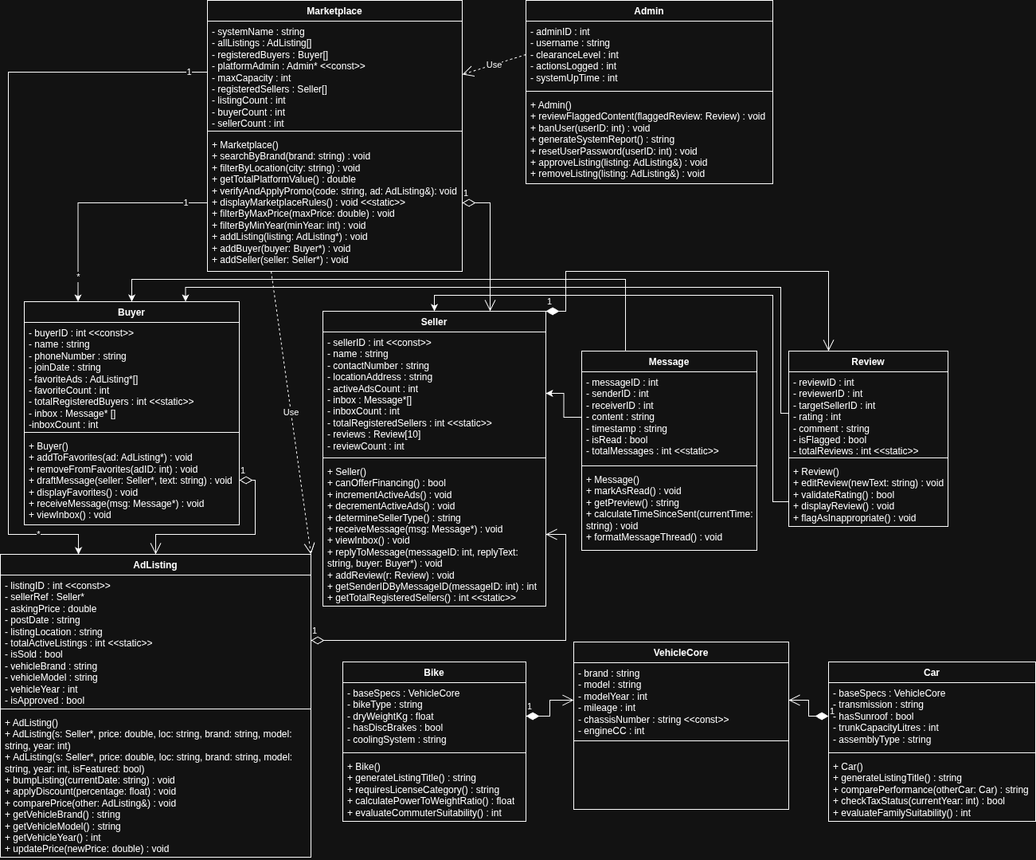
8. Class Diagram
The entire Class Diagram is created on the website: Draw.io
The full .PNG file of the Class Diagram will be included alongside the Submission.

