Name: Muhammad Farhan
Roll no: 25K-0538
Section: BCS-2K
Date: 21/01/2026
OOP Lab
Instructor: Miss Gule Zehra.

Lab Task 1:
#include <iostream>
using namespace std;

int main()
{
int n, m;
cout << "enter size of first array:" << endl;
cin >> n;
cout << "enter size of second array:" << endl;
cin >> m;

int* array1 = new int[n];
int* array2 = new int[m];
for (int i = 0; i < n; i++)
{
cout << "enter "<<i+1<< " element of first array"<<endl;
cin >> array1[i];
}
for (int i = 0; i < m; i++)
{
cout << "enter "<<i+1<< " element of second array"<<endl;
cin >> array2[i];
}
int v;
if (n<m)
{
v=m;
}
else
{
v=n;
}
int* final = new int[v];

int k=0;
for (int i=0;i<n;i++)
{
for (int j=0; j<m; j++)
{
if (array1[i]==array2[j])
{
final[k]= array1[i];
k++;
array2[j]=999;
break;
}

}
}
int temp;
for (int i=0;i<k-1;i++)
{
for (int j=0;j<k-i-1;j++)
{
if (final[j]>final[j+1])
{
temp = final[j];
final[j] = final[j+1];
final[j+1] = temp;
}
}
}
for (int i = 0; i < k; i++)
{
cout << final[i] << " ";
}
delete array1;
delete array2;
delete final;
}

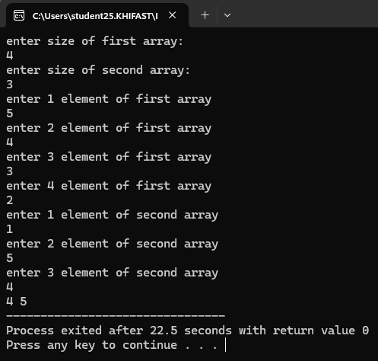

Lab Task 2:
#include <iostream>
using namespace std;

struct employee
{
int ID;
string name;
int salary;
};

int main()
{
struct employee emp[3];
int highest=0;

for(int i=0; i<3; i++)
{
cout << "Enter ID of employee#" << i+1 << endl;
cin >> emp[i].ID;
cout << "Enter name of employee#" << i+1 << endl;
cin >> emp[i].name;
cout << "Enter Salary of employee#" << i+1 << endl;
cin >> emp[i].salary;
if (highest < emp[i].salary)
{
highest = emp[i].salary;
}
}
for (int i=0; i<3; i++)
{
if (highest == emp[i].salary)
{
cout << "Employee#" << i+1 <<" has the highest salary." << endl;
cout << "ID: " << emp[i].ID << endl;
cout << "Name: " << emp[i].name << endl;
cout << "Salary: " << highest << endl;
}
}
}
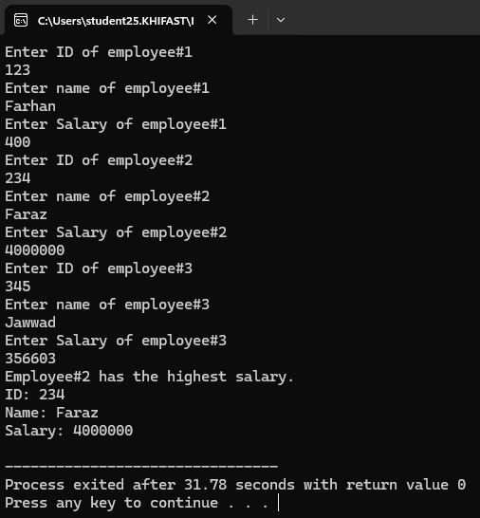

Lab Task 3:
#include <iostream>
using namespace std;

int main()
{
int n, m;
cout << "enter size of first array:" << endl;
cin >> n;
cout << "enter size of second array:" << endl;
cin >> m;

int* array1 = new int[n];
int* array2 = new int[m];

for (int i = 0; i < n; i++)
{
cout << "enter "<<i+1<< " element of first array"<<endl;
cin >> array1[i];
}
for (int i = 0; i < m; i++)
{
cout << "enter "<<i+1<< " element of second array"<<endl;
cin >> array2[i];
}

int k=0;
for (int i=0;i<m;i++)
{
for (int j=0; j<n; j++)
{
if (array2[i]==array1[j])
{
k++;
break;
}
}
}
if (k==m)
{
cout <<"True"<<endl;
}
else
{
cout << "False" << endl;
}
delete array1;
delete array2;
}

