Name: Muhammad Farhan
Roll no: 25K-0538
Section: BCS-2K
OOP Lab 2 Tasks

Task 1:
#include <iostream>
#include <string>
using namespace std;
void inputValue(struct BaseBall player[]);
void getValue(struct BaseBall player[]);
void search(struct BaseBall player[]);

struct BaseBall
{
string name;
int runs;
int hits;
};

int main()
{
struct BaseBall player[3];
int choice;
do
{
cout << "1. Enter Player Data."<<endl;
cout << "2. Show Player Data."<<endl;
cout << "3. Search Player and Update"<<endl;
cout << "4. Exit Program."<<endl;
cout << "Enter your choice:"<<endl;
cin >> choice;

switch(choice)
{
case 1:
inputValue(player);
break;

case 2:
getValue(player);
break;

case 3:
search(player);
break;

case 4:
break;
}

} while(choice!=4);

return 0;
}

void inputValue(BaseBall player[])
{
for(int i=0;i<3;i++)
{
cout << "Enter Player "<<i+1<< " Data"<< endl;
cout <<"Enter Player Name:";
cin >>player[i].name;
cout <<"Enter Number of Home Runs:";
cin >>player[i].runs;
cout <<"Enter Number of Hits:";
cin >>player[i].hits;
cout << endl;
}
}

void getValue(BaseBall player[])
{
for(int i=0;i<3;i++)
{
cout << "Player "<<i+1<< " Data"<< endl << endl;
cout <<"Name: "<< player[i].name<<endl;
cout <<"Home Runs: "<< player[i].runs<<endl;
cout <<"Hits: "<< player[i].hits<<endl<<endl;
}
}

void search(BaseBall player[])
{
string namo;
int flag=0;
int choice;
int i=0;
cout << "Enter player name to search: " <<endl;
cin >> namo;
for(i=0; i<3; i++)
{
if(namo == player[i].name)
{
cout << "Player "<<i+1<< " Data"<< endl << endl;
cout <<"Name: "<< player[i].name<<endl;
cout <<"Home Runs: "<< player[i].runs<<endl;
cout <<"Hits: "<< player[i].hits<<endl;
cout<<endl;
flag=1;
break;
}
}
if (flag=0)
{
cout <<"Player not found."<< endl << endl;
}
do
{
cout << "1. Update Player Data."<<endl;
cout << "2. Return to main menu."<<endl;
cout << "Enter your choice:"<<endl;
cin >> choice;
switch (choice)
{
case 1:
cout <<"Enter Player Name:";
cin >>player[i].name;
cout <<"Enter Number of Home Runs:";
cin >>player[i].runs;
cout <<"Enter Number of Hits:";
cin >>player[i].hits;
cout<<endl;
return;

case 2:
break;
}
}while(choice!=2);
}
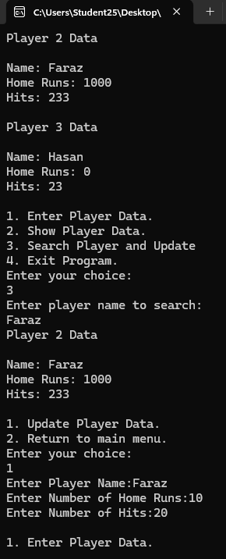
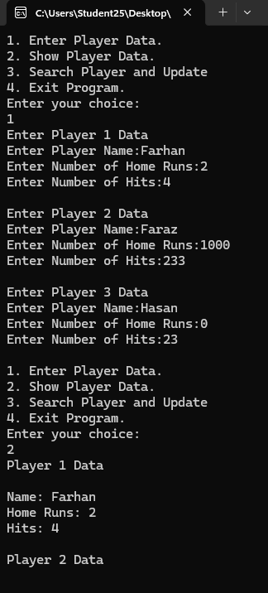
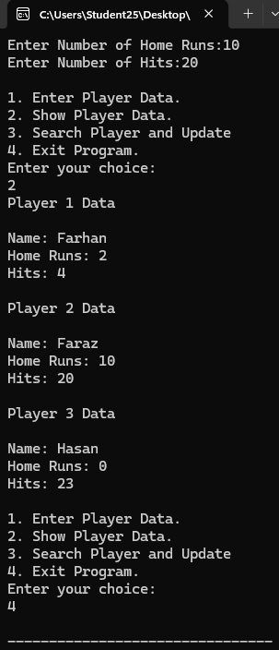

Task 2:
#include <iostream>
#include <string>
using namespace std;

class Date
{
string months[12] = {"January", "Febuary", "March", "April", "May", "June", "July", "August", "September", "October", "November", "December"};
int date, month, year;
public:
Date(int d, int m, int y)
{
if (d>=1 && d<=31)
date=d;
else
{
cout<< "Invalid date, default value of Date Assigned."<< endl<< endl;
date=30;
}

if (m>=1 && m<=12)
month=m;
else
{
cout<< "Invalid month, default value of Month Assigned."<< endl<< endl;
month=1;
}

if (y>=0)
year=y;
else
{
cout<< "Invalid year, default value of Year Assigned."<< endl<< endl;
year=2026;
}

}

void formatOne()
{
cout << month << "/" << date << "/" << year%100<< endl;
}

void formatTwo()
{
cout << months[month-1] <<" "<< date<<", "<<year <<endl;
}

void formatThree()
{
cout << date<< " "<< months[month-1]<< " " << year<<endl;
}
};

int main()
{
Date bolo1(5, -2, 2030), bolo2(0, 0, -4300);
bolo1.formatOne();
bolo1.formatTwo();
bolo1.formatThree();

bolo2.formatOne();
bolo2.formatTwo();
bolo2.formatThree();

Date
Int Date
Int Month
Int Year
String months
FormatOne()
FormatTwo()
FormatThree()
return 0;
}
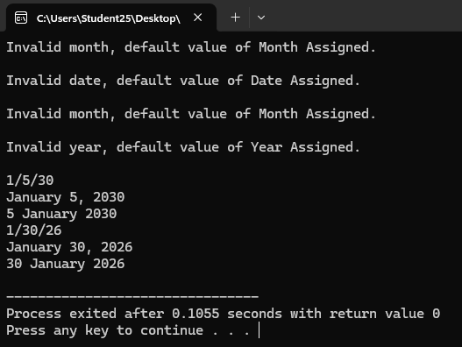
Task 3:
#include <iostream>
#include <string>
using namespace std;

class Person
{
string name;
int age;
bool male;
string occupation;
bool cook;

public:
void setName(string namo)
{
name = namo;
}
void setAge(int ageo)
{
age = ageo;
}
void setMale(bool gender)
{
male = gender;
}
void setOccupation(string occu)
{
occupation = occu;
}
void setCook(bool cooker)
{
cook = cooker;
}

string getName()
{
return name;
}
int getAge()
{
return age;
}
bool getMale()
{
return male;
}
string getOccupation()
{
return occupation;
}
bool getCook()
{
return cook;
}
};

int main()
{
Person p1, p2;
p1.setName("Farhan");
p1.setAge(19);
p1.setMale(true);
p1.setOccupation("Student");
p1.setCook(false);

cout << p1.getName()<< endl;
cout << p1.getAge()<< endl;
cout << p1.getMale()<< endl;
cout << p1.getOccupation()<< endl;
cout << p1.getCook()<< endl<<endl;

p2.setName("Ayeshia");
p2.setAge(20);
p2.setMale(false);
p2.setOccupation("Student");
p2.setCook(true);

cout << p2.getName()<< endl;
cout << p2.getAge()<< endl;
cout << p2.getMale()<< endl;
cout << p2.getOccupation()<< endl;
cout << p2.getCook()<< endl;

return 0;
}
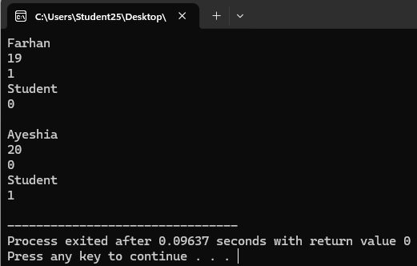

Person
String Name
Int Age
bool Male
String occupation
boolcook
setName(string namo)
setAge(int ageo)
setMale(bool gender)
setOccupation(string occu)
setCook(bool cooker)
getName()
getAge()
getMale()
getOccupation()
getCook()

