Name: Muhammad Farhan
Roll no: 25k-0538
Lab 3 Lab tasks

Lab Task 1:
#include <iostream>
#include <string>
using namespace std;

class Employee
{
string name;
int idNumber;
string department;
string position;

public:
Employee():name(""), idNumber(0), department(""), position("") {}

Employee(string n, int num, string dep, string pos):name(n), idNumber(num), department(dep), position(pos) {}

~Employee()
{
cout << "I am Destructor"<<endl;
}
void setName(string nam)
{
name = nam;
}
void setidNumber(int num)
{
idNumber = num;
}
void setDepartment(string dep)
{
department = dep;
}
void setPosition(string pos)
{
position = pos;
}

string getName()
{
return name;
}
int getidNumber()
{
return idNumber;
}
string getDepartment()
{
return department;
}
string getPosition()
{
return position;
}

};

int main()
{
Employee emp1,emp2,emp3("Farhan", 538, "Computer Science", "Student");

cout << "Employee#1:"<< endl;
cout << "Name: " << emp1.getName()<<endl;
cout << "ID Number: " << emp1.getidNumber()<<endl;
cout << "Department: " << emp1.getDepartment()<<endl;
cout << "Position: " << emp1.getPosition()<<endl;
cout <<endl;

cout << "Employee#2:"<< endl;
cout << "Name: " << emp2.getName()<<endl;
cout << "ID Number: " << emp2.getidNumber()<<endl;
cout << "Department: " << emp2.getDepartment()<<endl;
cout << "Position: " << emp2.getPosition()<<endl;
cout <<endl;

cout << "Employee#3:"<< endl;
cout << "Name: " << emp3.getName()<<endl;
cout << "ID Number: " << emp3.getidNumber()<<endl;
cout << "Department: " << emp3.getDepartment()<<endl;
cout << "Position: " << emp3.getPosition()<<endl;
cout <<endl;

emp1.setName("Faraz");
emp1.setidNumber(780);
emp1.setDepartment("Data Science");
emp1.setPosition("Deen");

emp2.setName("Shoaib");
emp2.setidNumber(973);
emp2.setDepartment("FinTech");
emp2.setPosition("Lecturer");

cout << "Employee#1:"<< endl;
cout << "Name: " << emp1.getName()<<endl;
cout << "ID Number: " << emp1.getidNumber()<<endl;
cout << "Department: " << emp1.getDepartment()<<endl;
cout << "Position: " << emp1.getPosition()<<endl;
cout <<endl;

cout << "Employee#2:"<< endl;
cout << "Name: " << emp2.getName()<<endl;
cout << "ID Number: " << emp2.getidNumber()<<endl;
cout << "Department: " << emp2.getDepartment()<<endl;
cout << "Position: " << emp2.getPosition()<<endl;
cout <<endl;

cout << "Employee#3:"<< endl;
cout << "Name: " << emp3.getName()<<endl;
cout << "ID Number: " << emp3.getidNumber()<<endl;
cout << "Department: " << emp3.getDepartment()<<endl;
cout << "Position: " << emp3.getPosition()<<endl;
cout <<endl;

return 0;
}
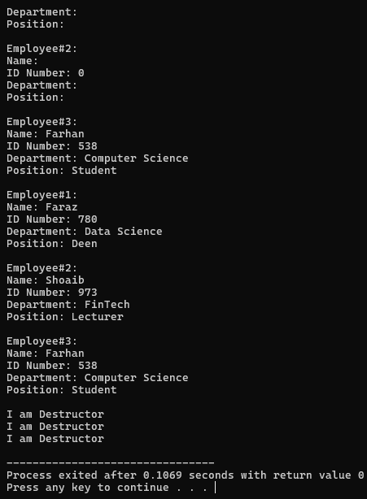

Employee
string name
int idNumber
string department
string position
setName()
setidNumber()
setDepartment()
setPosition()
getName()
getidNumber()
getDepartment()
getPosition()

LabTask 2:
#include <iostream>
#include <string>
using namespace std;

class Student
{
string stdID, stdName, dept;
public:
Student(): stdID(""), stdName(""), dept("") {}

Student(string ido, string nam): stdID(ido), stdName(nam) {}

Student(string ido, string nam, string dep)
:stdID(ido), stdName(nam), dept(dep) {}

Student(string nam, string dep, bool dummy)
:stdName(nam), dept(dep) {}

void setData()
{
cout << "--- User Input for Student ---" << endl;
cout << "Enter ID: ";
cin >> this->stdID;
cout << "Enter Name: ";
cin >> this->stdName;
cout << "Enter Dept: ";
cin >> this->dept;
}

void displayData()
{
cout << "--- Student Record ---" << endl;
cout << "ID: " << this->stdID << endl;
cout << "Name: " << this->stdName << endl;
cout << "Dept: " << this->dept << endl;
cout << "----------------------" << endl;
cout <<endl;
}
~Student()
{
cout << "Destructor called for Student: " << this->stdName << endl;
}
};

int main()
{
//local objects
Student obj1, obj2("12345", "Ali Hassan"), obj3("23456", "Sheeraz Depp", "Computer Science");
Student obj4(obj3);
//dynamic objects
Student* s1= new Student("111", "Riley Victoria", "FinTech");
Student* s2= new Student("222", "Alex Wilson", "Electrical Engineering");
Student* s3= new Student("333", "Erika", "Accounting and Finance");

//displaying everything
obj1.displayData();
obj2.displayData();
obj3.displayData();
obj4.displayData();

s1->displayData();
s2->displayData();
s3->displayData();

obj1.setData();
obj1.displayData();

//calling destructors
delete s1;
delete s2;
delete s3;
obj1.~Student();
obj2.~Student();
obj3.~Student();
obj4.~Student();

return 0;
}

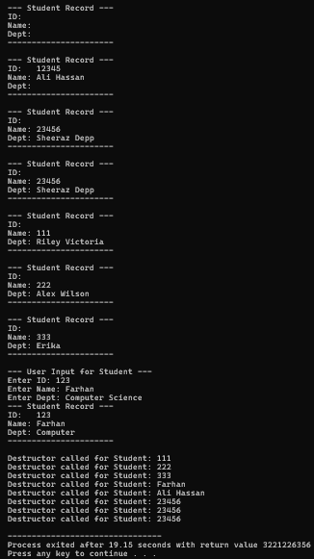

LabTask 3:
#include <iostream>
#include <cstring>
using namespace std;

class StudentRecord
{
int rollNo;
char* name;
float gpa;

public:

StudentRecord()
{
rollNo=0;
gpa = 0.0;
name = new char[20];
strcpy(name, "Unknown");
}
StudentRecord(int rollNo, float gpa, const char* name)
{
int len=strlen(name);
this->name = new char[len+1];
strcpy(this->name, name);
this->rollNo = rollNo;
this->gpa=gpa;
}

StudentRecord(const StudentRecord &cop)
{
int len=strlen(cop.name);
this->name = new char[len + 1];
strcpy(this->name, cop.name);
rollNo = cop.rollNo;
gpa = cop.gpa;
}

~StudentRecord() {
delete[] name;
}

void displayData()
{
cout << "Roll Number: " << rollNo << endl;
cout << "Name: " << name << endl;
cout << "GPA: " << gpa << endl;
}

void inputData()
{
char temp[100];
cout << "Enter Name: ";
cin >> temp;
delete[] this->name;
this->name = new char[strlen(temp) + 1];
strcpy(this->name, temp);
cout << "Enter Roll No and GPA: ";
cin >> rollNo >> gpa;
}

};

int main()
{
StudentRecord* obj[3];

obj[0] = new StudentRecord();

obj[1] = new StudentRecord(123, 3.3, "Farhan");

obj[2] = new StudentRecord(*obj[1]);

obj[2]->inputData();

for(int i = 0; i < 3; i++)
{
obj[i]->displayData();
}

for(int i = 0; i < 3; i++)
{
delete obj[i];
}

return 0;
}
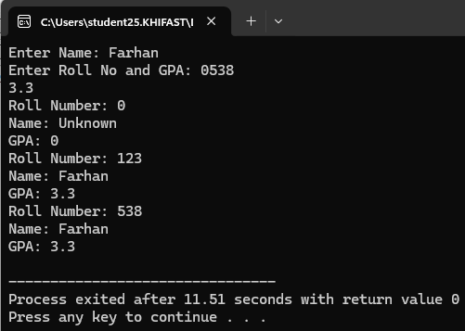

#include <iostream>
using namespace std;

class TicTacToe {
private:
int board[3][3];

public:
TicTacToe() {
for(int i=0;i<3;i++)
for(int j=0;j<3;j++)
board[i][j] = 0;
}

void displayBoard() {
cout << "\nBoard:\n";
for(int i=0;i<3;i++){
for(int j=0;j<3;j++){
char c = (board[i][j]==0)?' ': (board[i][j]==1)?'X':'O';
cout << c;
if(j<2) cout << " | ";
}
cout << "\n";
if(i<2) cout << "--+---+--\n";
}
}

bool makeMove(int player, int row, int col) {
if(row<0 || row>2 || col<0 || col>2 || board[row][col]!=0){
cout << "Invalid move. Try again.\n";
return false;
}
board[row][col] = player;
return true;
}

int checkWin() {
// rows columns
for(int i=0;i<3;i++){
if(board[i][0]==board[i][1] && board[i][1]==board[i][2] && board[i][0]!=0)
return board[i][0];
if(board[0][i]==board[1][i] && board[1][i]==board[2][i] && board[0][i]!=0)
return board[0][i];
}
// diagonal
if(board[0][0]==board[1][1] && board[1][1]==board[2][2] && board[0][0]!=0)
return board[0][0];
if(board[0][2]==board[1][1] && board[1][1]==board[2][0] && board[0][2]!=0)
return board[0][2];
// checking draw or not
for(int i=0;i<3;i++)
for(int j=0;j<3;j++)
if(board[i][j]==0) return 0; // game continues
return -1; // draw
}
};

int main() {
TicTacToe game;
int player = 1, row, col, status = 0;

cout << "Tic-Tac-Toe Game\nPlayer 1 = X, Player 2 = O\n";

while(status==0){
game.displayBoard();
cout << "Player " << player << ", enter row and column (0-2): ";
cin >> row >> col;
if(game.makeMove(player,row,col)){
status = game.checkWin();
if(status==0)
player = (player==1)?2:1;
}
}

game.displayBoard();
if(status==1) cout << "Player 1 wins.\n";
else if(status==2) cout << "Player 2 wins.\n";
else cout << "It's a draw.\n";

return 0;
}
