Name: Muhammad Farhan
Roll no: 25K-0538
Section: BCS-3K
Course: Data Structures – Lab
Course Instructor: Miss Fatima Gado
Lab: Lab 4
Date of Lab: 07/09/2026
Date of Task 1 Submission: 07/09/2026 (during Lab)
Date of Task 2-5 Submission: 12/09/2026

Note: I will only include the screenshots of the codes here. The actual codes are way too long to add in this document. Therefore, I will include the .cpp files, as well as my Github with all the codes uploaded.
Task 1:

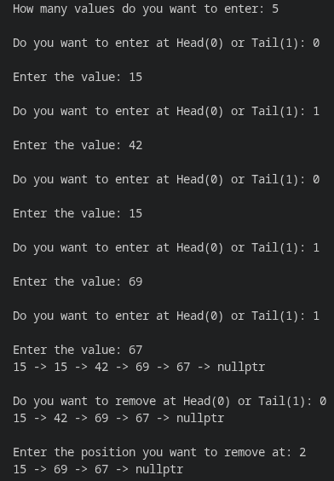

Task 2:
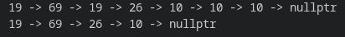

Task 3:

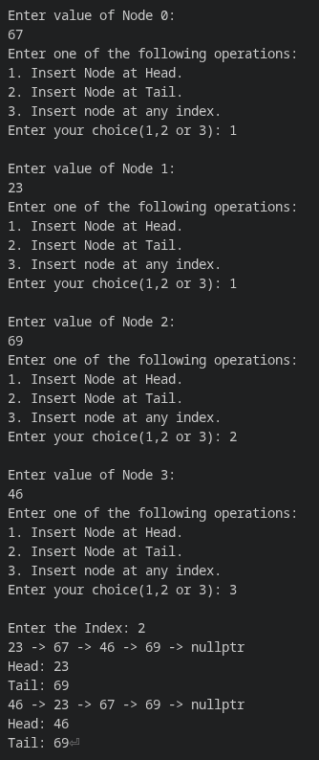

Task 4:

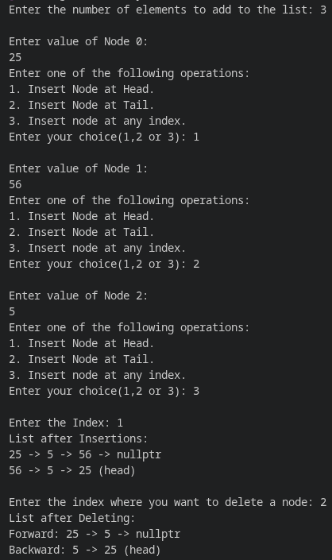

Task 5:
