Name: Muhammad Farhan
Roll no: 25K-0538
Section: BCS-3K
Course: Computer Organization & Assembly Langauge – Lab
Course Instructor: Ms. Fareeha Jabeen
Date: 08/09/2026

Task 1:
INCLUDE Irvine32.inc

.data
myName BYTE "Farhan", 0 ;using BYTE because BYTE is 8 bits, and my name is 6 bits
roll BYTE 38 ;BYTE works for double digits
age BYTE 19
CGPA REAL4 3.58 ;REAL4 for floating point

.code
main PROC
CALL DumpRegs ;just for checking

exit
main ENDP
END main

Task 2:

INCLUDE Irvine32.inc

.data
myName BYTE "Facharn", 0 ;using BYTE because BYTE is 8 bits, and my name is 6 bits
roll BYTE 38 ;BYTE works for double digits
age
CGPA REAL4 3.58 ;REAL4 for floating point

.code
main PROC

MOV EAX, 13h ;18 = 13h in hexa
MOV EBX, 1001b ;random binary

CALL DumpRegs ;

exit
main ENDP
END main

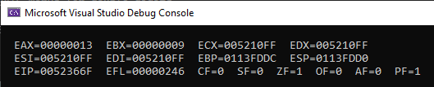

Task 3:

INCLUDE Irvine32.inc
COMMENT*
Name: Muhammad Farhan
Roll no: 25K-0538
The task is to show and practice how the comments work,
reasoning for which data type to use and when.
its fun.
*

.data
rolly WORD 0538 ;WORD because 538 is too big for BYTE
phoney DWORD 1234567 ; DWORD because phone number needs more space
namae BYTE "Farhano", 0 ;string is stored in BYTE regardless of size i believe

.code
main PROC

exit
main ENDP
END main

Task 4:

INCLUDE Irvine32.inc

.data

.code
main PROC

mov EAX, 25h ;step 1
mov EBX, 100h ;step 2
add EAX, 25h ;step 3
mov EBX, EAX ;step 4
add EBX, 69h ;step 5

call DumpRegs

exit
main ENDP
END main
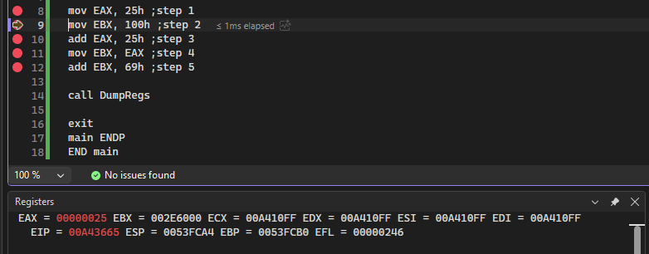

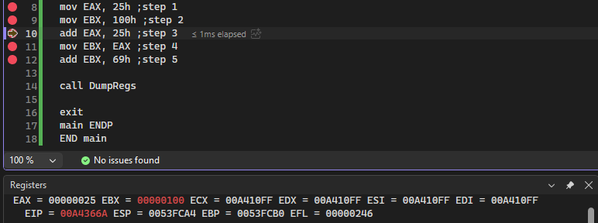
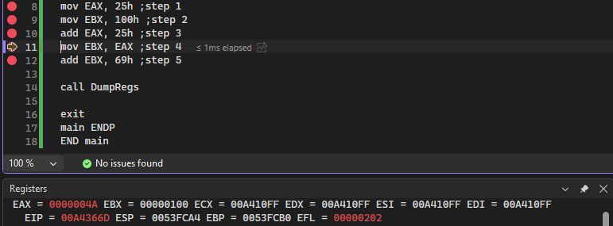
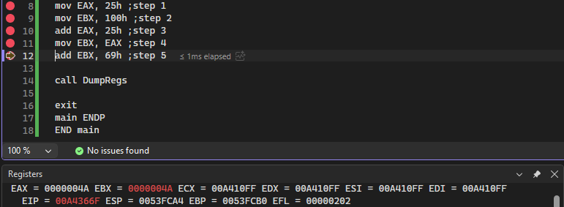
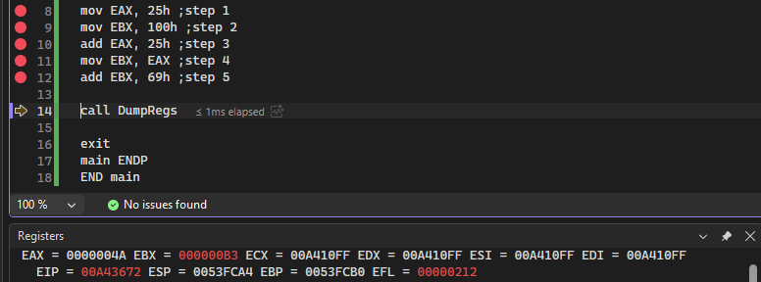

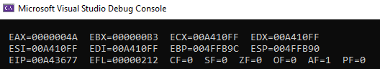
Task 5:

INCLUDE Irvine32.inc

.data
number1 WORD 69
number2 WORD 67

.code
main PROC
mov eax, 0 ;clearing the registers for more clarity
mov ebx, 0 ;although this is optional

mov AX, number1
mov BX, number2
add AX, 12 ;adding 12 to AX

sub AX, BX ;subbing BX from AX, also the breakpoint is here

call DumpRegs
exit
main ENDP
END main

