PakWheels Car Marketplace System
OOP Assignment 2 Documentation

Student ID: 25K0538
Name: Muhammad Farhan
Course: Object-Oriented Programming
Subject Code: CS1004
University: FAST-NUCES, Karachi

Website Replication : PakWheels.com
This program replicates key features of the PakWheels vehicle marketplace (www.pakwheels.com). In Assignment 2, each feature has been redesigned using advanced OOP principles: Inheritance, Polymorphism, Abstraction, Operator Overloading, and Friend Functions. For each feature the PakWheels website screenshot is shown first, followed by the updated code and reasoning.

Feature 1: Vehicle Listings
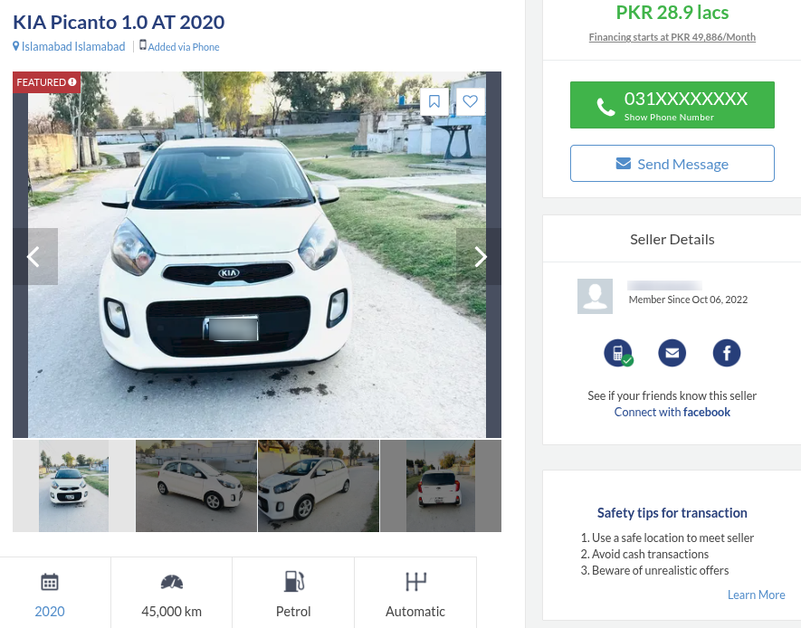

My Implementation: The Vehicle hierarchy now replaces the flat vehicle data fields from Assignment 1. Vehicle is an abstract base class with common attributes (brand, model, modelYear, mileage, chassisNumber, engineCC). Car and Bike each inherit from it and add their own specific fields. ListingBase stores a Vehicle* pointer, so any vehicle type such as Car, Bike, CommercialTruck, Van, or Bus, they can be attached to a listing without changing the listing class itself.

// Vehicles.h
class Vehicle
{
protected:
string brand, model;
int modelYear;
string chassisNumber;
virtual void displaySpecs() const = 0; // pure virtual
};
25K0538
class Car : public Vehicle
{
private:
string transmission;
bool hasSunroof;
int trunkCapacityLitres;
};

// Listings.h
class ListingBase
{
protected:
Vehicle* vehicleItem; // polymorphic vehicle pointer
double askingPrice;
};

// Main.cpp, creating a listing with a Car
Vehicle* dummyCar = new Car("Honda","Civic",2020,45000,"PK123",1800,
"Auto",true,400,"Local");
ListingBase* dummyAd = new StandardAd(sellers[0], dummyCar, 6500000, "Lahore");

Feature 2: Search & Filter
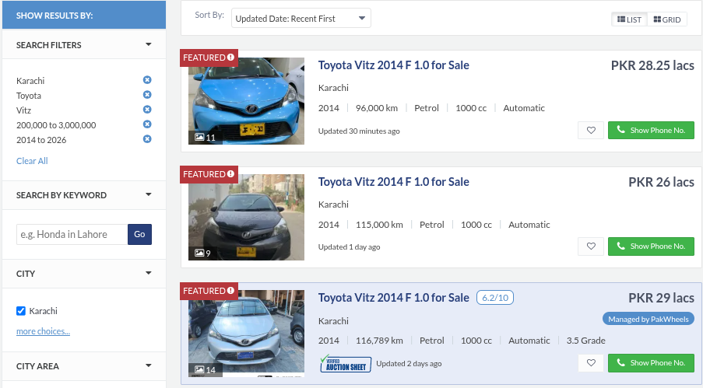

My Implementation: The Marketplace class now uses function overloading for search: search(string brand) and search(string brand, int minYear) are two distinct overloads. Printing listings no longer calls a custom display method, instead the overloaded operator<< on ListingBase delegates to a virtual print() function, so the correct output for StandardAd or FeaturedAd is automatically selected. filterByLocation() and filterByMaxPrice() continue from Assignment 1.

// MarketPlace.h, function overloading
void search(string brand) const;
void search(string brand, int minYear) const;

// MarketPlace.cpp, uses overloaded << operator on listings
void Marketplace::search(string brand) const
{
for (int i = 0; i < listingCount; i++)
{
if (allListings[i]->getVehicleItem()->getBrand() == brand)
cout << *(allListings[i]) << endl; // calls virtual print()
}
}

// Listings.cpp, friend operator<< delegates to virtual print()
ostream& operator<<(ostream& os, const ListingBase& listing)
{
listing.print(os);
return os;
}

Feature 3: Seller Profile

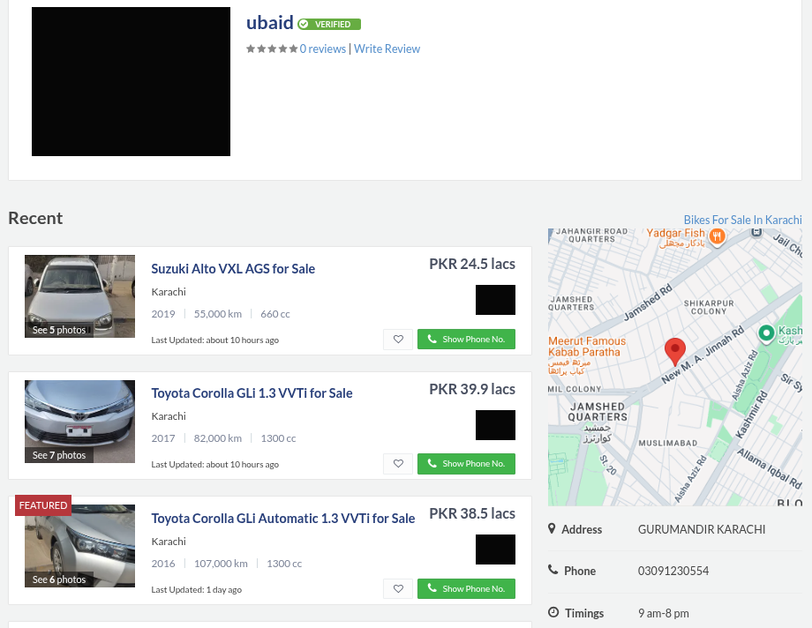

My Implementation: Seller is now a derived class of User. The base class User holds the common identity fields such as userID, name, and inbox, which were duplicated across Seller and Buyer in Assignment 1. Seller adds its own fields: contactNumber, locationAddress, activeAdsCount, and a reviews array. The static member totalRegisteredSellers still tracks platform wide seller counts, and determineSellerType() classifies the seller based on active ad count.

// Users.h
class User
{
protected:
int userID; string name;
Message* inbox[10];
int inboxCount;
static int globalUserCount;
virtual void displayDashboard() const = 0; // pure virtual
};

class Seller : public User
{
private:
string contactNumber;
string locationAddress;
int activeAdsCount;
Review* reviews[10];
int reviewCount;
static int totalRegisteredSellers;
public:
string determineSellerType();
bool canOfferFinancing();
void displayDashboard() const override;
};

Feature 4: Saved / Favorite Listings
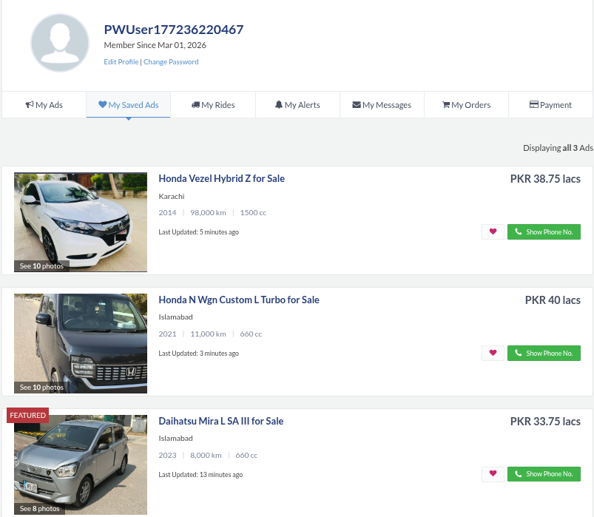

My Implementation: Buyer is also a derived class of User, inheriting userID, name, and inbox. It adds phoneNumber, joinDate, and a favoriteAds array of ListingBase* pointers. Since ListingBase is now abstract and both StandardAd and FeaturedAd are concrete, the favorites list works polymorphically, so a buyer can save any type of listing without knowing which subclass it is. The static totalRegisteredBuyers count is maintained the same way as in Assignment 1.

// Users.h
class Buyer : public User
{
private:
string phoneNumber;
string joinDate;
ListingBase* favoriteAds[10]; // aggregation, polymorphic
int favoriteCount;
static int totalRegisteredBuyers;
public:
void addToFavorites(ListingBase* ad);
void removeFromFavorites(int adID);
void displayFavorites();
void displayDashboard() const override;
};

// Users.cpp
void Buyer::addToFavorites(ListingBase* ad)
{
if (favoriteCount >= 10)
{
cout << "List is full." << endl;
return;
}
favoriteAds[favoriteCount++] = ad;
cout << "Listing added to Favorites." << endl;
}

Feature 5: Buyer-Seller Messaging
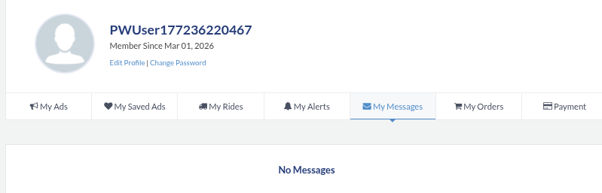

My Implementation: Both Buyer and Seller now inherit receiveMessage() and viewInbox() from the User base class, eliminating the duplicate inbox logic from Assignment 1. Buyer::draftMessage() creates a Message object on the heap and delivers it directly to the Seller's inbox via the inherited receiveMessage(). Seller::replyToMessage() locates the message by ID in its inbox, constructs a reply, and routes it to the correct Buyer using getSenderIDByMessageID().

// Users.h, inbox managed in base class
class User
{
public:
void receiveMessage(Message* msg); // shared by Buyer and Seller
void viewInbox();
};

// Users.cpp, Buyer sends message via Seller's inherited inbox
void Buyer::draftMessage(Seller* seller, string text)
{
Message* msg = new Message(userID, seller->getUserID(), text, "Now");
seller->receiveMessage(msg);
}

// Main.cpp, routing reply to the correct buyer
int senderID = sellers[i]->getSenderIDByMessageID(mID);
Buyer* targetBuyer = nullptr;
for (int j = 0; j < bCount; j++)
{
if (buyers[j]->getUserID() == senderID)
targetBuyer = buyers[j];
}
if (targetBuyer)
sellers[i]->replyToMessage(mID, reply, targetBuyer);

Feature 6: Admin / Listing Moderation
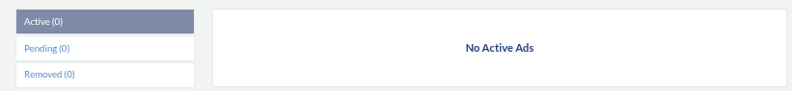

My Implementation: Admin is now a derived class of User. It is also declared as a friend class of User, giving it direct access to private members like userID and name without requiring getters. This is necessary for Admin level tasks such as password resets and ban logging. approveListing() and removeListing() both accept a ListingBase& reference, so they work polymorphically on both StandardAd and FeaturedAd objects. The clearanceLevel guard ensures lower ranked admins cannot perform destructive actions.

// Users.h
class Admin : public User
{
private:
int clearanceLevel;
int actionsLogged;
public:
void approveListing(ListingBase& listing);
void removeListing(ListingBase& listing);
void banUser(int targetUserID);
string generateSystemReport();
void displayDashboard() const override;
};

// Admin is declared friend of User to access private data
class User
{
friend class Admin; // Admin can access userID, name directly
};

// Users.cpp
void Admin::banUser(int targetUserID)
{
if (clearanceLevel < 2)
{
cout << "Insufficient clearance." << endl;
return;
}
cout << "User " << targetUserID << " banned by Admin " << name << endl;
actionsLogged++;
}

Feature 7: Seller Reviews


My Implementation: The Review class remains largely the same as Assignment 1, with reviewID, reviewerID, targetSellerID, rating, comment, and isFlagged. Seller now stores Review* pointers instead of Review value objects, and dynamically allocates them for flexibility. The Admin's reviewFlaggedContent() method takes a Review& reference and calls displayReview() on it. This is only possible because Admin is a friend of User, and through inheritance, has the authority to access and act on flagged content flagged by buyers through flagAsInappropriate().

// Review.cpp
void Review::flagAsInappropriate()
{
isFlagged = true;
cout << "Review " << reviewID << " flagged for Admin attention." << endl;
}

// Users.cpp: Admin reviewing flagged content
void Admin::reviewFlaggedContent(Review& flaggedReview)
{
if (flaggedReview.getIsFlagged())
{
cout << "Admin " << name << " reviewing flagged content:" << endl;
flaggedReview.displayReview();
actionsLogged++;
}
}

1. Inheritance
The design introduces three distinct inheritance hierarchies, giving the system 10 inheritance relationships in total. Each relationship is justified below. The base class captures what is common, and each derived class only adds what is unique to that type.

Relationship | Justification
User → Admin | Admin is a specialized User with clearance level and moderation actions.
User → Buyer | Buyer is a User who saves favorites, sends messages, and registers on the platform.
User → Seller | Seller is a User who posts listings, manages an inbox, and collects reviews.
Vehicle → Car | Car is a Vehicle with car-specific fields (transmission, sunroof, trunk).
Vehicle → Bike | Bike is a Vehicle with bike-specific fields (bikeType, dryWeight, discBrakes).
Vehicle → CommercialTruck | CommercialTruck is a Vehicle with payload and axle count.
Vehicle → Van | Van is a Vehicle with seating capacity and roof type.
Vehicle → Bus | Bus is a Vehicle with passenger capacity and route type.
ListingBase → StandardAd | StandardAd is a listing with a 2% platform fee and standard display format.
ListingBase → FeaturedAd | FeaturedAd is a listing with a 5% fee, bump counter, and priority display.

1.1 User Hierarchy
User is the abstract base class for all platform participants. It holds the fields and methods that every user type must have: userID (auto assigned from globalUserCount), name, an inbox array of Message pointers, and the shared receiveMessage() / viewInbox() methods. The pure virtual displayDashboard() forces each derived class to implement its own dashboard. Admin, Buyer, and Seller all inherit these shared capabilities without duplicating any code.

class User
{
protected:
int userID; string name;
Message* inbox[10]; int inboxCount;
static int globalUserCount;
public:
User(string n);
virtual ~User();
void receiveMessage(Message* msg);
void viewInbox();
virtual void displayDashboard() const = 0; // pure virtual
friend class Admin;
};

class Admin : public User {int clearanceLevel; ... };
class Buyer : public User {string phoneNumber; ListingBase* favoriteAds[10]; ... };
class Seller : public User {string contactNumber; Review* reviews[10]; ... };

1.2 Vehicle Hierarchy
Vehicle is the abstract base class for all vehicle types. All five derived classes share the six core attributes (brand, model, modelYear, mileage, chassisNumber, engineCC) through protected inheritance. The pure virtual functions displaySpecs() and print() are defined differently in each derived class. This design means a single Vehicle* pointer inside ListingBase can point to any vehicle type, enabling full polymorphism across the listings system.

class Vehicle
{
protected:
string brand, model;
int modelYear, mileage;
string chassisNumber;
int engineCC;
public:
virtual void displaySpecs() const = 0; // pure virtual
virtual void print(ostream& os) const = 0; // pure virtual
virtual ~Vehicle();
};

class Car: public Vehicle {string transmission; bool hasSunroof; ... };
class Bike: public Vehicle {string bikeType; float dryWeightKg; ... };
class CommercialTruck: public Vehicle { float payloadCapacityTons; int axleCount; };
class Van: public Vehicle {int seatingCapacity; bool isHighRoof; };
class Bus: public Vehicle {int passengerCapacity; string routeType; };

1.3 Listing Hierarchy
ListingBase is the abstract base class for all ad types. It stores the common listing data: listingID, the sellerRef pointer, the polymorphic vehicleItem pointer, askingPrice, listingLocation, isSold, and isApproved. It also defines the platform behavior that all listings must have, such as: markAsSold(), updatePrice(), applyDiscount(). The pure virtual calculatePlatformFee() and print() are left to each derived class to define, ensuring that StandardAd uses a 2% fee and FeaturedAd uses a 5% fee with a bump counter.

class ListingBase
{
protected:
const int listingID;
Seller* sellerRef;
Vehicle* vehicleItem;
double askingPrice;
bool isSold;
bool isApproved;
static int totalActiveListings;
public:
virtual double calculatePlatformFee() const = 0; // pure virtual
virtual void print(ostream& os) const = 0; // pure virtual
void markAsSold();
void updatePrice(double);
void applyDiscount(float);
};

class StandardAd : public ListingBase
{
double calculatePlatformFee() const override; // returns askingPrice * 0.02
};

class FeaturedAd : public ListingBase
{
int bumpCount;
double calculatePlatformFee() const override; // returns askingPrice * 0.05
FeaturedAd& operator++(); // prefix bump
FeaturedAd operator++(int); // postfix bump
};

2. Polymorphism
The system uses both forms of polymorphism: function overriding through virtual functions (runtime polymorphism), and function overloading (compile time polymorphism). The combination means the same call can automatically produce different behaviour depending on the actual type of the object at runtime, while the same function name can accept different argument signatures at compile time.

2.1 Function Overriding (Virtual Functions)
Every abstract base class defines pure virtual functions that each derived class overrides. The virtual keyword guarantees that the correct override is called through a base class pointer, even when the actual object type is not known at the call site.

Virtual Function | Overriding Classes
User::displayDashboard() | Admin, Buyer, Seller : each prints its own dashboard format
Vehicle::displaySpecs() | Car, Bike, CommercialTruck, Van, Bus : each prints its own specs
Vehicle::print(ostream&) | Car, Bike, CommercialTruck, Van, Bus : drives operator<< polymorphism
ListingBase::calculatePlatformFee() | StandardAd (2%), FeaturedAd (5%)
ListingBase::print(ostream&) | StandardAd and FeaturedAd : drives operator<< polymorphism
Vehicle::~Vehicle() | Virtual destructor : ensures correct cleanup through base pointer
User::~User() | Virtual destructor : ensures Buyer/Seller cleanup through User*
ListingBase::~ListingBase() | Virtual destructor : deletes vehicleItem through base pointer

A concrete example of runtime polymorphism is in Marketplace::search(). The listing is stored as ListingBase* in the allListings[] array. When printed, operator<< calls the virtual print(), and the correct output is produced whether it is a StandardAd or a FeaturedAd, with no if-else check needed:

// Marketplace.cpp -> polymorphic printing via virtual print()
for (int i = 0; i < listingCount; i++)
if (allListings[i]->getVehicleItem()->getBrand() == brand)
cout << *(allListings[i]) << endl; // calls StandardAd::print() or FeaturedAd::print()

// Listings.cpp -> operator<< delegates to virtual print()
ostream& operator<<(ostream& os, const ListingBase& listing)
{
listing.print(os); // resolved at runtime
return os;
}

2.2 Function Overloading
Marketplace::search() is overloaded with two signatures. The single-argument version searches by brand name alone, while the two argument version additionally filters by minimum model year. Both are const and loop the same allListings[] array, but the condition differs. This is a clean compile-time overload. The caller picks the right version automatically based on what arguments they pass.

// MarketPlace.h
void search(string brand) const;
void search(string brand, int minYear) const;

// MarketPlace.cpp
void Marketplace::search(string brand) const
{
for (int i = 0; i < listingCount; i++)
{
if (allListings[i]->getVehicleItem()->getBrand() == brand)
cout << *(allListings[i]) << endl;
}
}

void Marketplace::search(string brand, int minYear) const
{
for (int i = 0; i < listingCount; i++)
{
Vehicle* v = allListings[i]->getVehicleItem();
if (v->getBrand() == brand && v->getModelYear() >= minYear)
cout << *(allListings[i]) << endl;
}
}
Marketplace::operator+= is also overloaded. One version accepts User* and another accepts ListingBase*. Both perform a capacity check and append to their respective arrays. Operator overloading with different signatures is function overloading applied to operators, handled in the next section.

3. Abstraction
Abstraction means exposing only what the outside world needs to know about an object, and hiding the implementation details. In this system, abstraction is achieved in two ways: through abstract classes (classes with at least one pure virtual function that cannot be instantiated), and through the separation of interface (.h files) from implementation (.cpp files). Three classes are abstract.

3.1 Abstract Class: User
User cannot be instantiated directly because displayDashboard() is pure virtual. This makes sense because a generic "User" has no meaningful dashboard, only Admin, Buyer, and Seller do. The class still holds real data and real methods that are useful to all derived classes, but the act of displaying a dashboard is left entirely to the derived class to define. The header file exposes the public interface, the .cpp file implements the shared logic.

// Users.h -> interface (abstract class)
class User {
public:
virtual void displayDashboard() const = 0; // pure virtual -> cannot instantiate User
void receiveMessage(Message* msg); // concrete shared method
void viewInbox(); // concrete shared method
};

// Users.cpp -> implementation
void User::receiveMessage(Message* msg)
{
if (inboxCount >= 10)
{
cout << "Inbox full." << endl;
return;
}
inbox[inboxCount++] = msg;
}

// Admin, Buyer, Seller each must provide their own displayDashboard()
void Admin::displayDashboard() const override
{
cout << "=== ADMIN DASHBOARD ===" << endl;
cout << "Admin ID: " << userID << " Clearance: Level " << clearanceLevel << endl;
}

3.2 Abstract Class: Vehicle
Vehicle cannot be instantiated because displaySpecs() and print() are both pure virtual. A raw Vehicle object has no type. Tt is neither a Car nor a Bike, so it should never exist on its own. By making it abstract, the design enforces that every vehicle in the system is a concrete, identifiable type. The print() function is specifically designed to work alongside the overloaded operator<<, creating a clean separation between how output is triggered and how it is formatted.

// Vehicles.h -> abstract interface
class Vehicle {
public:
virtual void displaySpecs() const = 0; // pure virtual
virtual void print(ostream& os) const = 0; // pure virtual, drives operator<<
virtual ~Vehicle();
friend ostream& operator<<(ostream& os, const Vehicle& v);
};

// Vehicles.cpp -> Car's concrete override
void Car::print(ostream& os) const
{
os << "Car: " << brand << " " << model << " " << modelYear << endl
<< "Mileage: " << mileage << " km" << endl
<< "Transmission: " << transmission << endl;
}

3.3 Abstract Class: ListingBase
ListingBase cannot be instantiated because calculatePlatformFee() and print() are pure virtual. A raw listing has no defined fee structure and no defined display format, those are decisions for StandardAd and FeaturedAd. The concrete methods (markAsSold, updatePrice, applyDiscount) contain validation logic that is shared and should not be duplicated in every derived class. Keeping them in the base class and keeping the fee calculation abstract is the right split of responsibility.

// Listings.h -> abstract interface
class ListingBase
{
public:
// Concrete shared methods:
void updatePrice(double newPrice);
void markAsSold();
void applyDiscount(float percentage);

// Pure virtual -> must be implemented by derived classes:
virtual double calculatePlatformFee() const = 0;
virtual void print(ostream& os) const = 0;
};

// Listings.cpp
double StandardAd::calculatePlatformFee() const
{
return askingPrice * 0.02; // 2% fee
}
double FeaturedAd::calculatePlatformFee() const
{
return askingPrice * 0.05; // 5% premium fee
}

4. Operator Overloading
The system implements 11 operator overloads across four classes. Each one is documented with its type (member vs. global/friend), its signature, and the reasoning for why that operator was the right choice. Operators are only overloaded when they produce intuitive, readable code that clearly maps to the real world meaning of the operation.

4.1 Vehicle::operator== (member function)
Compares two Vehicle objects for identity using their chassis number. The chassis number is the definitive physical identifier of a vehicle. No two vehicles in the world share the same one. Making this a member function is appropriate because both operands are Vehicle objects and the comparison is symmetric.

// Vehicles.h
bool operator==(const Vehicle& other) const;

// Vehicles.cpp
bool Vehicle::operator==(const Vehicle& other) const
{
return chassisNumber == other.chassisNumber;
}

// Usage example
if (*car1 == *car2)
cout << "Duplicate vehicle detected." << endl;

4.2 operator<< for Vehicle (friend / global function)
Overloads the stream insertion operator for any Vehicle object. It is implemented as a global friend function because the left hand operand is ostream (not a Vehicle), so it cannot be a member. It delegates to the virtual print() function, which means the correct output is produced automatically for Car, Bike, CommercialTruck, Van, or Bus through polymorphism.

// Vehicles.h
friend ostream& operator<<(ostream& os, const Vehicle& v);

// Vehicles.cpp
ostream& operator<<(ostream& os, const Vehicle& v)
{
v.print(os); // calls the correct override at runtime
return os;
}

4.3 ListingBase::operator< and operator> (member functions)
These allow two listings to be compared by asking price. This is a natural extension of comparison for market listings — comparing by price is the most common way a buyer would rank options. Both are member functions because both operands are ListingBase objects.

// Listings.h
bool operator<(const ListingBase& other) const;
bool operator>(const ListingBase& other) const;

// Listings.cpp
bool ListingBase::operator<(const ListingBase& other) const
{
return this->askingPrice < other.askingPrice;
}
bool ListingBase::operator>(const ListingBase& other) const
{
return this->askingPrice > other.askingPrice;
}

4.4 operator<< for ListingBase (friend / global function)
Same reasoning as the Vehicle version, the left-hand operand is ostream, so this must be a global function and is declared friend to call the protected print(). It is what makes cout << *listing work anywhere in the program, including inside Marketplace search and filter methods.

// Listings.h
friend ostream& operator<<(ostream& os, const ListingBase& listing);

// Listings.cpp
ostream& operator<<(ostream& os, const ListingBase& listing)
{
listing.print(os); // virtual dispatch to StandardAd or FeaturedAd
return os;
}

4.5 FeaturedAd::operator++ prefix and postfix (member functions)
The prefix ++ immediately bumps the featured ad and sets postDate to "Just Now", then returns a reference to the same object. The postfix ++ saves a copy first, then calls the prefix version on the actual object, and returns the saved copy, this is the standard pattern for postfix. These operators are a natural fit because "bumping" an ad is conceptually an increment of its visibility counter.

// Listings.h
FeaturedAd& operator++(); // prefix
FeaturedAd operator++(int); // postfix

// Listings.cpp
FeaturedAd& FeaturedAd::operator++()
{
bumpCount++;
postDate = "Just Now";
return *this;
}

FeaturedAd FeaturedAd::operator++(int)
{
FeaturedAd temp = *this; // save current state
++(*this); // apply the actual bump
return temp; // return pre-bump copy
}

4.6 Marketplace::operator+= for User* and ListingBase* (member, overloaded)
Two overloads of += allow the marketplace to register users and listings using the same operator. This is a very natural syntax, adding something to the platform feels exactly like +=. Both overloads check capacity before inserting, and both return *this so chains are possible. These are member functions because the left hand operand is always the Marketplace object.

// MarketPlace.h
Marketplace& operator+=(User* newUser);
Marketplace& operator+=(ListingBase* newListing);

// MarketPlace.cpp
Marketplace& Marketplace::operator+=(User* newUser)
{
if (userCount >= maxCapacity)
{
cout << "Capacity reached." << endl;
return *this;
}
platformUsers[userCount++] = newUser;
cout << "User '" << newUser->getName() << "' registered." << endl;
return *this;
}

// Main.cpp — usage
pakWheels += sellers[sCount++]; // registers a seller
pakWheels += dummyAd; // posts a listing

4.7 operator>> for Buyer and Seller (friend / global functions)
These overload the stream extraction operator to allow reading Buyer and Seller data directly from cin. They are global friend functions because the left hand operand is istream (not a class object). They need friend access to write directly into private members like name, phoneNumber, and contactNumber without going through setters.

// Users.h
friend istream& operator>>(istream& in, Buyer& b);
friend istream& operator>>(istream& in, Seller& s);

// Users.cpp
istream& operator>>(istream& in, Buyer& b)
{
cout << "Enter Buyer Name: "; in >> b.name;
cout << "Enter Phone Number: "; in >> b.phoneNumber;
b.joinDate = "Today";
return in;
}

// Main.cpp — usage
Buyer* newB = new Buyer("Temp", "Temp", "Temp");
cin >> *newB; // fills in actual name and phone

5. Friend Functions and Friend Classes
Friend declarations grant a specific external function or class direct access to private and protected members. They are used sparingly and only when a relationship genuinely requires cross boundary data access that cannot be cleanly solved with public getters. There are five friend declarations in this system.

5.1 Admin as Friend Class of User
Admin is declared a friend of User, meaning an Admin object can directly read and write User's private members (userID, name, inbox). This is justified because Admin performs platform level actions that specifically require user data, such as banUser() logs the target's ID, generateSystemReport() reads static counts, and reviewFlaggedContent() operates inside the user's domain. Using only public getters would expose this data to every class in the system, so the friend declaration limits it to Admin only.

// Users.h
class User
{
friend class Admin; // Admin gets direct access to all private/protected members
};

// Users.cpp -> Admin directly using inherited name (a protected member of User)
void Admin::banUser(int targetUserID)
{
cout << "User " << targetUserID << " banned by Admin " << name << endl;
// 'name' is protected in User -> accessible here because Admin is a friend
actionsLogged++;
}

5.2 operator>> as Friend of Buyer
The extraction operator for Buyer is a global friend function. It needs direct write access to Buyer's private members name, phoneNumber, and joinDate. Without friend status, the only option would be public setters, which would expose these fields to every part of the program. Since >> is only for initial registration input, friend access is the more controlled and appropriate choice.

// Users.h
class Buyer : public User
{
friend istream& operator>>(istream& in, Buyer& b);
};

// Users.cpp
istream& operator>>(istream& in, Buyer& b)
{
cout << "Enter Buyer Name: ";
in >> b.name; // private in User
cout << "Enter Phone Number: ";
in >> b.phoneNumber; // private in Buyer
b.joinDate = "Today"; // private in Buyer
return in;
}

5.3 operator>> as Friend of Seller
Same justification as the Buyer version. The Seller version additionally writes to locationAddress, which is private. This approach keeps registration input self-contained in a single operator function rather than scattering setter calls across main.

// Users.h
class Seller : public User
{
friend istream& operator>>(istream& in, Seller& s);
};

// Users.cpp
istream& operator>>(istream& in, Seller& s)
{
cout << "Enter Seller Name: ";
in >> s.name;
cout << "Enter Contact Number: ";
in >> s.contactNumber;
cout << "Enter Location: ";
in >> s.locationAddress;
return in;
}

5.4 operator<< as Friend of Vehicle
The stream insertion operator for Vehicle is a global friend function. It needs to call the virtual print() method, which is protected. Without friend access, print() would have to be public, which would expose it unnecessarily to the rest of the program. Declaring the operator a friend keeps print() protected while still allowing operator<< to work correctly.

// Vehicles.h
class Vehicle
{
friend ostream& operator<<(ostream& os, const Vehicle& v);
};

// Vehicles.cpp
ostream& operator<<(ostream& os, const Vehicle& v)
{
v.print(os); // print() is protected, so friend access required
return os;
}

5.5 operator<< as Friend of ListingBase
Identical reasoning to the Vehicle version. ListingBase::print() is protected. The friend operator<< is the only intended external way to print a listing, which is a clean and deliberate design. The print format is controlled entirely inside the class, and nothing outside can call print() directly except the designated output operator.

// Listings.h
class ListingBase
{
friend ostream& operator<<(ostream& os, const ListingBase& listing);
};

// Listings.cpp
ostream& operator<<(ostream& os, const ListingBase& listing)
{
listing.print(os); // print() is protected, so again friend access required
return os;
}

6. Class Diagram
The complete Class Diagram for the Assignment 2 system was created on Draw.io. It shows all three inheritance hierarchies (User, Vehicle, ListingBase), the abstract classes, the friend relationships, and the association/aggregation links between classes. The full PNG file of the class diagram is included as a separate file alongside this submission.

Hierarchy | Classes Included
User Hierarchy | User (abstract) → Admin, Buyer, Seller
Vehicle Hierarchy | Vehicle (abstract) → Car, Bike, CommercialTruck, Van, Bus
Listing Hierarchy | ListingBase (abstract) → StandardAd, FeaturedAd
Supporting Classes | Message, Review, Marketplace
Friend Relationships | Admin ← User, operator<< ← Vehicle, operator<< ← ListingBase, operator>> ← Buyer, operator>> ← Seller
Association / Aggregation | ListingBase → Vehicle (polymorphic), Buyer → ListingBase (favorites), Marketplace → User[] + ListingBase[]

7. Functionality Summary
The main menu is organised into four panels: Admin, Seller, Buyer, and Marketplace. All functionality from Assignment 1 is preserved. The table below summarises what each panel does and which Assignment 2 OOP concept it demonstrates.

Panel / Feature | OOP Concepts Demonstrated
Admin: System Report | Inheritance (Admin extends User), static members across Buyer/Seller/ListingBase
Admin: Approve Listing | Polymorphism : approveListing() takes ListingBase& and works on any subtype
Admin: Remove Listing | Friend class : Admin accesses User's private data; virtual destructor cleanup
Seller: Register | Inheritance; operator>> friend function reads private fields from cin
Seller: Post Vehicle Ad | Abstraction : Car/Bike created as Vehicle*; StandardAd/FeaturedAd as ListingBase*
Seller: Update Price | ListingBase::updatePrice() : called polymorphically through base pointer
Seller: View Inbox and Reply | Shared receiveMessage/viewInbox from User base; getSenderIDByMessageID
Buyer: Register | Inheritance; operator>> friend function
Buyer: Favorites | ListingBase* polymorphic favorites array : works with any listing type
Buyer: Send Message | DraftMessage() : uses inherited userID; delivers via seller's inherited inbox
Marketplace: Search by Brand | Function overloading; operator<< triggers virtual print() polymorphism
Marketplace: Search + Year | Function overloading second overload
Marketplace: Filter Location | filterByLocation() : operator<< on ListingBase
Marketplace: Filter Price | operator< and operator> on ListingBase for comparison; filterByMaxPrice()

