Name: Muhammad Farhan
Roll no: 25K-0538
Section: BCS-3K
Course: Computer Organization and Assembly Language - Lab
Course Instructor: Miss Fareeha Jabeen
Date of Submission: 22/10/2026

Task 1:

INCLUDE Irvine32.inc

rows = 4
cols = 3

.data
students DWORD 70, 80, 90
DWORD 60, 75, 85
DWORD 88, 92, 79
DWORD 55, 65, 70
msg1 BYTE "Total Marks of Student: ", 0
msg2 BYTE "Total Marks of all Class: ", 0

.code
main PROC

mov ESI, OFFSET students
mov ECX, rows
l1:
push ECX
mov EAX, 0
mov ECX, cols
l2:
add EAX, [ESI]
add ESI, TYPE students
loop l2:
mov EDX, OFFSET msg1
call WriteString
call WriteDec
call Crlf
pop ECX
loop l1:

exit
main ENDP
END main
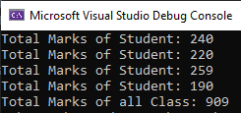

Task 2:
INCLUDE Irvine32.inc

.data
string BYTE "KARACHI", 0
lengthy DWORD LENGTHOF string - 1

.code
main PROC

mov ECX, lengthy
mov ESI, OFFSET string
l1:
movzx EAX, BYTE PTR [ESI]
push EAX
inc ESI
loop l1

mov ECX, lengthy
l2:
pop EAX
call WriteChar
loop l2

exit
main ENDP
END main

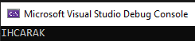

Task 3:
INCLUDE Irvine32.inc

.data
racers DWORD 3 DUP(?)

.code
main PROC

mov ESI, 0
mov ECX, 3
l1:
mov EAX, 0
call ReadInt
mov racers[ESI], EAX
push EAX
add ESI, TYPE racers
loop l1

pop racers[4]
pop racers[0]
pop racers[8]

call Crlf
call Crlf
mov ECX, 3
mov ESI, 0
l2:
mov EAX, racers[ESI]
call WriteDec
call Crlf
add ESI, TYPE racers
loop l2

exit
main ENDP
END main

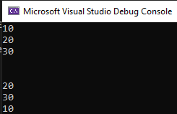

Task 4:
INCLUDE Irvine32.inc

.data
msg1 BYTE "Length of Room: ", 0
msg2 BYTE "Width of Room: ", 0
msg3 BYTE "Area of Room: ", 0
msg4 BYTE "Total Area of Both Rooms: ", 0
total DWORD 0
saveAddress DWORD ?

.code
main PROC
mov ECX, 2
mov EAX, 0
mov EBX, 0
room:
call Crlf

mov EDX, OFFSET msg1
call WriteString
call ReadInt
mov EBX, EAX

mov EDX, OFFSET msg2
call WriteString
call ReadInt

push EAX
push EBX

call calculatePrice
add total, EAX
call Crlf
mov EDX, OFFSET msg3
call WriteString
call WriteDec

loop room

call Crlf
call Crlf
mov EDX, OFFSET msg4
call WriteString
mov EAX, total
call WriteDec

exit
main ENDP

calculatePrice PROC
pop saveAddress
pop EBX
pop EAX

mul EBX

push saveAddress
ret
calculatePrice ENDP

END main

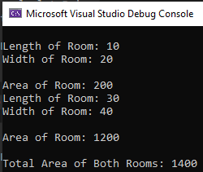

Task 5:
INCLUDE Irvine32.inc

.data
msg1 BYTE "Enter Account Balance: ", 0
msg2 BYTE "Enter Withdrawal Amount: ", 0
msg3 BYTE "Transaction logged", 0
msg4 BYTE "Remaining Balance: ", 0

balance DWORD ?
withdraw DWORD ?

.code
main PROC
mov EDX, OFFSET msg1
call WriteString
call ReadInt
mov balance, EAX

mov EDX, OFFSET msg2
call WriteString
call ReadInt
mov withdraw, EAX

mov EAX, balance
sub EAX, withdraw

call audit

call DumpRegs

call Crlf
mov EDX, OFFSET msg4
call WriteString
call WriteDec
call Crlf

exit
main ENDP

audit PROC
pushad
pushfd

mov EDX, OFFSET msg3
call WriteString
call Crlf

mov EBX, 5
add EBX, 10

popfd
popad
ret
audit ENDP

END main



