Name: Muhammad Farhan

Roll no: 25K-0538

Section: BCS-2K

Course: Digital Logic Design – Lab

Course Instructor: Sir Aashir Mahboob

Lab: 9
Task 1:
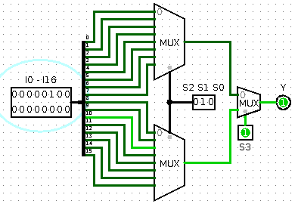

Task 2:
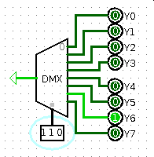

Task 3:
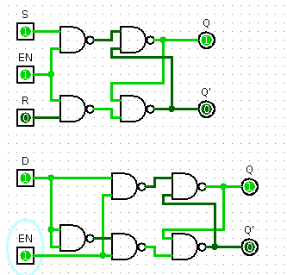

Task 4:
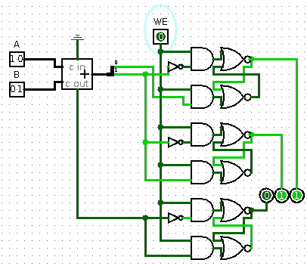

Task 5:
