Name: Muhammad Farhan
Roll no: 25K-0538
Data Structures Lab 2
Date: 27/08/2026

1D and 2D Dynamic Array:
#include <iostream>
using namespace std;

int main()
{
int *dynamicArray1D = new int[5];
int **dynamicArray2D = new int*[5];

for (int i = 0; i < 5 ; i++)
{
dynamicArray2D[i] = new int[5];
}

for (int i = 0; i < 5 ; i++)
{
dynamicArray1D[i] = (i*3)/2;
}

for (int i = 0; i < 5 ; i++)
{
for (int j = 0; j < 5 ; j++)
{
dynamicArray2D[i][j] = (i*j)+10;
}

}

cout << "1D Array: \n";
for (int j = 0; j < 5 ; j++)
{
cout << dynamicArray1D[j] << " ";
}
cout << "\n\n\n";

cout << "2D Array: \n";
for (int i = 0; i < 5 ; i++)
{
for (int j = 0; j < 5 ; j++)
{
cout << dynamicArray2D[i][j] << " ";

}
cout << "\n";
}

delete[] dynamicArray1D;
for (int j = 0; j < 5 ; j++)
{
delete[] dynamicArray2D[j];
}
delete[] dynamicArray2D;

return 0;
}
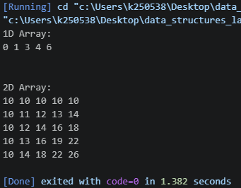

Task 1:
#include <iostream>
using namespace std;

int main()
{
int size = 3;
int matriz[size][size] = {{1, 0, 0},
{0, 1, 0},
{0, 0, 1}};

int dia = 0;
int nondia = 0;
for (int i = 0; i < size; i++)
{
for (int j=0; j < size; j++)
{
if (i == j && matriz[i][j] == 1)
{
dia++;
}
else
{
nondia++;
}
}
}

if (dia == size && nondia == ((size*size)-size))
{
cout << "The Matriz is a Identity Matrix.\n";
}
else
{
cout << "The Matriz is not a Identity Matrix, how sad.\n";
}

return 0;
}
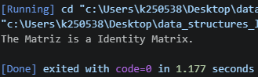

Task 2:
#include <iostream>
using namespace std;

int main()
{
cout << "Enter the size of array: ";
int size;
cin >> size;

int* arr = new int[size];

for (int i = 0; i < size; i++)
{
cout << "Enter the Element #" << i + 1 << ": ";
cin >> arr[i];
}

int* unique = new int[size];
int unique_count = 0;

for (int i = 0; i < size; i++)
{
bool found = false;

for (int j = 0; j < unique_count; j++)
{
if (arr[i] == unique[j])
{
found = true;
cout << arr[i] << " is a duplicate element.\n" << "Enter a new unique element: ";
int new_element;
cin >> new_element;

bool already_exists = false;

for (int k = 0; k < unique_count; k++)
{
if (new_element == unique[k])
{
already_exists = true;
break;
}
}

if (!already_exists)
{
unique[unique_count] = new_element;
unique_count++;
}

break;
}
}

if (!found)
{
unique[unique_count] = arr[i];
unique_count++;
}
}

cout << "\nOriginal Array: ";

for (int i = 0; i < size; i++)
{
cout << arr[i] << " ";
}

cout << "\nNew Array: ";

for (int i = 0; i < unique_count; i++)
{
cout << unique[i] << " ";
}

delete[] arr;
delete[] unique;

return 0;
}

