Name: Muhammad Farhan
Roll no: 25K-0538
Course: Data Structures – Lab 2
Course Instructor: Miss Fatima Gado
Date of Submission: 01/09/2026
Task 3:
//25K0538, Muhammad Farhan
//For this task, the most efficient and suitable way to store is to use Jagged Array.
#include <iostream>
using namespace std;

int main()
{
string departments[4] = {"SE", "AI", "CS", "DS"};
int sizes[4] = {3,4,2,1};
double** GPA = new double*[4]; //4 departments
GPA[0] = new double[3] {3.3, 3.67, 3}; //SE
GPA[1] = new double[4] {2.3, 2.67, 2, 3}; //AI
GPA[2] = new double[2] {4, 3.3}; //CS
GPA[3] = new double[1] {2.67}; //DS

for (int i = 0; i < 4; i++)
{
cout << departments[i] << ": ";
for (int j = 0; j < sizes[i]; j++)
{
cout << GPA[i][j] << " ";
}
cout << endl;
}

for (int i = 0; i < 4; i++)
{
delete[] GPA[i];
}
delete[] GPA;
return 0;
}
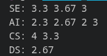

Task 4:

//25K0538, Muhammad Farhan
//For this task, the most efficient and suitable way to store is to use Jagged Array.
#include <iostream>
#include <string>
using namespace std;

int main()
{
int rows[4] = {3,2,1,1}; //size is small so its easier to input names
string** Names = new string*[4]; //4 rows
Names[0] = new string[3] ; //R1
Names[1] = new string[4] ; //R2
Names[2] = new string[1] ; //R3
Names[3] = new string[1] ; //R4

//taking inputs
for (int i = 0; i < 4; i++)
{
cout << "\nRow " << i+1 << ": " << endl;
for (int j = 0; j < rows[i]; j++)
{
cout << "Enter name for R" << i+1 << "C" << j+1 << ": ";
cin >> Names[i][j];
cout << endl;
}
cout << endl;
}

//showing output
for (int i = 0; i < 4; i++)
{
cout << "Row " << rows[i] << ": ";
for (int j = 0; j < rows[i]; j++)
{
cout << Names[i][j] << " ";
}
cout << endl;
}

for (int i = 0; i < 4; i++)
{
delete[] Names[i];
}
delete[] Names;
return 0;
}

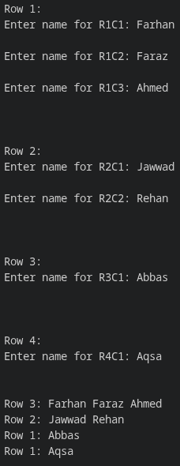

Task 5:
//25K0538, Muhammad Farhan
#include <iostream>
using namespace std;

int main()
{
int sizes[4] = {3,4,2,1};
int** array = new int*[4];
array[0] = new int[3] {3, 4, 3};
array[1] = new int[4] {10, 2, 7, 3};
array[2] = new int[2] {4, 8};
array[3] = new int[1] {9};

int max = 0;
int max_index = 0;
for (int i = 0; i < 4; i++)
{
int count = 0;
for (int j = 0; j < sizes[i]; j++)
{
count++;
}
if (count > max)
{
max = count;
max_index = i;
}
}

cout << "Row " << max_index+1 << " contains the maximum number of elements." << endl;
cout << "Size: " << max << endl;
for (int i = 0; i < max; i++)
{
cout << array[max_index][i] << " ";
}

for (int i = 0; i < 4; i++)
{
delete[] array[i];
}
delete[] array;
return 0;
}
