Name: Muhammad Farhan
Roll on: 25K-0538
Section: BCS-3K
Course: Computer Organization & Assembly Language – Lab
Lab: 5
Date: 17/09/2026

Task 1:
INCLUDE Irvine32.inc

.data
warehouse BYTE 100, 200, 150, 80, 60

msg BYTE "Updated Stock: "
msg1 BYTE " "

.code
main PROC
mov esi, OFFSET warehouse
add BYTE PTR [esi+3], 25

mov edx, OFFSET msg
call WriteString

movzx EAX, BYTE PTR [esi]
call WriteInt

mov EDX, OFFSET msg1

call WriteString
add esi, TYPE warehouse
movzx EAX, BYTE PTR [esi]
call WriteInt

call WriteString
add esi, TYPE warehouse
movzx EAX, BYTE PTR [esi]
call WriteInt

call WriteString
add esi, TYPE warehouse
movzx EAX, BYTE PTR [esi]
call WriteInt

call WriteString
add esi, TYPE warehouse
movzx EAX, BYTE PTR [esi]
call WriteInt

exit
main ENDP
END main

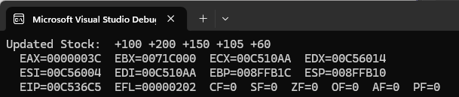

Task 2:
INCLUDE Irvine32.inc

.data
value DWORD 00450078h
msg1 BYTE "Low Part (Hex) = ", 0
msg2 BYTE "High Part (Hex) = ", 0

.code
main PROC

mov EDX, OFFSET msg1
call WriteString

mov eax, [value]
movzx eax, ax
call WriteHex
call Crlf

mov EDX, OFFSET msg2
call WriteString

mov ax, WORD PTR [value + 2]
movzx eax, ax
call WriteHex
call Crlf

exit
main ENDP
END main

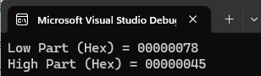

Task 3:
Include Irvine32.inc

.data
shop DWORD 1200, 1500, 900, 1750, 2000

msg1 BYTE "Total Sales = ", 0
.code
main PROC

mov eax, 0
mov esi, offset shop

add eax, [esi]
add esi, type shop

add eax, [esi]
add esi, type shop

add eax, [esi]
add esi, type shop

add eax, [esi]
add esi, type shop

add eax, [esi]

mov edx, offset msg1
call writestring

call writeInt
call Crlf

exit
main ENDP
END main

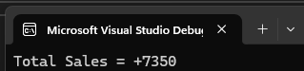

Task 4:
INCLUDE Irvine32.inc

.data
cinema WORD 500, 750, 750, 1000, 1000, 1200
msg1 BYTE "Price of Seat 4 = ",0
.code
main PROC
mov esi, 3

mov edx, offset msg1
call WriteString

mov ax, [cinema + (TYPE cinema * esi)]
movzx EAX, ax
call WriteInt
exit
main ENDP
END main

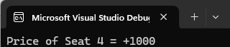

Task 5:
INCLUDE Irvine32.inc

.data
scanner DWORD 250, 899, 1500, 375
msg1 BYTE "Items Scanned = ",0
msg2 BYTE "Memory used (Bytes) = ",0
msg3 BYTE "Total Bill (Cents) = ", 0

.code
main PROC
mov edx, offset msg1
call writestring

mov esi, TYPE scanner
mov eax, esi
call WriteINT
call Crlf

mov eax, SIZEOF scanner
mov edx, offset msg2
call WriteString
call WriteInt
call Crlf

mov eax, [scanner]
add eax, [scanner + esi]
add esi, type scanner
add eax, [scanner + esi]
add esi, type scanner
add eax, [scanner + esi]

mov edx, offset msg3
call writeString
call WriteInt

exit
main ENDP
END main

