Name: Muhammad Farhan

Roll no: 25K-0538
Section: BCS-2K

Course: Object Oriented Programming – Lab
Course Instructor:
Sir Muhammad Owais
Lab 7 Tasks Submission

Task 1:
#include <iostream>
#include <string>
using namespace std;

class Content
{
protected:
static int counter;
const int contentID;
string title;
public:
Content(string t): title(t), contentID(counter++) {}

void virtual displayContent()
{
cout<<"Content ID:\t"<<contentID<<endl;
cout<<"Title: \t\t"<<title<<endl;
}
};

class VideoLesson: public Content
{
protected:
int videoLength;
public:
VideoLesson(string t, int len): Content(t), videoLength(len) {}

void displayContent()
{
cout<<"Content ID:\t"<<contentID<<endl;
cout<<"Title: \t\t"<<title<<endl;
cout <<"Video Length: \t"<<videoLength<<endl<<endl;
}
};

class AudioLecture: public Content
{
protected:
int audioLength;
public:
AudioLecture(string t, int len): Content(t), audioLength(len) {}

void displayContent()
{
cout<<"Content ID:\t"<<contentID<<endl;
cout<<"Title: \t\t"<<title<<endl;
cout <<"Audio Length: \t"<<audioLength<<endl<<endl;
}
};

class TextTutorial: public Content
{
protected:
int numOfPages;
public:
TextTutorial(string t, int num): Content(t), numOfPages(num) {}

void displayContent()
{
cout<<"Content ID:\t"<<contentID<<endl;
cout<<"Title: \t\t"<<title<<endl;
cout <<"Audio Length: \t"<<numOfPages<<endl<<endl;
}
};

int Content::counter=0;

int main()
{
Content* Array[3];
VideoLesson video1("OOP Lab 7", 20);
AudioLecture audio1("EW Lab 6", 10);
TextTutorial text1("EW Lab 7", 10);

Array[0] = &video1;
Array[1] = &audio1;
Array[2] = &text1;

for (int i = 0; i < 3; ++i)
{
Array[i]->displayContent();
}

return 0;
}
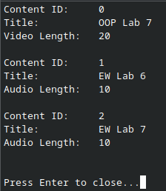

Task 2:
#include <iostream>
#include <string>
using namespace std;

class Shipment
{
protected:
static int counter;
const int shipmentID;
float weight;
public:
Shipment(float w): weight(w), shipmentID(counter++) {}

float virtual calculateCost() {return 0.0;}
};

class StandardDelivery:public Shipment
{
public:
StandardDelivery(float w): Shipment(w) {}

float calculateCost() {return weight*5;}
};

class ExpressDelivery: public Shipment
{
public:
ExpressDelivery(float w): Shipment(w) {}

float calculateCost() {return (weight*8.0)+50;}
};

class InternationalDelivery: public Shipment
{
public:
InternationalDelivery(float w): Shipment(w) {}

float calculateCost() {return (weight*12.0)+100;}
};

int Shipment::counter=0;

int main()
{
Shipment* Array[3];
StandardDelivery normal(20);
ExpressDelivery fast(20);
InternationalDelivery global(20);

Array[0] = &normal;
Array[1] = &fast;
Array[2] = &global;

for (int i = 0; i < 3; ++i)
{
cout<<"Shipement #"<<i+1<<" Cost:\t"<<Array[i]->calculateCost()<<endl<<endl;
}

return 0;
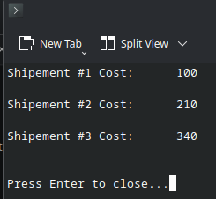
}

Task 3:
#include <iostream>
#include <string>
using namespace std;

class Device
{
protected:
const string deviceID;
string status;
public:
Device(string ID="N/A", string stat="OFF"): deviceID(ID), status(stat) {}
virtual ~Device() {}

virtual void turnOn() {status="ON";}
void turnOff() {status="OFF";}
string getStatus() {return status;}
};

class Light: virtual public Device
{
protected:
int brightness;
public:
Light(string ID="N/A", string stat="OFF"): Device(ID, stat), brightness(0) {}
void turnOn() override { status="ON"; cout<<"Light "<<deviceID<<" turned ON"<<endl; }
void dim(int level)
{
if(level <=100 && level>=0)
{
brightness=level;
cout<<"Light "<<deviceID<<" brightness set to "<<level<<"%"<<endl;
}
else
cout<<"Invalid Brightness Input.\n"<<endl;
}

};

class Camera: virtual public Device
{
protected:
bool isRecording;
public:
Camera(string ID="N/A", string stat="OFF"): Device(ID, stat), isRecording(false) {}

void turnOn() override { status="ON"; cout<<"Camera "<<deviceID<<" started recording"<<endl; }
void startRecording()
{
isRecording=true;
cout<<"Camera "<<deviceID<<" started recording"<<endl;
}
};

class Thermostat: public Light, public Camera
{
int temperature;
public:
Thermostat(string ID="N/A", string stat="OFF"):Device(ID,stat), Light(ID,stat), Camera(ID,stat), temperature(35) {}
void turnOn() override { status="ON"; cout<<"Thermostat "<<deviceID<<" temperature set to "<<temperature<<" degrees C"<<endl; }
void setTemperature(int t)
{
temperature=t;
cout<<"Thermostat "<<deviceID<<" temperature set to "<<t<<" degrees C"<<endl;
}
};

class Routine
{
const string routineID;
string name;
Device **devices;
int count, capacity;
public:
Routine(string ID="N/A", string n="N/A"): routineID(ID), name(n), count(0), capacity(1) {devices = new Device*[capacity];}

void addDevice(Device* d)
{
if(count==capacity)
{
capacity*=2;
Device** temp = new Device* [capacity];

for(int i=0; i<count; ++i)
temp[i]=devices[i];

delete[] devices;
devices = temp;
temp=nullptr;
}
devices[count++] = d;
}

void addDevice(Device* arr[], int l)
{
for(int i=0;i<l;++i)
addDevice(arr[i]);
}

void execute()
{
for(int i=0; i<count; ++i)
{
devices[i]->turnOn();
}
}
~Routine() {delete[] devices;}
};

class Homeowner
{
private:
const string homeownerID;
string name;
public:
Homeowner(string ID="N/A", string n="N/A"): homeownerID(ID), name(n) {}

void createRoutine(Routine r) {r.execute();}

void controlDevice(Device* d) {d->turnOn();}
};

int main()
{
Light l1("L1", "OFF");
l1.dim(80);
Camera c1("C1", "OFF");
Thermostat t1("T1", "OFF");
t1.setTemperature(24);

l1.turnOn();
l1.dim(50);
c1.startRecording();
t1.setTemperature(22);

Routine r("R1", "Morning Mode");
Device* arr[] = {&l1, &c1, &t1};
r.addDevice(arr, 3);
cout<<"Routine \"Morning Mode\" executed:"<<endl;
r.execute();

return 0;
}
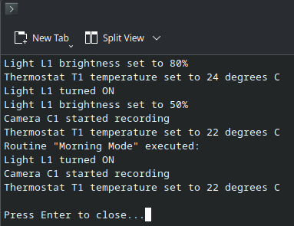
Note: All codes are uploaded to my Github, You can check them at anytime. The link Is uploaded alongside this word document.

