Name : Muhammad Farhan

Roll no: 25K-0538

Section: BCS-2K

Course: Object Oriented Programming – Lab

Course Instructor: Sir Muhammad Owais

Lab: 11
Tasks: 5

Task 1:
#include <iostream>
#include <string>
using namespace std;

template <typename T, typename U>
class Pair
{
private:
T variable_one;
U variable_two;

public:
Pair(T var1, U var2) : variable_one(var1), variable_two(var2)
{}

void display()
{
cout << "Pair: (" << variable_one << "," << variable_two << ")\n";
}
};

int main()
{
Pair<int, string> pair_one(5, "Hello");
Pair<double, int> pair_two(3.14, 42);

pair_one.display();
pair_two.display();

return 0;
};
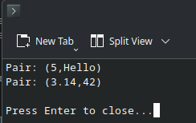

Task 2:
#include <iostream>
#include <string>
using namespace std;

class InsufficientFundsException
{
private:
string error_message;

public:
InsufficientFundsException(string msg) : error_message(msg)
{}

string getMessage()
{
return error_message;
}
};

class BankAccount
{
private:
double balance;

public:
BankAccount(double in_balance) : balance(in_balance)
{
}

void withdraw(double amount)
{
if (amount > balance)
{
throw InsufficientFundsException("Insufficient Funds to complete withdrawl.");
}
balance -= amount;
cout << "Withdrawl Successful.\n";
}

double getBalance()
{
return balance;
}
};

int main()
{
BankAccount account_one(600);
try
{
cout << "Current Balance: " << account_one.getBalance() << "\n";
account_one.withdraw(200);
cout << "Current Balance: " << account_one.getBalance() << "\n";
account_one.withdraw(800);
}
catch(InsufficientFundsException e)
{
cout << "Error: " << e.getMessage() << "\n";
}
cout << "Current Balance: " << account_one.getBalance() << "\n";

return 0;
}
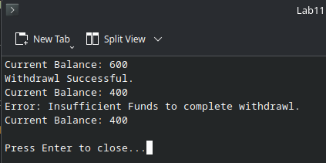

Task 3:
#include <iostream>
#include <string>
using namespace std;

class Exception
{
private:
string error;

public:
Exception(string msg) : error(msg)
{}

string getError()
{
return error;
}
};

template <typename T>
class DataTool
{
private:
T* array;
int size;

public:
DataTool(T* input_array, int input_size) : array(input_array), size(input_size)
{}

T findMax()
{
if (size <= 0)
{
throw Exception("Array is Empty.");
}
T max = array[0];
for (int i = 0 ; i < size ; i++)
{
if (array[i] > max)
{
max = array[i];
}
}
return max;
}
};

int main()
{
int int_array[] = {15, 25, 24, 16, 9, 39, 69};
int int_size = sizeof(int_array) / sizeof(int_array[0]);
//basically a guaranteed way to get the size of any array of any data type, you could hard code it to divide by 4 for int only

try
{
DataTool<int> tool_one(int_array, int_size);
cout << "Max Integer: " << tool_one.findMax() << "\n";
}
catch(Exception e)
{
cout << "Error: " << e.getError();
}
double double_array[] = {23.432, 54.453, 3.444, 6.9999};
double double_size = sizeof(double_array) / sizeof(double_array[0]);

try
{
DataTool<double> tool_two(double_array, double_size);
cout << "Max Double: " << tool_two.findMax() << "\n";
}
catch(Exception e)
{
cout << "Error: " << e.getError();
}

return 0;
}
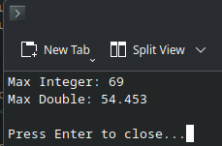

Task 4:
#include <iostream>
#include <string>
using namespace std;

class BaseException
{
private:
string message;

public:
BaseException(string msg) : message(msg)
{}

string getError() const
{
return message;
}
};

class InvalidAgeException : public BaseException
{
public:
InvalidAgeException(string msg) : BaseException(msg)
{}
};

class InvalidSalaryException : public BaseException
{
public:
InvalidSalaryException(string msg) : BaseException(msg)
{}
};

class InvalidHeightException : public BaseException
{
public:
InvalidHeightException(string msg) : BaseException(msg)
{}
};

int main()
{
int age, salary;
double height;

try
{
cout << "Enter Age: ";
cin >> age;
if (age <=0 || age >= 120)
{
throw InvalidAgeException("Age must be between 1 and 119.");
}

cout << "Enter Salary: ";
cin >> salary;
if (salary <= 0)
{
throw InvalidSalaryException("Salary must be Positive.");
}

cout << "Enter Height: ";
cin >> height;
if (height <= 0)
{
throw InvalidHeightException("Height must be Positive.");
}
}
catch (const InvalidAgeException& e)
{
cout << "InvalidAgeException caught: " << e.getError() << "\n";
}
catch (const InvalidSalaryException& e)
{
cout << "InvalidSalaryException caught: " << e.getError() << "\n";
}
catch (const InvalidHeightException& e)
{
cout << "InvalidHeightException caught: " << e.getError() << "\n";
}

return 0;
}

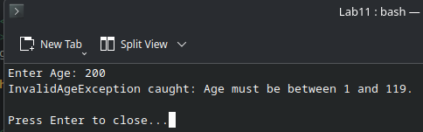

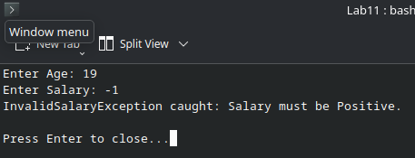

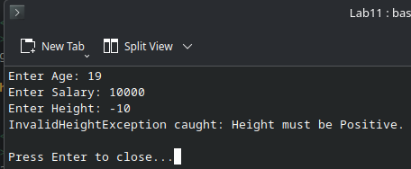

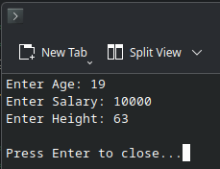

Task 5:

#include <iostream>
#include <string>
using namespace std;

class OutOfBoundsException
{
private:
string error;

public:
OutOfBoundsException(string msg) : error(msg)
{}

string getError() const
{
return error;
}
};

template <typename T>
class SmartArray
{
private:
T* Array;
int size;

public:
SmartArray(int input_size) : size(input_size)
{
Array = new T[size];
}

~SmartArray()
{
delete []Array;
}

T& operator[] (int index)
{
if (index < 0 || index >= size)
{
throw OutOfBoundsException("Invalid index access attempted.");
}
return Array[index];
}
};

int main()
{
SmartArray<int> array_one(5);

try
{
for (int i = 0 ; i < 5 ; i++)
{
array_one[i] = i;
}

for (int i = 0 ; i < 5 ; i++)
{
cout << "Index " << i << ": " << array_one[i] << "\n";
}

cout << "Index 5: " <<array_one[5] << "\n";
}
catch (const OutOfBoundsException& e)
{
cout << "Error: " << e.getError();
}
}

