Name: Muhammad Farhan
Roll no: 25K-0538
Section: BCS-3K
Course: Data Structures
Course Instructor: Sir Shoaib Rauf
Assignment: 2
Date of Submission: 01/11/2026

Question 1:
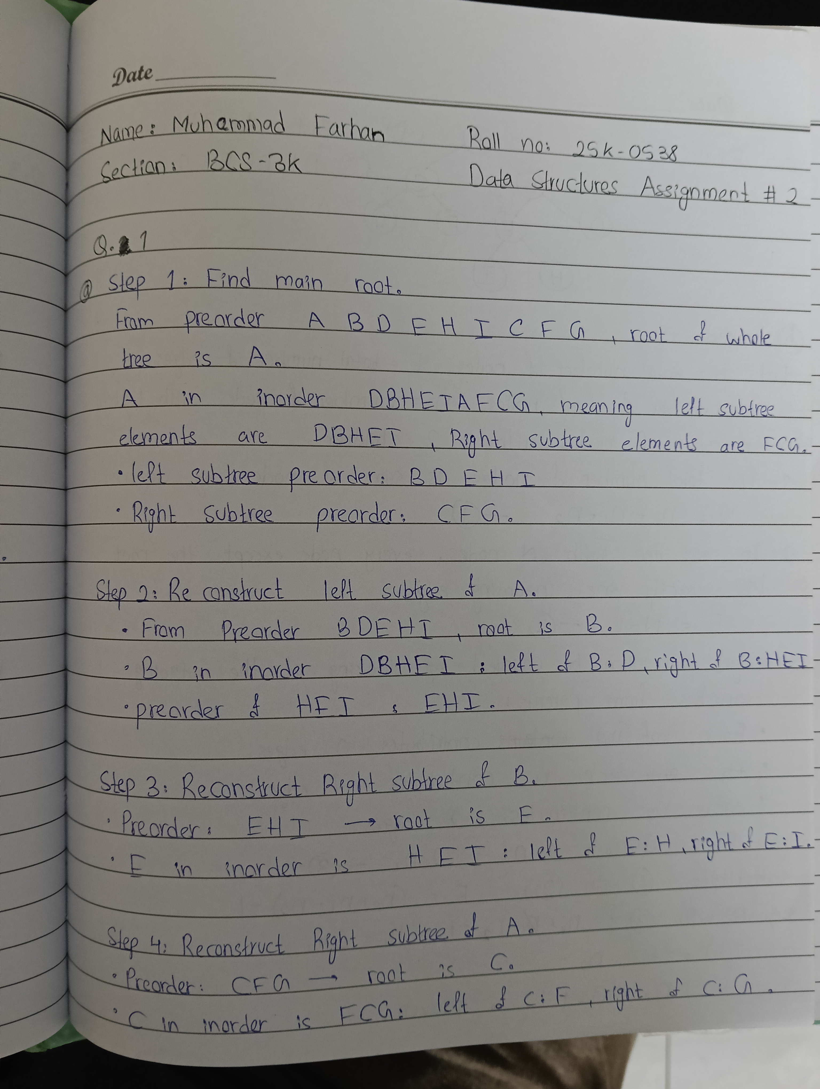

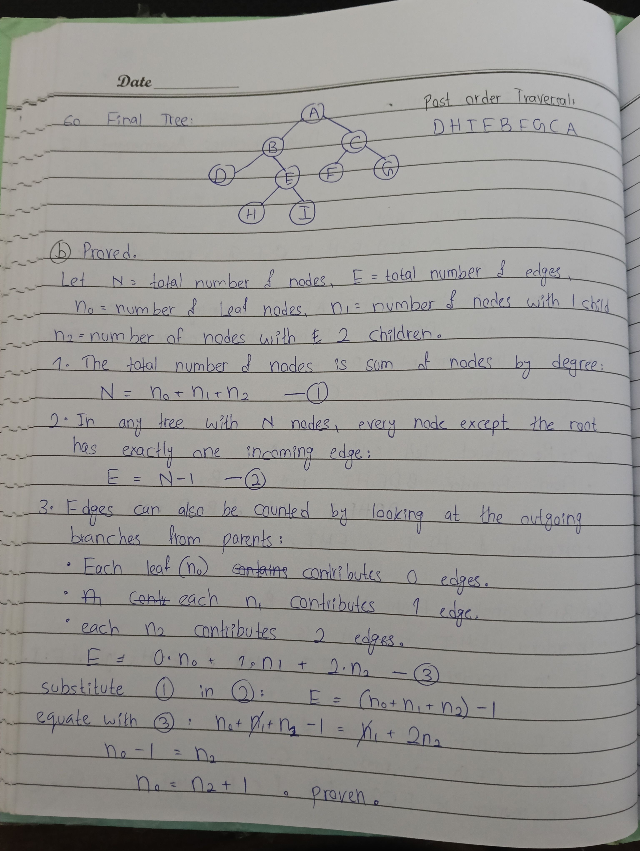

Question 2:
#include <iostream>
#include <string>

using namespace std;

struct Node
{
int key;
Node* left;
Node* right;

Node(int value) : key(value), left(nullptr), right(nullptr)
{
}
};

class BST
{
private:
Node* root;

// helper to insert a key recursively; ignores duplicates
Node* insert_helper(Node* current, int key)
{
if (current == nullptr)
{
return new Node(key);
}
if (key < current->key)
{
current->left = insert_helper(current->left, key);
}
else if (key > current->key)
{
current->right = insert_helper(current->right, key);
}
return current;
}

// helper to search for a key recursively
bool search_helper(Node* current, int key)
{
if (current == nullptr)
{
return false;
}
if (current->key == key)
{
return true;
}
if (key < current->key)
{
return search_helper(current->left, key);
}
return search_helper(current->right, key);
}

// helper to find the node with the minimum value
Node* find_min_node(Node* current)
{
while (current != nullptr && current->left != nullptr)
{
current = current->left;
}
return current;
}

// helper to find the node with the maximum value
Node* find_max_node(Node* current)
{
while (current != nullptr && current->right != nullptr)
{
current = current->right;
}
return current;
}

// helper to delete a key handling leaf, 1-child, and 2-child cases
Node* delete_helper(Node* current, int key)
{
if (current == nullptr)
{
return nullptr;
}

if (key < current->key)
{
current->left = delete_helper(current->left, key);
}
else if (key > current->key)
{
current->right = delete_helper(current->right, key);
}
else
{
// case 1: Leaf node aka no children
if (current->left == nullptr && current->right == nullptr)
{
delete current;
return nullptr;
}

// case 2: one child
if (current->left == nullptr)
{
Node* temp = current->right;
delete current;
return temp;
}
else if (current->right == nullptr)
{
Node* temp = current->left;
delete current;
return temp;
}

// case 3: two children
// find inorder successor, which is the smallest node in right subtree
Node* successor = find_min_node(current->right);
current->key = successor->key;
current->right = delete_helper(current->right, successor->key);
}
return current;
}

// helper to compute height. edges: empty is -1, single node is 0
int height_helper(Node* current)
{
if (current == nullptr)
{
return -1;
}
int left_height = height_helper(current->left);
int right_height = height_helper(current->right);
if (left_height > right_height)
{
return left_height + 1;
}
else
{
return right_height + 1;
}
}

// helper to free allocated memory
void destroy_tree(Node* current)
{
if (current != nullptr)
{
destroy_tree(current->left);
destroy_tree(current->right);
delete current;
}
}

public:
BST() : root(nullptr)
{
}

~BST()
{
destroy_tree(root);
}

void insert(int key)
{
root = insert_helper(root, key);
}

bool search(int key)
{
return search_helper(root, key);
}

void delete_node(int key)
{
root = delete_helper(root, key);
}

int find_min()
{
if (root == nullptr)
{
cout << "Tree is empty\n";
return -1;
}
return find_min_node(root)->key;
}

int find_max()
{
if (root == nullptr)
{
cout << "Tree is empty\n";
return -1;
}
return find_max_node(root)->key;
}

int height()
{
return height_helper(root);
}

// Inorder successor without using parent pointers
int inorder_successor(int key)
{
Node* current = root;
Node* target = nullptr;
Node* successor = nullptr;

// find target node while tracking the deepest node we turned left from
while (current != nullptr)
{
if (key < current->key)
{
successor = current;
current = current->left;
}
else if (key > current->key)
{
current = current->right;
}
else
{
target = current;
break;
}
}

if (target == nullptr)
{
cout << "Key not found\n";
return -1;
}

// case A, right subtree exists means min value in right subtree
if (target->right != nullptr)
{
return find_min_node(target->right)->key;
}

// case B, no right subtree means lowest ancestor where target is in left subtree
if (successor != nullptr)
{
return successor->key;
}

cout << "No inorder successor exists\n";
return -1;
}
};
Question 3:
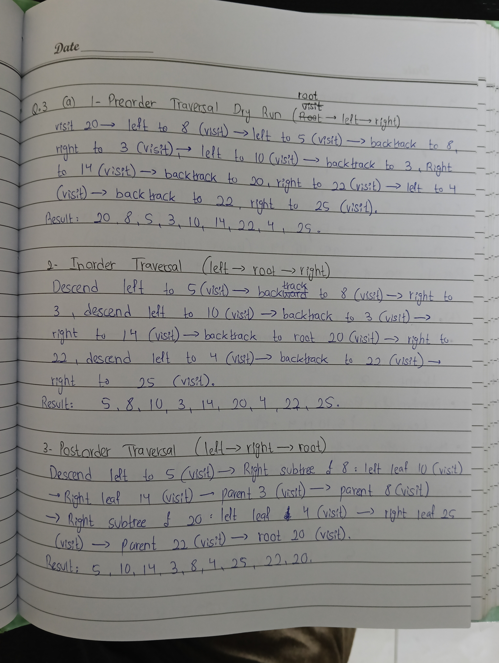

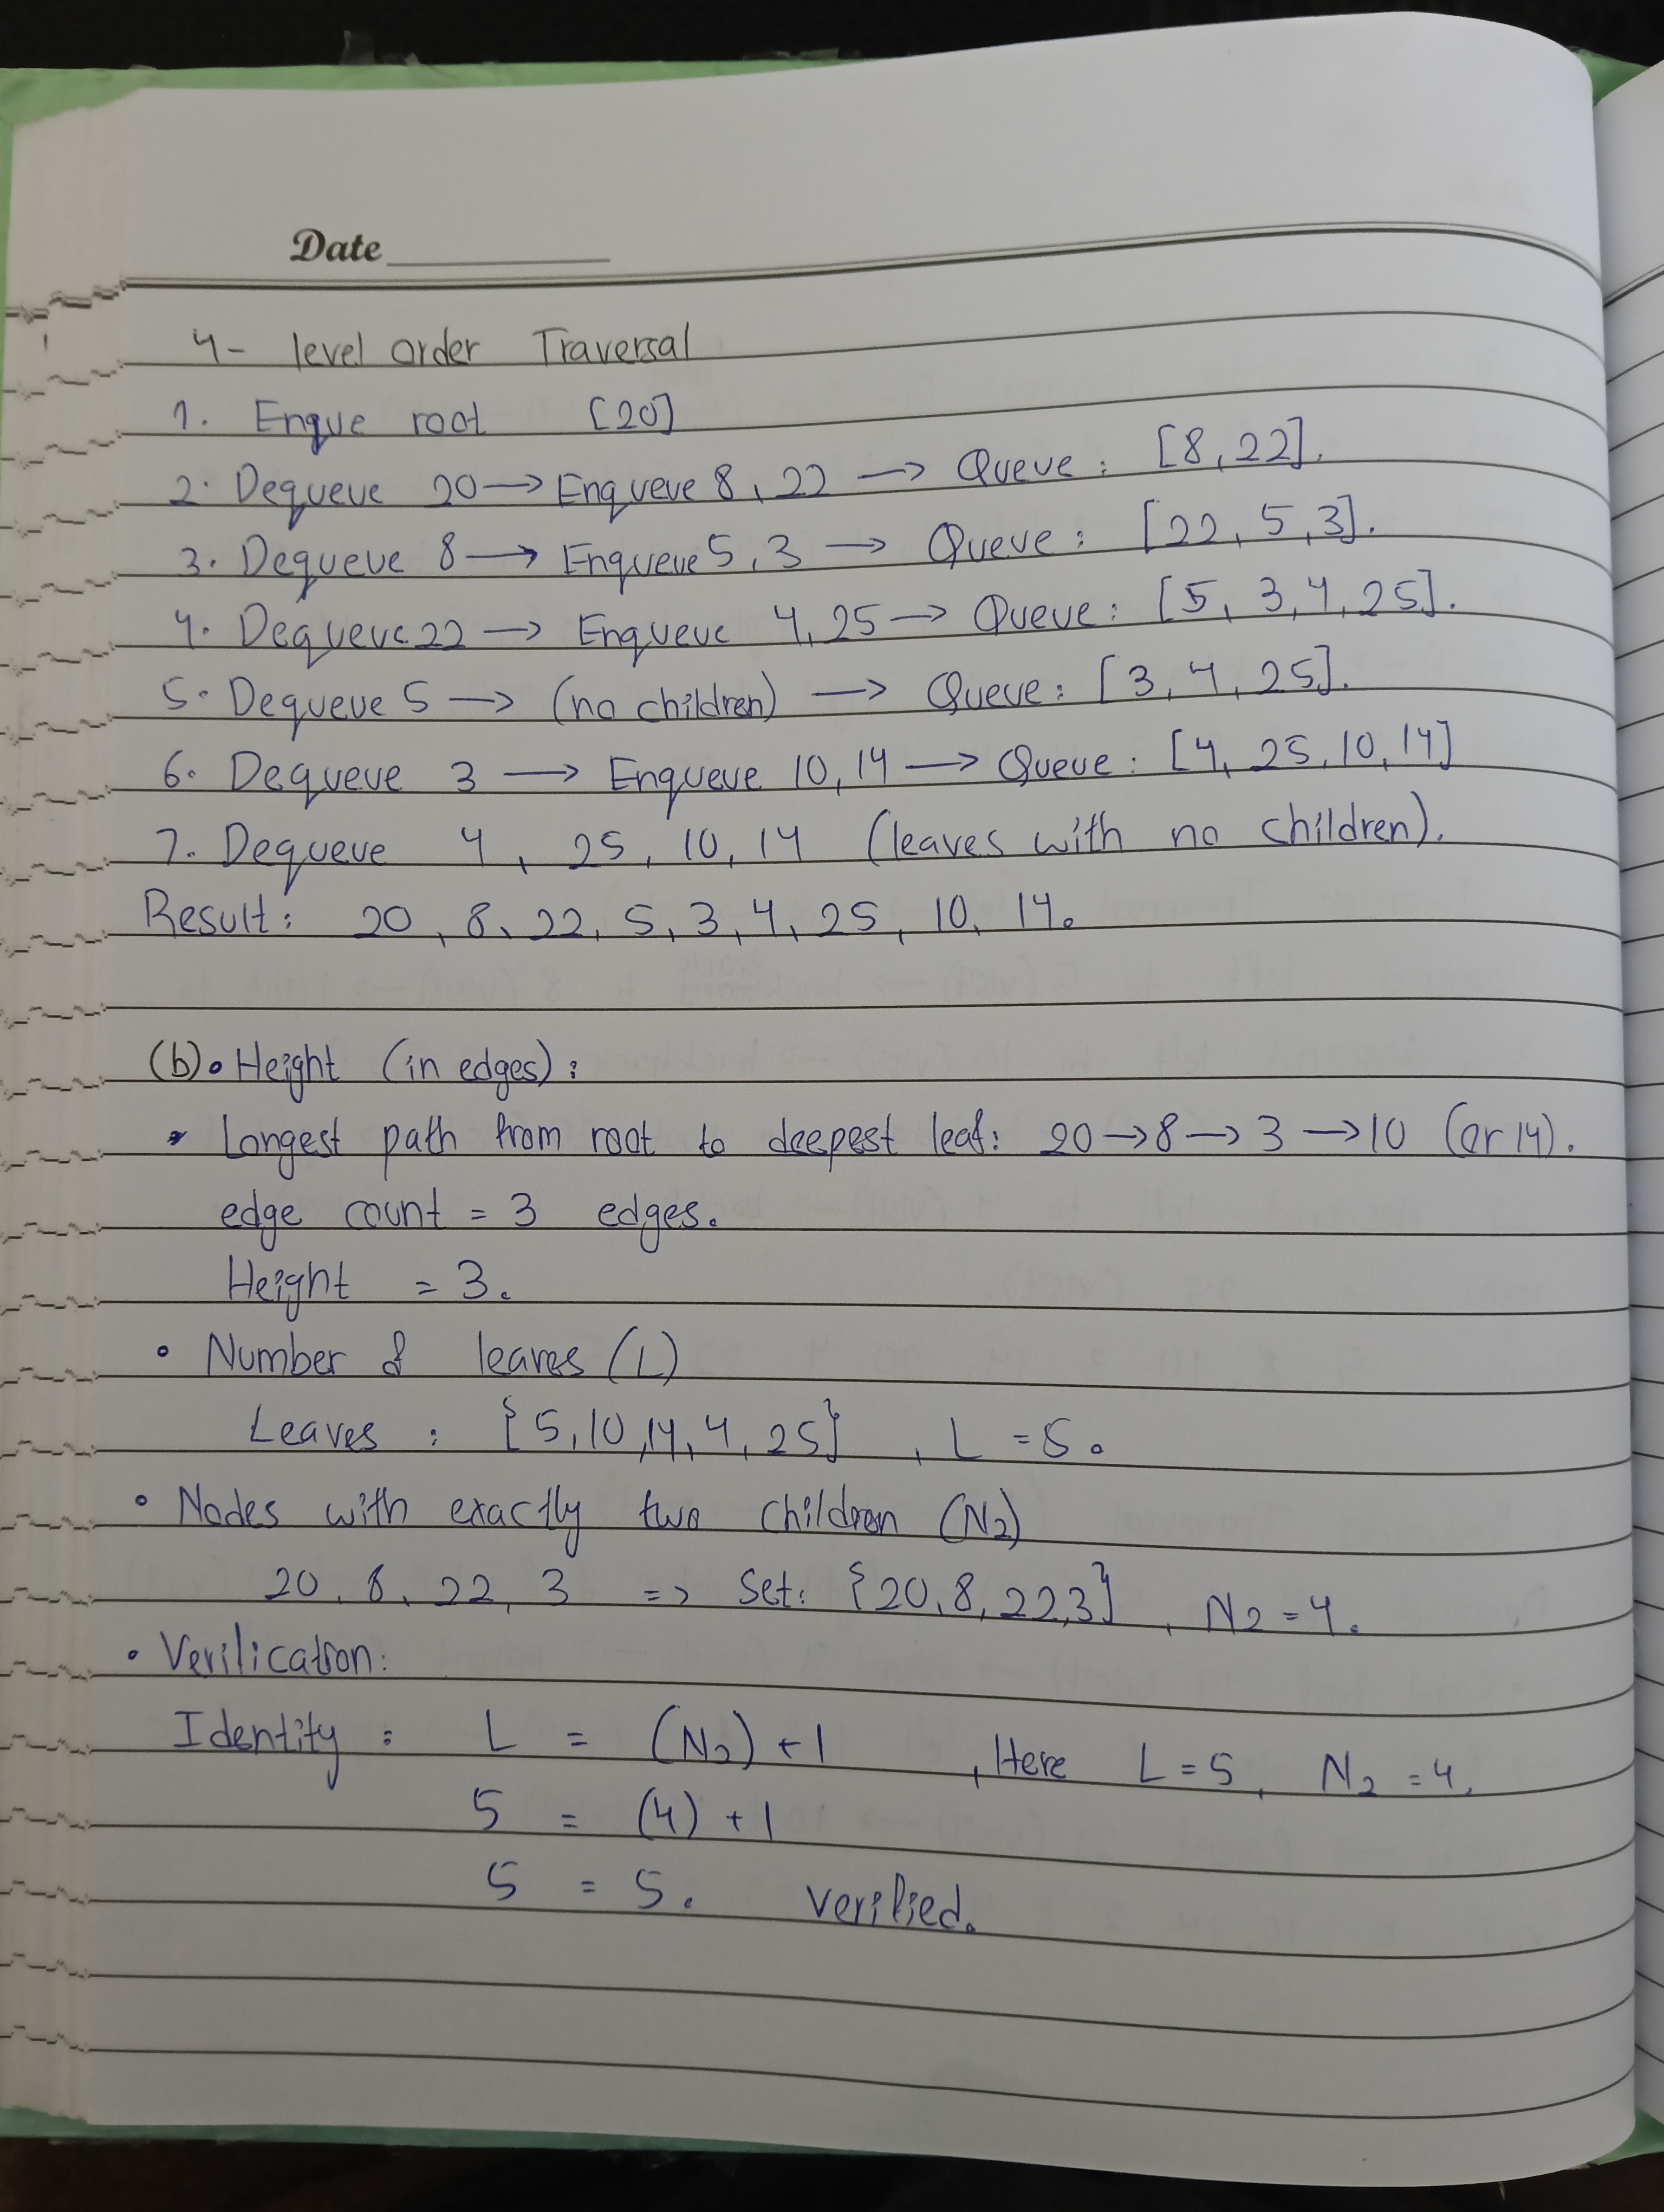

Question 4:
#include <iostream>
#include <string>

using namespace std;

class MinHeap
{
private:
int* heap_array;
int capacity;
int heap_size;

// helper functions to get indices
int parent(int index)
{
return (index - 1) / 2;
}

int left_child(int index)
{
return (2 * index) + 1;
}

int right_child(int index)
{
return (2 * index) + 2;
}

// helper to swap two elements in the array
void swap_nodes(int index_one, int index_two)
{
int temp = heap_array[index_one];
heap_array[index_one] = heap_array[index_two];
heap_array[index_two] = temp;
}

// restores heap property upward and prints array after every swap
void sift_up(int index, int& swap_count)
{
while (index > 0 && heap_array[parent(index)] > heap_array[index])
{
swap_nodes(index, parent(index));
swap_count++;
index = parent(index);
cout << "swap " << swap_count << ": ";
print_heap();
}
}

// restores heap property downward and prints array after every swap
void sift_down(int index)
{
int smallest = index;
int left = left_child(index);
int right = right_child(index);

if (left < heap_size && heap_array[left] < heap_array[smallest])
{
smallest = left;
}

if (right < heap_size && heap_array[right] < heap_array[smallest])
{
smallest = right;
}

if (smallest != index)
{
swap_nodes(index, smallest);
cout << "after swap: ";
print_heap();
sift_down(smallest);
}
}

public:
MinHeap(int max_capacity) : heap_array(new int[max_capacity]), capacity(max_capacity), heap_size(0)
{
}

~MinHeap()
{
delete[] heap_array;
}

// loads the given initial array h
void load_array(int source_array[], int size)
{
heap_size = size;
for (int i = 0; i < size; i++)
{
heap_array[i] = source_array[i];
}
}

// inserts a new job deadline into the min heap
void insert(int key, int& swap_count)
{
if (heap_size == capacity)
{
cout << "Heap is full\n";
return;
}

heap_array[heap_size] = key;
heap_size++;
sift_up(heap_size - 1, swap_count);
}

// removes and returns the minimum deadline
int extract_min()
{
if (heap_size <= 0)
{
cout << "Heap is empty\n";
return -1;
}

if (heap_size == 1)
{
heap_size--;
return heap_array[0];
}

int min_value = heap_array[0];
heap_array[0] = heap_array[heap_size - 1];
heap_size--;

cout << "last element moved to root: ";
print_heap();

sift_down(0);

return min_value;
}

// decreases the deadline of a job at a given index
void decrease_key(int index, int new_value)
{
if (index < 0 || index >= heap_size)
{
cout << "Invalid index\n";
return;
}

if (new_value > heap_array[index])
{
cout << "New value is greater than current value\n";
return;
}

heap_array[index] = new_value;
int dummy_swaps = 0;
sift_up(index, dummy_swaps);
}

// prints the current array representation
void print_heap()
{
for (int i = 0; i < heap_size; i++)
{
cout << heap_array[i] << " ";
}
cout << "\n";
}
};

int main()
{
MinHeap scheduler(30);

// initial array h from given data
int initial_h[] = {5, 11, 8, 14, 17, 9, 12, 20, 16, 19};
scheduler.load_array(initial_h, 10);

cout << "initial array h:\n";
scheduler.print_heap();

// part b
cout << "\npart b:\n";
int total_swaps = 0;
cout << "inserting 6:\n";
scheduler.insert(6, total_swaps);
cout << "inserting 4:\n";
scheduler.insert(4, total_swaps);
cout << "total swaps in part b: " << total_swaps << "\n";

// part c
cout << "\npart c:\n";
cout << "first extract min:\n";
scheduler.extract_min();
cout << "second extract min:\n";
scheduler.extract_min();

// part d
cout << "\npart d:\n";
cout << "decreasing key at index 7 from 20 to 3:\n";
scheduler.decrease_key(7, 3);

return 0;
}

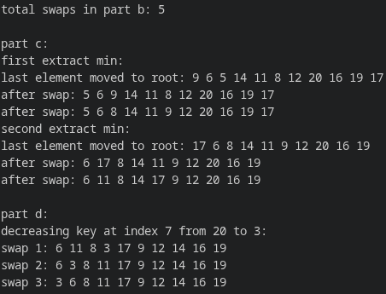

Question 5:
#include <iostream>
#include <string>

using namespace std;

struct Job
{
string name;
int priority;
int arrival_order;

Job() : name(""), priority(0), arrival_order(0)
{
}

Job(string job_name, int job_priority, int job_order) : name(job_name), priority(job_priority), arrival_order(job_order)
{
}
};

class PriorityQueue
{
private:
Job* heap_array;
int capacity;
int heap_size;
int arrival_counter;

//helper functions to get tree indices
int parent(int index)
{
return (index - 1) / 2;
}

int left_child(int index)
{
return (2 * index) + 1;
}

int right_child(int index)
{
return (2 * index) + 2;
}

//return true if job at first index has higher priority than job at second index
bool has_higher_priority(int first_index, int second_index)
{
if (heap_array[first_index].priority < heap_array[second_index].priority)
{
return true;
}
if (heap_array[first_index].priority == heap_array[second_index].priority)
{
return heap_array[first_index].arrival_order < heap_array[second_index].arrival_order;
}
return false;
}

//swap two jobs in the array
void swap_jobs(int first_index, int second_index)
{
Job temp = heap_array[first_index];
heap_array[first_index] = heap_array[second_index];
heap_array[second_index] = temp;
}

//moves a job up to restore heap order
void sift_up(int index)
{
while (index > 0 && has_higher_priority(index, parent(index)))
{
swap_jobs(index, parent(index));
index = parent(index);
}
}

//moves a job down to restore heap order
void sift_down(int index)
{
int highest = index;
int left = left_child(index);
int right = right_child(index);

if (left < heap_size && has_higher_priority(left, highest))
{
highest = left;
}

if (right < heap_size && has_higher_priority(right, highest))
{
highest = right;
}

if (highest != index)
{
swap_jobs(index, highest);
sift_down(highest);
}
}

public:
PriorityQueue(int max_capacity) : heap_array(new Job[max_capacity]), capacity(max_capacity), heap_size(0), arrival_counter(0)
{
}

~PriorityQueue()
{
delete[] heap_array;
}

//pushes a new job into the priority queue
void push(string job_name, int priority)
{
if (heap_size == capacity)
{
cout << "queue is full\n";
return;
}

arrival_counter++;
heap_array[heap_size] = Job(job_name, priority, arrival_counter);
heap_size++;
sift_up(heap_size - 1);
}

//removes and returns the highest priority job
string pop()
{
if (heap_size <= 0)
{
cout << "queue is empty\n";
return "";
}

string top_job = heap_array[0].name;
heap_array[0] = heap_array[heap_size - 1];
heap_size--;
sift_down(0);

return top_job;
}

//returns the highest priority job without removing it
string peek()
{
if (heap_size <= 0)
{
cout << "queue is empty\n";
return "";
}

return heap_array[0].name;
}
};

int main()
{
PriorityQueue print_server(20);

//priorities from the given data: j1(3), j2(1), j3(2), j4(1), j5(3), j6(2)
int p_j1 = 3;
int p_j2 = 1;
int p_j3 = 2;
int p_j4 = 1;
int p_j5 = 3;
int p_j6 = 2;

//step 1 to 3
print_server.push("J1", p_j1);
print_server.push("J2", p_j2);
print_server.push("J3", p_j3);

//step 4
cout << "step 4 pop: " << print_server.pop() << "\n";

//step 5 to 6
print_server.push("J4", p_j4);
print_server.push("J5", p_j5);

//step 7 to 8
cout << "step 7 pop: " << print_server.pop() << "\n";
cout << "step 8 pop: " << print_server.pop() << "\n";

//step 9
print_server.push("J6", p_j6);

//step 10 to 12
cout << "step 10 pop: " << print_server.pop() << "\n";
cout << "step 11 pop: " << print_server.pop() << "\n";
cout << "step 12 pop: " << print_server.pop() << "\n";

return 0;
}

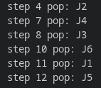

Question 6:
#include <iostream>
#include <string>

using namespace std;

struct Student
{
string student_id;
string name;
string department;
double cgpa;
string award;

Student() : student_id(""), name(""), department(""), cgpa(0.0), award("None")
{
}

Student(string id, string student_name, string dept, double student_cgpa) : student_id(id), name(student_name), department(dept), cgpa(student_cgpa), award("None")
{
}
};

//merges two sorted subarrays into one in descending order
void merge(Student* students, int left, int mid, int right)
{
int left_size = mid - left + 1;
int right_size = right - mid;

//allocate temporary arrays for left and right halves
Student* left_arr = new Student[left_size];
Student* right_arr = new Student[right_size];

for (int i = 0; i < left_size; i++)
{
left_arr[i] = students[left + i];
}
for (int j = 0; j < right_size; j++)
{
right_arr[j] = students[mid + 1 + j];
}

int i = 0;
int j = 0;
int k = left;

//using >= ensures stability by picking the left element first on tie
while (i < left_size && j < right_size)
{
if (left_arr[i].cgpa >= right_arr[j].cgpa)
{
students[k] = left_arr[i];
i++;
}
else
{
students[k] = right_arr[j];
j++;
}
k++;
}

//copy any remaining elements from left half
while (i < left_size)
{
students[k] = left_arr[i];
i++;
k++;
}

//copy any remaining elements from right half
while (j < right_size)
{
students[k] = right_arr[j];
j++;
k++;
}

delete[] left_arr;
delete[] right_arr;
}

//divide and conquer merge sort
void merge_sort(Student* students, int left, int right)
{
if (left < right)
{
int mid = left + (right - left) / 2;

merge_sort(students, left, mid);
merge_sort(students, mid + 1, right);
merge(students, left, mid, right);
}
}

//assigns rector's list and dean's list based on university criteria
void assign_awards(Student* students, int total_students)
{
for (int i = 0; i < total_students; i++)
{
if (students[i].cgpa >= 3.75)
{
students[i].award = "Rector's List";
}
else if (students[i].cgpa >= 3.50)
{
students[i].award = "Dean's List";
}
else
{
students[i].award = "None";
}
}
}

//displays final ranked merit list handling ties in rank
void display_merit_list(Student* students, int total_students)
{
int current_rank = 1;

for (int i = 0; i < total_students; i++)
{
//update rank only when cgpa drops
if (i > 0 && students[i].cgpa < students[i - 1].cgpa)
{
current_rank = i + 1;
}

cout << "Rank " << current_rank << ": "<< students[i].student_id << " | "<< students[i].name << " | "
<< students[i].department << " | "<< "CGPA: " << students[i].cgpa << " | "<< students[i].award << "\n";
}
}

int main()
{
//ill be honest, i used ai to generate the students list, i am not writing down all 30 by hand.
const int total_students = 30;
Student students[total_students] = {
Student("23K-0101", "Ali Khan", "CS", 3.82),
Student("23K-0102", "Bilal Ahmed", "SE", 3.45),
Student("23K-0103", "Hamza Tariq", "CS", 3.75),
Student("23K-0104", "Ayesha Siddiqui", "AI", 4.00),
Student("23K-0105", "Zainab Fatima", "DS", 3.65),
Student("23K-0106", "Usman Ghani", "CS", 3.20),
Student("23K-0107", "Saad Rehman", "SE", 3.90),
Student("23K-0108", "Hassan Raza", "AI", 3.50),
Student("23K-0109", "Fatima Noor", "CS", 3.75),
Student("23K-0110", "Mustafa Ali", "DS", 3.10),
Student("23K-0111", "Sara Khan", "SE", 3.65),
Student("23K-0112", "Omar Farooq", "CS", 3.95),
Student("23K-0113", "Mariam Tariq", "AI", 3.35),
Student("23K-0114", "Ahmed Raza", "DS", 4.00),
Student("23K-0115", "Danish Iqbal", "CS", 3.55),
Student("23K-0116", "Hiba Malik", "SE", 3.88),
Student("23K-0117", "Zubair Shah", "AI", 2.95),
Student("23K-0118", "Khadija Bibi", "CS", 3.70),
Student("23K-0119", "Taha Siddiqui", "DS", 3.50),
Student("23K-0120", "Anas Javed", "SE", 3.40),
Student("23K-0121", "Noman Bashir", "CS", 3.60),
Student("23K-0122", "Yusra Nadeem", "AI", 3.82),
Student("23K-0123", "Fahad Mustafa", "DS", 3.15),
Student("23K-0124", "Sana Sheikh", "SE", 3.78),
Student("23K-0125", "Haris Mehmood", "CS", 3.65),
Student("23K-0126", "Laiba Arshad", "AI", 3.25),
Student("23K-0127", "Asad Ullah", "DS", 3.52),
Student("23K-0128", "Maham Zahra", "CS", 3.91),
Student("23K-0129", "Waqas Akram", "SE", 2.85),
Student("23K-0130", "Zeeshan Qureshi", "AI", 3.70)
};

merge_sort(students, 0, total_students - 1);
assign_awards(students, total_students);
display_merit_list(students, total_students);

return 0;
}
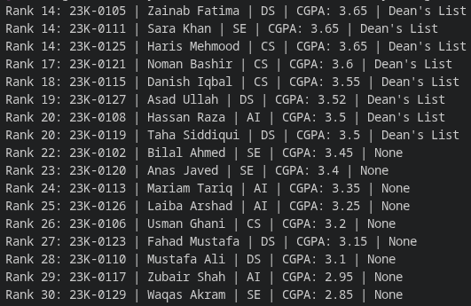

Question 7:

#include <iostream>
#include <string>

using namespace std;

struct Parcel
{
long long tracking_number;
string sender_name;
string destination_city;
int region_code;
Parcel* next;

Parcel() : tracking_number(0), sender_name(""), destination_city(""), region_code(0), next(nullptr)
{
}

Parcel(long long tracking, string sender, string destination, int region) : tracking_number(tracking), sender_name(sender), destination_city(destination), region_code(region), next(nullptr)
{
}
};

void counting_sort_by_digit(Parcel* parcels, int total_parcels, long long place_value)
{
Parcel* output = new Parcel[total_parcels];
int count[10] = {0};

for (int i = 0; i < total_parcels; i++)
{
int digit = (parcels[i].tracking_number / place_value) % 10;
count[digit]++;
}

for (int i = 1; i < 10; i++)
{
count[i] += count[i - 1];
}

// backwards loop preserves stability
for (int i = total_parcels - 1; i >= 0; i--)
{
int digit = (parcels[i].tracking_number / place_value) % 10;
output[count[digit] - 1] = parcels[i];
count[digit]--;
}

for (int i = 0; i < total_parcels; i++)
{
parcels[i] = output[i];
}

delete[] output;
}

// part 1, radix sort for tracking numbers
void radix_sort_tracking(Parcel* parcels, int total_parcels)
{
long long max_value = 0;
for (int i = 0; i < total_parcels; i++)
{
if (parcels[i].tracking_number > max_value)
{
max_value = parcels[i].tracking_number;
}
}

for (long long place_value = 1; max_value / place_value > 0; place_value *= 10)
{
counting_sort_by_digit(parcels, total_parcels, place_value);
}
}

void split_list(Parcel* source, Parcel** front_ref, Parcel** back_ref)
{
Parcel* slow = source;
Parcel* fast = source->next;

while (fast != nullptr)
{
fast = fast->next;
if (fast != nullptr)
{
slow = slow->next;
fast = fast->next;
}
}

*front_ref = source;
*back_ref = slow->next;
slow->next = nullptr;
}

Parcel* merge_lists(Parcel* left_list, Parcel* right_list)
{
if (left_list == nullptr)
{
return right_list;
}
if (right_list == nullptr)
{
return left_list;
}

Parcel* head = nullptr;
Parcel* tail = nullptr;

// <= keeps relative order stable for identical region codes
if (left_list->region_code <= right_list->region_code)
{
head = left_list;
left_list = left_list->next;
}
else
{
head = right_list;
right_list = right_list->next;
}
tail = head;

while (left_list != nullptr && right_list != nullptr)
{
if (left_list->region_code <= right_list->region_code)
{
tail->next = left_list;
left_list = left_list->next;
}
else
{
tail->next = right_list;
right_list = right_list->next;
}
tail = tail->next;
}

if (left_list != nullptr)
{
tail->next = left_list;
}
else
{
tail->next = right_list;
}

return head;
}

// part 2, merge sort on linked list with o(log n) stack space
Parcel* merge_sort_regions(Parcel* head)
{
if (head == nullptr || head->next == nullptr)
{
return head;
}

Parcel* left_half = nullptr;
Parcel* right_half = nullptr;

split_list(head, &left_half, &right_half);

left_half = merge_sort_regions(left_half);
right_half = merge_sort_regions(right_half);

return merge_lists(left_half, right_half);
}

void print_array(Parcel* parcels, int total_parcels)
{
for (int i = 0; i < total_parcels; i++)
{
cout << parcels[i].tracking_number << " "<< parcels[i].sender_name << " "<< parcels[i].destination_city << " "<< parcels[i].region_code << "\n";
}
cout << "\n";
}

void print_list(Parcel* head)
{
Parcel* current = head;
while (current != nullptr)
{
cout << current->region_code << " "<< current->tracking_number << " " << current->sender_name << " "<< current->destination_city << "\n";
current = current->next;
}
cout << "\n";
}

int main()
{
const int total_parcels = 5;
Parcel parcel_array[total_parcels] = {
Parcel(84920, "Farhan", "Karachi", 104),
Parcel(999201931, "Faraz", "Lahore", 102),
Parcel(7, "Ali", "Islamabad", 104),
Parcel(10203040, "Bilal", "Peshawar", 101),
Parcel(504, "Hamza", "Quetta", 102)
};

cout << "Part 1:\n";
radix_sort_tracking(parcel_array, total_parcels);
print_array(parcel_array, total_parcels);

Parcel* head = &parcel_array[0];
for (int i = 0; i < total_parcels - 1; i++)
{
parcel_array[i].next = &parcel_array[i + 1];
}
parcel_array[total_parcels - 1].next = nullptr;

cout << "Part 2:\n";
head = merge_sort_regions(head);
print_list(head);

return 0;
}

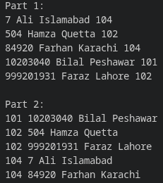

Question 8:
#include <iostream>
#include <string>

using namespace std;

const int N = 4;

void solver(int maze[N][N], int row, int col, string ans, int& path_count)
{
if (row < 0 || col < 0 || row >= N || col >= N || maze[row][col] == 0 || maze[row][col] == -1)
{
return;
}

if (row == N - 1 && col == N - 1)
{
cout << ans << endl;
path_count++;
return;
}

maze[row][col] = -1;

solver(maze, row + 1, col, ans + 'D', path_count);
solver(maze, row, col + 1, ans + 'R', path_count);
solver(maze, row - 1, col, ans + 'U', path_count);
solver(maze, row, col - 1, ans + 'L', path_count);

maze[row][col] = 1;
}

int main()
{
int maze[N][N] = {
{1, 0, 0, 0},
{1, 1, 0, 0},
{0, 1, 0, 0},
{1, 1, 1, 1}
};

int path_count = 0;

if (maze[0][0] == 1 && maze[N - 1][N - 1] == 1)
{
solver(maze, 0, 0, "", path_count);
}

if (path_count == 0)
{
cout << "No path exists" << endl;
}

return 0;
}

Question 9:
#include <iostream>
#include <string>

using namespace std;

class Board
{
private:
int grid[6][8];
int total_arrangements;
string course_names[4];

public:
Board() : total_arrangements(0)
{
for (int i = 0; i < 6; i++)
{
for (int j = 0; j < 8; j++)
{
grid[i][j] = 0;
}
}

course_names[0] = "Programming";
course_names[1] = "Database Systems";
course_names[2] = "Operating Systems";
course_names[3] = "Computer Networks";
}

//checks damaged seat, row, column, and diagonal conflicts
bool is_safe(int row, int col)
{
// seat (3, 3) is unavailable
if (row == 3 && col == 3)
{
return false;
}

//check row
for (int j = 0; j < 8; j++)
{
if (grid[row][j] != 0)
{
return false;
}
}

//check column
for (int i = 0; i < 6; i++)
{
if (grid[i][col] != 0)
{
return false;
}
}

//check diagonals against already placed courses
for (int i = 0; i < 6; i++)
{
for (int j = 0; j < 8; j++)
{
if (grid[i][j] != 0)
{
int row_diff = row - i;
int col_diff = col - j;

if (row_diff < 0)
{
row_diff = -row_diff;
}
if (col_diff < 0)
{
col_diff = -col_diff;
}

if (row_diff == col_diff)
{
return false;
}
}
}
}

return true;
}

void print_board()
{
cout << "Arrangement " << total_arrangements << ":\n";
for (int c = 0; c < 4; c++)
{
for (int i = 0; i < 6; i++)
{
for (int j = 0; j < 8; j++)
{
if (grid[i][j] == c + 1)
{
cout << course_names[c] << " at (" << i << ", " << j << ")\n";
}
}
}
}
cout << "\n";
}

//recursive backtracking function
void assign_seats(int course_index)
{
// base case, all 4 courses placed successfully
if (course_index == 4)
{
total_arrangements++;
print_board();
return;
}

// programming must be placed in row 0
if (course_index == 0)
{
for (int col = 0; col < 8; col++)
{
if (is_safe(0, col))
{
grid[0][col] = course_index + 1;
assign_seats(course_index + 1);
grid[0][col] = 0;
}
}
}
else
{
//other courses can be placed in any remaining row from 1 to 5
for (int row = 1; row < 6; row++)
{
for (int col = 0; col < 8; col++)
{
if (is_safe(row, col))
{
grid[row][col] = course_index + 1;
assign_seats(course_index + 1);
grid[row][col] = 0;
}
}
}
}
}

int get_total()
{
return total_arrangements;
}
};

int main()
{
Board exam_hall;

exam_hall.assign_seats(0);

if (exam_hall.get_total() == 0)
{
cout << "No valid arrangement exists\n";
}
else
{
cout << "Total valid arrangements: " << exam_hall.get_total() << "\n";
}

return 0;
}

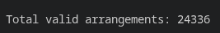

Question 10:
#include <iostream>
#include <string>

using namespace std;

void find_access_codes(int allowed_digits[], int total_allowed, int n, int target_sum, int start_index, int current_count, int current_sum, int current_code[], int& total_combinations)
{
//base case, required number of digits selected
if (current_count == n)
{
if (current_sum == target_sum)
{
total_combinations++;
for (int i = 0; i < n; i++)
{
cout << current_code[i] << " ";
}
cout << "\n";
}
return;
}

for (int i = start_index; i < total_allowed; i++)
{
//skip if adding this digit exceeds the target sum
if (current_sum + allowed_digits[i] > target_sum)
{
continue;
}

//select digit
current_code[current_count] = allowed_digits[i];

//recurse using i + 1 to enforce strictly increasing order and avoid reuse
find_access_codes(allowed_digits, total_allowed, n, target_sum, i + 1, current_count + 1, current_sum + allowed_digits[i], current_code, total_combinations);

//backtrack, reset current position
current_code[current_count] = 0;
}
}

int main()
{
int allowed_digits[] = {1, 2, 3, 4, 5};
int total_allowed = 5;
int n = 3;
int target_sum = 9;

int current_code[10];
int total_combinations = 0;

find_access_codes(allowed_digits, total_allowed, n, target_sum, 0, 0, 0, current_code, total_combinations);

if (total_combinations == 0)
{
cout << "No valid access code found\n";
}
else
{
cout << "Total combinations: " << total_combinations << "\n";
}

return 0;
}


