Name: Muhammad Farhan

Roll no: 25K-0538

Section: BCS-2K

Course: Object Oriented Programming – Lab

Course Instructor: Sir Muhammad Owais

Lab 8 Tasks

Task 1:
#include <iostream>
#include <string>
using namespace std;

class Device
{
protected:
const int DeviceID;
string device_type;
double power_rating;
bool status;

public:
Device(int id, string deviceT, double powerR, bool stat)
:DeviceID(id), device_type(deviceT), power_rating(powerR), status(stat)
{
}

virtual void turnOn()
{
status = true;
}

virtual void turnOff()
{
status = false;
}

virtual double calculatePowerUsage(int hours) = 0;
};

class Lights: public Device
{
public:
Lights(int id, string deviceT, double powerR, bool stat)
: Device(id, deviceT, powerR, stat)
{
}

double calculatePowerUsage(int hours) override
{
return power_rating * hours;
}
};

class Fan: public Device
{
int fan_speed;

public:
Fan(int id, string deviceT, double powerR, bool stat, int fanS)
: Device(id, deviceT, powerR, stat), fan_speed(fanS)
{
}

double calculatePowerUsage(int hours) override
{
return power_rating * hours * fan_speed;
}
};

class AC: public Device
{
int current_temperature;
int desired_temperature;

public:
AC(int id, string deviceT, double powerR, bool stat, int temperature, int desiredTemp)
: Device(id, deviceT, powerR, stat), current_temperature(temperature), desired_temperature(desiredTemp)
{
}

void turnOn() override
{
status = true;
current_temperature = desired_temperature;
}

void turnOff() override
{
current_temperature = desired_temperature;
status = false;
}

double calculatePowerUsage(int hours) override
{
return power_rating * hours * (1 - (current_temperature - desired_temperature) / 100);
}
};

class SecuritySystem: public Device
{
bool system_status_check;
bool intrusion_detection;

public:
SecuritySystem(int id, string deviceT, double powerR, bool stat, bool statusCheck, bool intrusion = false)
: Device(id, deviceT, powerR, stat), system_status_check(statusCheck), intrusion_detection(intrusion)
{
}

void turnOff() override
{
if(system_status_check == true)
{
status = false;
}
else
{
cout << "System Status Check Failed." << endl;
intrusion_detection = true;
}
}

double calculatePowerUsage(int hours) override
{
return power_rating + (system_status_check ? 500 : 100);
//Question doesn't mention the rate, so I made my own.
}

friend void access_security_logs(SecuritySystem& system);
friend class MaintenanceTool;
};

class User
{
protected:
const string user_id;
string user_role;
int access_level;

public:
User(string id, string role, int level)
: user_id(id), user_role(role), access_level(level)
{
}

friend void access_security_logs();

void view_accessible_devices()
{
if (access_level == 1)
{
cout << "1. Lights \n 2. Fans \n 3. Air Conditioners" << endl;
}
else if (access_level == 2)
{
cout << "1. Lights \n 2. Fans \n 3. Air Conditioners \n 4. Security System" << endl;
}
}

void show_security_logs(SecuritySystem& system)
{
if (user_role == "Maintenance Staff" || user_role == "Maintenance staff")
{
access_security_logs(system);
}
else
{
cout << "Access Denied." << endl;
}
}

};

void access_security_logs(SecuritySystem& system)
{
cout << "Security Logs Accessed: " << endl;
if (system.intrusion_detection == true)
{
cout << "-Intrusion Detected" << endl;
cout << "-System Reset Required" << endl;
}
else
{
cout << "No Logs Recorded" << endl;
}
}

class MaintenanceTool
{
public:
void reset_security_alerts(SecuritySystem& system)
{
system.intrusion_detection = false;
}
//This class could have been a function but, the question's requirement I suppose.
};

int main()
{
Lights light(101, "Light", 60.0, false);
Fan fan(102, "Fan", 80.0, false, 3);
AC ac(103, "AC", 200.0, false, 30, 22);
SecuritySystem sec(104, "Security System", 150.0, false, true);

User regular_user("U01", "Regular User", 1);
User maintenance_user("U02", "Maintenance Staff", 2);

cout << "--- Turning Devices On ---" << endl;
light.turnOn();
fan.turnOn();
ac.turnOn();
sec.turnOn();

cout << endl;

cout << "--- Power Usage (5 hours) ---" << endl;
cout << "Lights: " << light.calculatePowerUsage(5) << "Watts" << endl;
cout << "Fan: " << fan.calculatePowerUsage(5) << "Watts" << endl;
cout << "AC: " << ac.calculatePowerUsage(5) << "Watts" << endl;
cout << "Security System: " << sec.calculatePowerUsage(5) << "Watts" << endl;

cout << endl;

cout << "--- Accessible Devices ---" << endl;
cout << "Regular User: " << endl;
regular_user.view_accessible_devices();
cout << "Maintenance Staff: " << endl;
maintenance_user.view_accessible_devices();

cout << endl;

cout << "--- Security Log Access ---" << endl;
cout << "Regular User attempts: " << endl;
regular_user.show_security_logs(sec);
cout << "Maintenance Staff attempts: " << endl;
maintenance_user.show_security_logs(sec);

cout << endl;

cout << "--- Triggering Intrusion ---" << endl;
SecuritySystem sec2(105, "Security System", 150.0, false, false);
sec2.turnOff();
maintenance_user.show_security_logs(sec2);

cout << endl;

cout << "--- Resetting Intrusion Alert ---" << endl;
MaintenanceTool tool;
tool.reset_security_alerts(sec2);

cout << endl;

cout << "Alert reset. Checking logs again: " << endl;
maintenance_user.show_security_logs(sec2);

return 0;
}

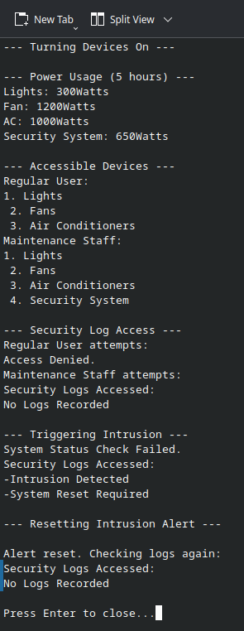

Task 2:
#include <iostream>
#include <string>
using namespace std;

class Account
{
const string account_number;
string account_holder;
double balance;
public:
Account(string number, string name, double balan)
: account_number(number), account_holder(name), balance(balan)
{
}

double operator+(Account& acc2)
{
return balance + acc2.balance;
}

Account& operator-=(double transaction_amount)
{
balance -= transaction_amount;
return *this;
}

Account& operator+=(double transaction_amount)
{
balance += transaction_amount;
return *this;
}

bool operator>(const Account& acc)
{
if (balance > acc.balance)
{
return true;
}
else
{
return false;
}
}

friend ostream& operator<<(ostream& out, const Account& acc1);
};

ostream& operator<<(ostream& out, const Account& acc1)
{
out << "Account Number: " << acc1.account_number << endl;
out << "Account Holder: " << acc1.account_holder << endl;
out << "Balance: " << acc1.balance << endl << endl;
return out;
}

int main()
{
//making objects
Account account1("JP12345", "Farhan", 1000);
Account account2("PK12345", "Faraz", 2000);

//getting total balance
cout << "Total Balance: " << account1 + account2 << endl;

//account details before transfer
cout << account1;
cout << account2;

//transfering balance
account2 -= 500;
account1 += 500;

//account details after transfer
cout << account1;
cout << account2;

return 0;
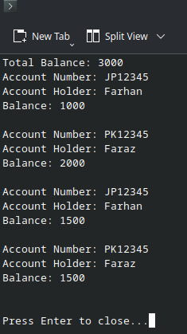
}

Task 3:

Question 1:
Yes, a friend function can handle object + primitive arguments. Since its outside the class, we can explicitly control both parameters.
Example code:
#include <iostream>
#include <string>
using namespace std;

class Account
{
int balance;
public:
Account(int bal): balance(bal)
{
}
friend Account& operator+(Account& acc, int bal);

void print_balance()
{
cout << "Balance: " << balance << endl;
}
};

Account& operator+(Account& acc, int bal) //Account object will always be the first arguement.
{
acc.balance += bal;
return acc;
}

int main()
{
Account acc(100);
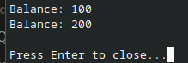
acc.print_balance(); //before
acc = acc + 100;
acc.print_balance(); //after
//acc = 100 + acc; This line will cause Errors.
//acc.print_balance();
return 0;
}

The only limitation is the order of arguments, the function in above code will only run on arguments with (Account object) + (int), and not with (int) + (Account object). For that we would need a 2nd operator overloaded function to handle that.

Question 2:
A friend function always needs an object to access the members. Being a friend only grants it permission to access them directly, It still needs the object itself to access them in the first place.
The only way it could access members without an object parameter is if those members are static, because static members belong to the entire class rather than a particular object.

#include <iostream>
#include <string>
using namespace std;

class Account
{
int const account_id;
int balance;
static int number_of_accounts;

public:
Account(int bal): balance(bal), account_id(number_of_accounts++)
{
}

void print_balance() //no arguements passed
{
cout << "Balance: " << balance << endl;
}

friend void show_total();
};

void show_total()
{
cout << "Number of Accounts are: " << Account::number_of_accounts << endl;
}

int Account::number_of_accounts = 0;

int main()
{
Account acc1(100);
Account acc2(200);
Account acc3(300);
show_total(); //no arguements passed, yet it can still access private static members of the class.

return 0;



