Name: Muhammad Farhan
Roll no: 25K-0538
Section: BCS-3K
Course: Computer Organization and Assembly Language
Course Instructor: Miss Fareeha Jabeen
Date: 22/10/2026

Task 1:
INCLUDE Irvine32.inc

.data
daystart BYTE 10010110b

.code
main PROC
mov EAX, 0
mov EBX, 0

mov AL, daystart

OR AL, 00001001b
AND AL, 01101111b

XOR AL, 00000110b
mov BL, AL
XOR BL, 11111111b

call DumpRegs

exit
main ENDP
END main
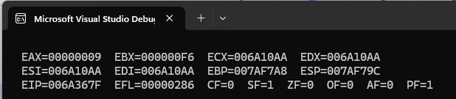
Task 2:
INCLUDE Irvine32.inc

.data

.code
main PROC
XOR EAX, EAX
XOR EBX, EBX
XOR ECX, ECX
XOR EDX, EDX

mov Al, '8'
AND AL, 00001111b
mov BL, AL

OR AL, 00110000b

mov CL, 'g'
AND CL, 11011111b

mov DL, 'M'
OR Dl, 00100000b

call DumpRegs

exit
main ENDP
END main

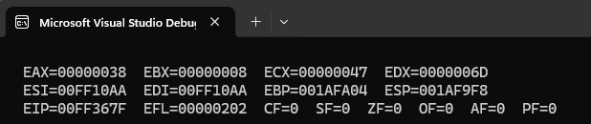

Task 3:
INCLUDE Irvine32.inc

.data
msg1 BYTE "Enter status Number (0 - 7): ", 0
msg2 BYTE "Paper Tray is Empty.", 0
msg3 BYTE "Jam Detected.",0
msg4 BYTE "Printer is Ready.", 0
.code
main PROC
mov EAX, 0
mov EDX, OFFSET msg1
call WriteString
call ReadInt
mov EBX, EAX
AND EBX, 00000110b
cmp EBX, 00000110b
JE combo
test EAX, 00000010b
JNZ empty
test EAX, 00000100b
JNZ jam

call Crlf
mov EDX, OFFSET msg4
call WriteString
jmp escaper

combo:
call Crlf
mov EDX, OFFSET msg2
call WriteString
call Crlf
mov EDX, OFFSET msg3
call WriteString
jmp escaper

empty:
call Crlf
mov EDX, OFFSET msg2
call WriteString
jmp escaper

jam:
call Crlf
mov EDX, OFFSET msg3
call WriteString

escaper:

exit
main ENDP
END main

Task 4:
INCLUDE Irvine32.inc

.data
msg1 BYTE "Comparision EAX = 50 with 75: ", 0
msg2 BYTE "Comparision EAX = 75 with 75: ", 0
msg3 BYTE "Comparision EAX = 90 with 75: ", 0
msg4 BYTE "Comparision AL = -100 with 100: ", 0

.code
main PROC
XOR EAX, EAX
mov EAX, 50
cmp EAX, 75
mov EDX, OFFSET msg1
call WriteString
call Crlf
call DumpRegs

XOR EAX, EAX
mov EAX, 75
cmp EAX, 75
mov EDX, OFFSET msg2
call WriteString
call Crlf
call DumpRegs

XOR EAX, EAX
mov EAX, 90
cmp EAX, 75
mov EDX, OFFSET msg3
call WriteString
call Crlf
call DumpRegs

XOR EAX, EAX
mov AL, -100
cmp AL, 100
mov EDX, OFFSET msg4
call WriteString
call Crlf
call DumpRegs

exit
main ENDP
END main

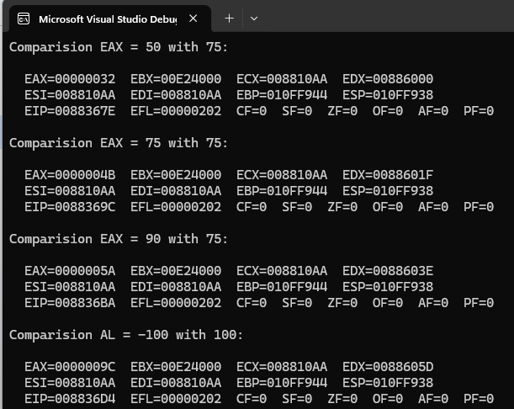
Task 5:
INCLUDE Irvine32.inc

.data
msg1 BYTE "Grade: A", 0
msg2 BYTE "Grade: B", 0
msg3 BYTE "Grade: C", 0
msg4 BYTE "Grade: Fail", 0

.code
main PROC

xor EAX, EAX
call ReadInt

cmp EAX, 85
JAE Agrade
cmp EAX, 70
JAE Bgrade
cmp EAX, 50
JAE Cgrade
mov EDX, OFFSET msg4
call WriteString
jmp escaper

Agrade:
mov EDX, OFFSET msg1
call WriteString
jmp escaper

Bgrade:
mov EDX, OFFSET msg2
call WriteString
jmp escaper

Cgrade:
mov EDX, OFFSET msg3
call WriteString

escaper:

exit
main ENDP
END main


