Name: Muhammad Farhan

Roll no: 25K-0538

Section: BCS-2K

Course: Object Oriented Programming – Lab

Course Instructor: Sir Muhammad Owais

Lab 9 Tasks
Note: Only the task screenshots are included in this word/PDF document.
The .cpp files are uploaded alongside the submission and also uploaded on my github.
Github: Link to my Github

Task 1:
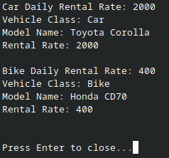

Task 2:
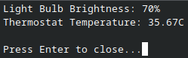

Task 3:

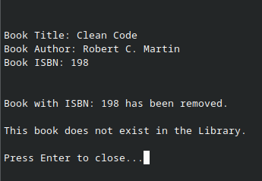

Task 4:
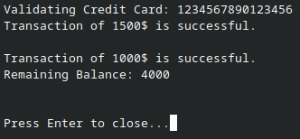

Task 5:
