Name: Muhammad Farhan
Roll no: 25K-0538
Course: Data Structures – Lab 1
Course Instructor: Miss Fatima Gado
Date of Submission: 01/09/2026

Note: Task 1, 2 and 3 are submitted in the exam submission folder.

Task 4:

#include <iostream>
using namespace std;

int main()
{
cout << "Enter the size of your Array: ";
int size;
cin >> size;
int *array = new int[size];

for (int i = 0; i < size; i++)
{
cout << "\nEnter the element #" << i+1 << ": ";
cin >> array[i];
}

cout << "The Array:" << endl;
for (int i = 0; i < size; i++)
{
cout << array[i] << " ";
}

cout << "\n\nEnter the NEW size of your Array: ";
int new_size;
cin >> new_size;
int *new_array = new int[new_size];
for (int i = 0; i < new_size; i++)
{
if (i < size)
{
new_array[i] = array[i];
}
else
{
cout << "\nEnter the element #" << i+1 << ": ";
cin >> new_array[i];
}
}

cout << "The New Array:" << endl;
for (int i = 0; i < new_size; i++)
{
cout << new_array[i] << " ";
}

delete[] array;
delete[] new_array;
return 0;
}
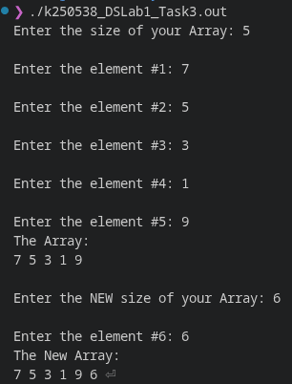

Task 5:
//25K0538, Muhammad Farhan
#include <iostream>
#include <string>
using namespace std;

class Product
{
private:
string name;
int* quantity;

public:
Product(string namae, int quant) : name(namae)
{
quantity = new int;
*quantity = quant;
}

Product(const Product &other)
{
name = other.name;
quantity = new int;
*quantity = *other.quantity;

}

~Product()
{
delete quantity;
}

Product& operator=(const Product& other)
{
if (this == &other)
{
return *this;
}

name = other.name;

delete quantity;
quantity = new int;
*quantity = *other.quantity;

return *this;
}

void display()
{
cout << "Product Name:\t" << name << endl;
cout << "Quantity:\t" << *quantity << endl;
}

};

int main()
{
Product prod1("soap", 10);
prod1.display();
Product prod2 = prod1;
prod2.display();
Product prod3("shampoo", 5);
prod3.display();
prod3 = prod1;
prod3.display();

return 0;
}

